

**School of Art and Creative Technologies**

**M.Sc.** **Data Analytics and Technologies**

**University of Bolton**

**Developing a Data-Driven Personalized Fitness Web Application for Obese and Sedentary Individuals**

Prepared by Rukayat Balogun

Student ID 2311143



September 2024

**Dedication**

This work is dedicated to all those people who morally, spiritually, and emotionally encourage obese and sedentary individuals; your strength and fight for healthier lives have led to the development of this webapp. Equally, this work is also dedicated to researchers and medical professions who strive to advance public health through innovation in data-driven technologies.

**Acknowledgement**

I am obliged to the following for invaluable inspiration and assistance which helped me complete my program:

They say you identify a talent when you see one; my supervisor in person of Dr. Celestine Iwendi saw potential in me when I had only resumed the first day at the project showcase of the graduating student last year. His mentorship not only sharpened me, but his guidance strengthened my decision all through my academic journey. His feedback not only encouraged me, but it also played a major role in nurturing and completing this research. I soon realized that his passion for excellence has enabled many students, myself included, beyond our limits and had a deep impact on my personal and academic development.

I would also like to extend my warm appreciation to the Adetuyis for their overall support of my relocation to the United Kingdom. Their support was an instrument of inspiration throughout the process; I will be forever grateful for such support and effort in this phase of my life.

It is now befitting that I express my appreciative sentiments to my lovely sister, Mrs. Oso, and her husband, whose medical profession has been an inspiration to me personally and an avenue for motivating me into making contributions to improve human life and health. Through their passion and commitment to the medical profession, I have learned the essence of persistence and purpose.

To my parents, Mr. and Mrs. Balogun, who constantly stood by me and believed in me even when I was not believing in myself. Your love and support have been the bedrock of my strength. Your consistency through every challenge, both emotionally and practically, made this achievement possible.

Lastly, I would like to acknowledge the support of the staff at the University of Bolton for creating a nurturing environment that allows student to thrive.

# Abstract

*One of the leading causes of chronic health issues worldwide according to the World Health Organization (WHO) is Obesity and Sedentary, followed by cardiovascular disease, diabetes and hypertension. Research has proven that the approach to dietary and fitness recommendations has been a Traditional one-size-fits-all which often fail to address individual needs leading to suboptimal health outcomes and low adherence rate. This research introduces an application developed to personalise fitness and diet by integrating machine learning algorithm into Django framework to improve the lifestyle of Obese and Sedentary individuals. This research uses two data sources, one from the American Time Use Survey (ATUS) and the other collected from the web application form using Django Form. The app which provides tailored fitness and dietary recommendation Sed based on the individuals height and weight was integrated to several machine learning models including Linear Regression, Decision Trees, Support Vector Machines, Gradient Boosting using Django ORM. While Gradient Boosting was evaluated to be the most effective algorithm with Mean Squared Error(MSE) of 0.1866 and accuracy rate of 92.5%. A comparative analysis with existing literature showed significant improvement in predictive accuracy and user engagement, highlighting the importance of improved user adherence and health outcomes. A feedback form on user engagement further confirmed the system’s usability and effectiveness. This research underscores the importance of data in a user-centric design to improve the overall digital health interventions.*

Keywords: Obesity, Sedentary Lifestyle, Personalized Fitness, Machine Learning, Web application, Body Mass Index (BMI), Gradient Boosting, Health Interventions, User Engagement, Data-driven Recommendations

Table of Contents

Abstract 7

Chapter 1: Introduction 8

1.0 Introduction 8

1.1 Background of Study 8

1.2 Health Implications of Obesity and Sedentary Lifestyles 9

1.3 Statement of the Problem 10

1.4 Purpose of the Research 10

1.5 Research Aims 11

1.6 Research Questions 11

1.7 Research Objectives 11

1.8 Relevance and Importance of the study 11

1.9 Scope of the Study 12

1.10 Summary 12

Chapter Two – Literature Review 13

2.1 Introduction 13

2.2 Current Public Health Guidelines and Interventions 20

2.3 Constraints of Conventional Diet and Fitness Programmes 20

2.4 Public Health Programmes Focusing on Obesity and Inactive Behaviors 21

2.5 Difficulties in Personalised Health Recommendations 21

2.6 Addressing Obstacles in Tailored Health Recommendations 21

2.7 Incorporating Wearable Technology and Smartwatch Data 21

2.8 Utilising Knowledge Graphs for Providing Dietary Recommendations 22

2.9 Predictive Machine Learning Models for Obesity Associated Gene Expression 22

2.10 Strategies to Encourage Health Eating Habits is Education 22

2.11 Health and Wellness Systems 22

2.12 Dietary Guidelines for Specific Health Conditions 23

2.13 Examining Gender Disparities in Obesity and Health Interventions 23

2.13.1 Limitations of Traditional Diet and Fitness Plans: 23

2.13.2 Public Health initiatives Targeting Obesity and Sedentary Lifestyle 23

2.13.3 Challenges in Personalized Health Recommendations 24

2.14 Strategies for Overcoming Challenges: 25

2.15 Summary 25

Chapter 3 – Methodology 27

3.1 Introduction 27

3.2 Research Philosophy 27

3.3 Proposed Workflow 28

3.3.1 Data Collection 29

3.3.2 Data Preprocessing 30

3.3.3 Exploratory Data Analysis (EDA) 31

3.3.4. Machine Learning Model Development 36

3.3.5 Web Application Development using Django 37

3.3.6 Integration of Machine Learning using Django 38

3.3.7 Recommendation Engine Development 38

3.3.8 Evaluation and Testing 42

3.4 Data Analysis Plan 42

3.5. Machine Learning 43

3.5.1 Linear Regression 43

3.5.2 Ridge Regression 43

3.5.3 Lasso Regression 43

3.5.4 Decision Tree Regressor 43

3.5.5 Random Forest Regressor 43

3.5.6 Support Vector Machine 43

3.5.7 Gradient Boosting 44

3.6 Rationale for Machine Learning Algorithm 44

3.7 Ethical Considerations 44

3.8 Summary 44

Chapter 4 – Result and Discussion 46

4.1 Introduction 46

4.2 Data Pre-processing Results 46

4.2.1 Data Cleaning 46

4.2.2 Handling Inconsistent Data 47

4.2.3 Handling Missing Values 47

4.2.4 Outlier Detection and Handling 48

4.3 Exploratory Data Analysis (EDA) 49

4.3.1 Distribution of BMI 49

4.3.2 Feature Correlation Analysis 49

4.3.3 Relationship Between Height and BMI 49

4.3.4 Joint Distribution of Height and Weight 50

4.3.5 Pairwise Relationship Between Features 50

4.4 Model Training and Validation 51

4.4.1 Model Selection 51

4.4.2 Data Splitting 51

4.4.3 Model Training 52

4.4.4 Model Validation 52

4.5 Model Performance Comparison 53

4.5.1 Best Model Selection 53

4.5.2 Discussion of Model Performance 53

4.6 BMI Prediction and Classification Results 53

4.6.1 Categorization of BMI Predictions 54

4.6.2 Classification Metrics 54

4.7 Recommendation System Outcomes 56

4.7.1 Personalized Recommendations 56

4.7.2 User Feedback and System Refinement 56

4.8 Summary 57

Chapter 5 – Discussion of Results 58

5.1 Introduction 58

5.2 Statistical Analysis and Data Preprocessing 58

5.3 Exploratory Data Analysis (EDA) 58

5.4 Machine Learning Model Performance 59

5.5 Discussion on the Recommendation System 59

5.6 Comparison with Existing Literature 59

5.7 Implications for Practice 61

5.8 Challenges and Limitations 62

5.8.1 Data Quality and Availability 63

5.8.2 Model Generalization 63

5.8.3 User Engagement 63

5.9 Summary 63

Chapter 6 – Conclusion, Recommendations, Future Work, and Limitations 64

6.1 Introduction 64

6.2 Summary of Findings 64

6.3 Recommendations 65

6.4 Future Work 65

6.5 Addressing Research Question 66

6.6 Final Thoughts 66

6.7 Summary 67

Reference 68

Bibliography 73

Appendix – Project Timeline 75

Appendix – Data Analysis Code 77

Appendix – Web Application Code 83

Appendix – Web Application Frontend 91

LIST OF TABLES

Table 2.1 An overview of academic publications and their relevance to research 13

Table 6.5 Addressing Research Question 66

LIST OF FIGURES

Figure 1: An illustration of Machine Learning Algorithm on fitness and dietary app 10

Figure 3.3: Proposed Workflow for the web application using Django 29

Figure 3.3.1: Snapshot of the data 31

Figure 3.3.3.1: Distribution of BMI 33

Figure 3.3.3.2: Feature Correlation Matrix 34

Figure 3.3.2.3: Height vs BMI 35

Figure 3.3.2.4: Joint Plot of Height and Weight Coloured by BMI 35

Figure 3.3.2.5: Pairwise Relationship 36

Figure 3.3.3.6: Weight vs BMI 37

Figure 3.3.7.4: Architecture of the web app 41

Figure 4.2.4: outliers 49

figure 4.4.4: Model Validation 53

figure 4.6.2 Classification Metrics 55

Fig 5.5: Comparison of Model Performance (MSE and Accuracy) 60

# Chapter 1: Introduction

## 1.0 Introduction

Fitness is a cornerstone of a healthy lifestyle, offering a multitude of benefits for both our body and minds (Magallanes, 2024). While the drawbacks of inactivity are well-documented, including obesity, weakened muscles, and reduced cardiovascular health, many struggle to incorporate sufficient exercise into their routines (Bruback, 2024). Time limitations, health concerns, and lack of access to facilities can all be barriers to achieving the recommended fitness level (Starns et al., 2024). This study aims at developing a personalized fitness web application using Python Django Framework and a health dataset to build a machine learning algorithm that can recommend fitness exercise for obese and sedentary individuals based on the user preference as shown in Figure 1.



Figure 1: An illustration of Machine Learning Algorithm on fitness and dietary app

## 1.1 Background of Study

The world is facing a global growing public health crisis; the twin epidemics of obesity and sedentary lifestyles (Umekar and Joshi, 2024). Sedentary as defined by Yadav is a physical inactivity behaviour characterised by low energy expenditure, has become a prominent feature of contemporary lifestyles. The combination of our progressively modern surroundings and technological progress promotes sedentary behaviour that results to a culture of sitting. His research demonstrates a definitive correlation between a sedentary lifestyle and a variety of chronic ailments, such as obesity, cardiovascular disease, and type 2 diabetes (Yadav, Research and Tiwari, 2024). The World Health Organization (WHO) has officially designated obesity as the most significant danger to the health of westernised countries. According to WHO, around 40% of adults in the United States are categorised as obese.

Rodbard defined obesity has a multifaceted problem with a substantial genetic element, while food and other factors also contribute. His research indicates that approximately 40-70% of an individual’s predisposition to obesity is governed by their genetic makeup. Nevertheless, his research also indicates a pivotal correlation between genetics and environment. He demonstrated that engaging in more physical exercise can reduce the impact of a greater genetic predisposition to fat. This underscores the constraints of existing universal approaches to recommendation for fitness (Rodbard et al., 2024).

Although the advantages of fitness for weight control have been well-documented, a significant number of people find it challenging to start and sustain healthy routines (Rodbard et al., 2024). Current Web-based programmes provide little assistance, typically including exercise schedules and educational materials (Fjellström et al., 2024). Nevertheless, these programmes generally lack customisation, as they do not consider individual variances in parameters such as genetics and fitness levels(Author King, 2023). He also stated that the absence of personalization may be a contributing factor to the frequently observed low rates of adherence in web-based fitness regimens.

## 1.2 Health Implications of Obesity and Sedentary Lifestyles

The research conducted by (Ghosh et al., 2023), which specifically targets a demographic of adults from South Asia, offers significant insight into the chronic illness linked to obesity and detrimental effects of sedentary on one’s well-bring. The study highlights the correlation between obesity and a group of long-lasting illnesses, specifically cardiovascular diseases (CVD) and type 2 diabetic mellitus (T2DM). In research conducted by Suanrueang, (2024) Hypertension is a significant risk factor for cardiovascular disease (CVD), was observed to be more common among females. Central obesity, as defined by visceral fat percentage, may be a more powerful predictor of hypertension than body mass index (BMI) alone. The result of the research indicates that there is a strong correlation in Obesity and diabetes (especially Type 2) which results from the individual’s tandem with weight gain. Relatively in a research conducted by Ghosh, (2023) which highlights an improved prevalence of additional obesity-related illness such as hypothyroidism and arthritis, particularly among the elderly population.

Furthermore, in a research conducted by Ozsoy, it highlights the impacts of sedentary lifestyles on one’s health and overall wellbeing. In this study, obesity’s negative effects on chronic health issues was discussed to be caused by inactivity. The participants of the survey, displayed signs of obesity, regardless of weight or height, but those who led sedentary lifestyles were more likely to experience co-morbidity consequences, particularly in older people. The study also found that even when people are aware of the benefits of fitness, they still lack the desire to be sedentary (Ozsoy et al., 2024a).

## 1.3 Statement of the Problem

Previous research has indicated that Traditional diet and fitness exercise plans use a one-size-fits-all approach, they usually do not cater to the specific needs of each person. These systems don’t account for individual difference in metabolism, physical capabilities, medical histories, and preferences, which leads to subpar results (Papry et al., 2024). The generalised strategy does not satisfy the specific requirements, which leads to low adherence and minimal health improvements. This study highlights the requirements for individualised medical treatments that can consider user particular demands are not met by the generalized plan which results in low adherence and little improvement in health.

Many of the recommendation systems in use, today are flawed, particularly those that employ collaborative filtering algorithms. The cold start problem arises when the system has insufficient data about the user’s data for accurate recommendation. Sparse data adds complexity to this challenge since it reduces the effectiveness of collaborative filtering techniques when there is less interaction data (Yue et al., 2021). Another significant barrier is the computational complexity of processing large datasets to generate recommendations in real time. Improving the recommendation systems requires resolving these problems.

Wearable technology such as smartwatches has gained popularity as a tool for monitoring health since it can gather rich and continuous health data. Nevertheless, a lot of the health care systems in place today fail to use the data generated by these devices for a tailored health suggestions. The underutilisation of continuous health data highlights the need for systems that can efficiently integrate and evaluate this data, as well as restricts the potential benefits of personalised health recommendations.

Using pathology data in conjunction with continuous health monitoring, this research seeks to close existing gaps in the present health systems. This research sets the stage for further development in individualized health management while simultaneously addressing a critical public health issue. This research hold promising substantially influencing public health by endowing people with the ability to make knowledgeable choices and take proactive measures towards improved health.

## 1.4 Purpose of the Research

To develop and evaluate a web application for a personalised fitness assistant designed especially for obese and sedentary individuals is the purpose of this study. This will be achieved using cutting edge technologies to provide individualised recommendations for obese and sedentary individuals. By combining the primary data using Django forms and secondary data from ATUS, this research seeks to address the major gaps in current health intervention systems and overcome the limitation of traditional recommendation styles.

## 1.5 Research Aims

This research aims to create an intuitive web application that can be used by all irrespective of ability, and that is simple to navigate. It centres on including necessary accessibility elements to guarantee inclusion and improve user experience. The application will be designed to meet user needs and support obese and sedentary with dietary and fitness recommendations. Through friendly user-interface, the application aims to provide a platform that encourage healthy living and physical exercise. A feedback evaluation of the app’s performance in accomplishing these objectives will be conducted, with emphasis on how it affects user’s activity levels and general health outcomes.

## 1.6 Research Questions

These following questions are the focus of this study:

1. How can the user interface be optimized for ease of use and accessibility?
2. What accessibility features are necessary to ensure inclusivity for all potential users?
3. How user friendly is the web application for individuals with varying levels of tech-savviness?
4. What features of the application are most effective in engaging and retaining users?
5. How effective is the recommendation fitness assistant web application in improving physical activity levels among obese and sedentary individuals?

## 1.7 Research Objectives

1. Develop and implement a user-friendly interface for the personalized fitness web application tailored to the needs of obese and sedentary individuals.
2. Ensure the web application adheres to current web accessibility standards to provide an inclusive experience for users with varying needs.
3. Integrate machine learning algorithms to provide personalized fitness and dietary recommendations based on user input and historical data.
4. Analyse user engagement data to identify which features are most frequently used and highly rated by users.
5. Use self-reported and objective measures to access changes in physical activity.

## 1.8 Relevance and Importance of the study

The significance of this study lies in its potential to revolutionized health management for obese and sedentary individuals through the development and implementation of sophisticated recommendation fitness assistant web application. Obesity and Sedentary lifestyles are leading contributors to various chronic diseases, including cardiovascular diseases, diabetes, and certain cancers. This research will not only mitigate these health risks, it will also improve overall well-being as these innovations can be applied beyond health management to other domains requiring personalized recommendations which can inform future research and development effort aimed at enhancing personalized health interventions and other applications of recommender systems.

## 1.9 Scope of the Study

The scope of the study encompasses the primary focus on obese and sedentary individuals who can benefit significantly from personalized diet and exercise recommendations using advanced algorithms that enhances accuracy and relevance. This study will focus on developing an intuitive and accessible user interface.

## 1.10 Summary

This chapter focuses on developing a personalized fitness web app to help tackle obesity and inactive lifestyles. It highlights the drawbacks of conventional fitness regimens, which frequently fail to take individual’s needs into consideration. The aim of this study is to develop a user-friendly app with personalized features using machine learning algorithms integrated with Django framework. This study will increase physical activity and enhance healthy lifestyles in sedentary and obese individuals.

# Chapter Two – Literature Review

## 2.1 Introduction

This chapter examines the literature on existing studies on obesity and sedentary lifestyles, identifying the strengths, limitations, methodology, knowledge contribution and its relevance to this thesis.

Table 2.1 An overview of academic publications and their relevance to research

|  |  |  |  |  |  |  |  |
| --- | --- | --- | --- | --- | --- | --- | --- |
| S/N | References | Research Focus | Relevance to this thesis | Methodology | Strengths | Limitations | Knowledge Contribution |
| 1 | Singhania and Reddy (2024) | Big Data Analytics and predictive modelling for chronic disease management | 4 | Review and analysis of big data applications; identification of key technologies and solutions | Comprehensive review of big data applications; identification of key technologies and solutions | General focus on chronic diseases; limited focus on personalized fitness applications | Highlights the potential of big data in personalizing health care and predictive analytics |
| 2 | Olmo, (2024) | Machine Learning and virtual gyms for healthcare | 5 | Case studies and implementation of online gym systems | Practical application of machine learning in fitness; detailed case studies | Focus on virtual gyms may not address broader aspects of personalised fitness web applications | Illustrates the practical implementation of machine learning in virtual gym environments for personalized health |
| 3 | Jeremiah Olawumi Arowoogun et al., (2024) | Predictive analytics in health and fitness personalization | 4 | Review and analytics of predictive analytics techniques | Comprehensive review; focus on predictive techniques | Broad focus on health and fitness; less on specific application | Reviews the role of predictive analytics in personalizing health and fitness interventions. |
| 4 | Mcgowan et al., (2024) | Persuasive system design (PSD) in mobile health (mhealth) apps. | 5 | Multiphase experimental design, prototyping, expert review and iterative design. | Emphasis on personalization and diversity in user’s needs; comprehensive methodology | Focus on persuasive design, less on direct health outcomes. | Provides insights into using persuasive design for personalized health interventions |
| 5 | Peruma et al., (2024) | Persuasive design techniques in mhealth apps | 4 | Survey-based approach with contrast mining | Detailed evaluation of persuasive design principles; user-centric design approach | Limited generalizability beyond mhealth apps; focus on user engagement over health outcomes. | Evaluates Persuasive design technique to enhance user engagement in health apps. |
| 6 | Shoba et al., (2024) | Dynamic cardiovascular rehabilitation for Personalized Exercise Plans Guided by Recurrent Neural Networks in the Cloud | 4 | Development and testing of a fitness recommendation system | High relevance to personalized fitness; user-centric approach. | Potential privacy concerns with health data usage; need for larger sample size. | Advances the understanding of user-centred design in fitness recommendation systems |
| 7 | Hu et al., (2024) | Wearable Technology for personalized exercise recommendations | 5 | Development and testing or wearable technology applications | Focus on wearable technology; high relevance to personalized fitness | Technical focus; need for long-term user engagement data | Explores the application of wearable technology in providing personalized exercise recommendations |
| 8 | Polak et al., (2016b) | User engagement strategies in digital health | 4 | Systematic review | Broad review on engagement strategies; relevant to digital health applications. | Focus on engagement, less on fitness-specific outcomes. | Reviews user engagement strategies to enhance digital health interventions |
| 9 | Mustafa et al., (2021) | Dietary recommendations for women with gestational diabetes mellitus | 4 | Randomized controlled trials (RCts) and systematic review | High-quality evidence from RCTs; relevant to chronic disease management | Focus on chronic disease; may not fully address personalized fitness applications | Emphasizes the effectiveness of mHealth interventions in managing chronic diseases through evidence-based research |
| 10 | Dirik,( 2023) | Machine learning techniques for obesity detection | 5 | Use of machine learning algorithms such as Random Forest and SVM for obesity prediction | Application of advanced machine learning techniques; high relevance to obesity detection | Limited focus on broader fitness applications; primarily technical evaluation. | Demonstrates the efficacy of machine learning in predicting obesity, highlighting the importance of technical models in health care |
| 11 | Thomas et al., (2024) | Transforming big data for AI applications in nutrition and obesity | 4 | Big data transformation techniques and AI and readiness | Focus on practical applications of AI in nutrition and obesity research | Technical focus on data transformation; less on direct health outcomes. | Provides into preparing large datasets for AI applications in health research |
| 12 | Szeto, Arnold and Maher (2024) | Wearable activity trackers for physical activity promotion in healthcare | 4 | Provides insights into the use of wearable activity for promoting physical activity, which can be applied in personalized fitness applications for obese and sedentary individuals | Delphi study to develop a checklist (WATCH) for implementing wearable activity trackers in healthcare settings | Implementation challenges due to varied settings and patient compliance | Offers a structured guide for integrating wearable activity trackers into healthcare, highlighting best practices and potential challenges |
| 13 | Yi et al., (2024) | Predicting gene expression related to obesity using Random Forest | 5 | Application of Random Forest machine learning algorithms | Advanced machine learning techniques; focus on obesity. | Technical focus; limited broader fitness application | Provides a novel application of Random Forests in predicting obesity-related genetic expressions |
| 14 | Dergaa et al., (2024) | AI-driven methods to improve physical activity | 4 | Systematic review of AI applications in physical activity enhancement | Comprehensive review; focus on AI applications | General focus; less on personalized fitness applications | Summarizes AI-driven strategies to increase physical activity, providing, providing a broach overview of AI applications |
| 15 | MacCarthy and Pazoki, (2024) | Machine Learning for personalized exercise plans | 5 | Review of machine learning techniques in exercise planning | Relevance to personalized fitness; detailed analysis of machine learning applications | Focus on technical aspects; need for more practical implementation data. | Highlights machine learning’s potential in customizing exercise plans to individuals needs |
| 16 | Ulfa et al., (2022) | Data-driven techniques for personalized nutrition and fitness | 5 | Development and evaluation of a data driven recommendation system | Integration of nutrition and fitness; data-driven approach | Potential data privacy concerns need for more diverse sample | Demonstrates the integration of nutrition and fitness recommendations through data-driven methods |
| 17 | Rodriguez et al., (2022) | Personalized exercise programs for obesity management | 4 | Clinical trials evaluating personalized exercise programs | Focus on obesity management empirical data from clinical trials | Clinical setting; may not generalize to broader populations | Provides empirical evidence on the effectiveness of personalized exercise programs in managing obesity |
| 18 | McConnell et al., (2018) | Mobile health technologies to promote physical activity | 4 | Review of mobile health (mhealth) application. | Comprehensive review; focus on technology application | Broad focus; less on personalized fitness application. | Reviews the use of mobile health technologies to enhance physical activity |
| 19 | Oyebode et al., (2023) | Predictive analytics in health and fitness personalization | 4 | Review and analysis of predictive analytics techniques | Comprehensive review; focus on predictive techniques | Broad focus on health and fitness; less on specific applications | Reviews the role of predictive analytics in personalizing health and fitness interventions |
| 20 | Al Ansari et al., (2023) | AI applications to enhance physical activity | 4 | Systematic review of AI applications in physical activity | Focus on AI; comprehensive review | General focus; less on personalised fitness. | Summarizes the sue of AI to boost physical activity, highlighting various applications |
| 21 | Busnatu et al., (2022) | Integration of wearable device with personalized health recommendations | 5 | Development and testing of integration frameworks | Focus on integration of wearable technology; practical application | Technical focus; need for long-term user engagement data | Examines the integration of wearable devices in delivering personalized health recommendations |
| 22 | Galekop, Uyl-de Groot and Redekop, (2024) | Personalized exercise and nutrition plans for obesity | 5 | Development and evaluation of personalized plans | Integration of exercise and nutrition; high relevance to obesity | Limited sample size; need for long term effective data | Combines exercise and nutrition plans tailored to individual needs to combat obesity |
| 23 | Husnain et al., (2024) | AI for developing personalized health interventions | 4 | Application of AI techniques in health intervention development | Focus on AI; comprehensive application analysis | General focus; less on fitness specifc application | Discusses AI’s role in creating personalized health interventions |
| 24 | Shokrzadeh et al., (2024) | Personalized dietary recommendations using knowledge graphs | 5 | Development and testing of knowledge graph-based recommendation systems | Focus on personalization advanced recommendation techniques | Primarily focused on dietary recommendations; less on fitness | Demonstrates the use of knowledge graphs to enhance dietary recommendations |
| 25 | Joshitha et al., (2024) | Personalized fitness coaching using AI and wearable devices | 5 | Integration of AI and wearable devices for personalized fitness coaching | Focus on practical application; high relevance to personalized fitness. | Technical focus; need for long-term user engagement data. | Explores combination of AI and wearables for personalized fitness coaching |
| 26 | Jubair, (2024) | Machine Learning for personalized fitness plans | 5 | Development and testing of machine learning models for fitness plans | Advanced machine learning techniques: high relevance to personalized fitness | Technical focus limited long-term effectiveness data. | Highlights machine learning’s potential in creating personalized fitness plans |
| 27 | Singh et al., (2024) | mHealth solutions for personalized health | 4 | Systematic review of mHealth solution | Comprehensive review; focus on personalized health | Broad focus; less on specific fitness applications. | Reviews mHealth solutions and their applications in personalized health |
| 28 | Retzlaff, (2024) | AI integration with personalized nutrition and fitness | 5 | Development and testing of AI-integrated programs | High relevance to personalized fitness; focus on integrations | Technical focus; need for broader application data | Explores the integration of AI with personalized nutrition and fitness programs |
| 29 | Jegan and Nimi, (2024) | Personalized exercise recommendations using wearable data | 5 | Development and testing of wearable data applications | Focus wear technology; high relevance personalized fitness | Need for long-tern user engagement data technical focus | Examines how wearable data can be used to personalise exercise recommendations |
| 30 | Chioma Anthonia Okolo et al., (2024) | Data-driven approaches to personalized health | 4 | Comprehensive review of data-driven health approaches | Broad review relevance to personalized health | General focus; less on specific fitness application | Provides a comprehensive review of data-driven health approaches |

## 2.2 Current Public Health Guidelines and Interventions

The International public health organization has put policies into place to lessen the risks associated with Obesity and Sedentary Lifestyles. The World Health Organization in conjuction has recommended that individuals engage in at least 150 minutes of moderate-to-intense aerobic activity or 75 minutes of vigorous-to-intense aerobic activity every week. Individuals are recommended to perform exercises that build muscle at least 2 times a week (WHO, 2020). These guidelines create a well-balanced diet that limits the intake of processed foods, added sugars, unhealthy fats and large quantities of fruits, vegetable, whole grains, and large qualities of fruits, vegetables, whole grains lean proteins (Henry & Frank, 2023).

The public health initiatives aim to create circumstances that encourage the adoption of healthful habits. The implementation of community programs, school interventions, corporate wellness initiatives, and policy modifications are essential strategies for fostering healthy eating and physical exercise (Sallis & Glanz, 2009; Polak et al., 2016). However, these programs quite often struggle to address individual differences and achieve sustained behavioural changes.

## 2.3 Constraints of Conventional Diet and Fitness Programmes

Traditional diet and fitness regimens frequently use a standardised approach that ignores individual differences in genetic, age, fitness levels and cultural preferences. Lack of customisation could lower adherence rates and demotivation (King, 2023). Furthermore, genetic techniques might not be sustainable in the long run since they disregard the preferences and lives of the individual, making it difficult for people to maintain good habits over time (Drew et al. 2024).

Research indicates that individualised health treatments that consider each patient’s unique needs and circumstances are more effectives at promoting behaviour changes and improving health outcomes (Papry et al., 2024). By providing tailored recommendations that align with user’s goals and preferences.

## 2.4 Public Health Programmes Focusing on Obesity and Inactive Behaviors

Public health Organisations advocates for healthy lifestyles through fitness and nutritious diet. They organise community programs which is focused in promoting healthy lifestyles to engage individuals to participate (Polak et al., 2016a). In addition, School-based interventions are added to school curriculum to promote the adoption of nutritious eating habits and engagement in physical activity during school hours (Polak et al., 2016b). Some workplace wellness programmes also help to facilitate physical activity challenges and offer nutritious food choices (Prowse et al., 2023). Organization have policy modifications such as implementing higher taxes on sugary beverages, providing financial assistance for the production of fruits and vegetables, and implementing urban planning strategies that encourage the development of pedestrian-friendly communities, establish favourable conditions for making healthier choices (Polak et al., 2016).

## 2.5 Difficulties in Personalised Health Recommendations

Developing a personalised recommendation several challenges. The “cold-start” challenge arise when systems struggle to provide accurate recommendations because of inadequate data (Ozsoy et al., 2024). Sparse data might make recommendation system less effective since they frequently rely on self-reported information that might be inaccurate (Tiribelli & Calvaresi, 2024). Notable to mention is privacy issues around the collection and use of personal health data make the deployment of personalized health recommendations much more difficult (Tiribelli & Calvaresi, 2024).

## 2.6 Addressing Obstacles in Tailored Health Recommendations

To overcome these obstacles, combining data from wearable devices, electronic health records, and environment sensors can provide a comprehensive understanding of an individual’s health. Advanced analytics, which include machine learning algorithms can handled complex datasets and discover trends to deliver personalized recommendation. By including user feedback to continuously improve the system can boost individual’s motivation and increase adherence. Also, ensuring data security and integrity are important ethical issues that play a vital role in building trust and increasing user involvement (Valentine et al., 2023)

## 2.7 Incorporating Wearable Technology and Smartwatch Data

Wearable device such as smartwatches, has a significant impact on collecting consistent and detailed health data such as heart rate, blood pressure, sleep habits, glucose levels, and body mass index. By combining this data with pathological information, it becomes possible to create customised dietary and fitness recommendations. According to research conducted by Gaikward, utilising data from smartwatches can be useful in personalized health and smartwatches can be useful in customising health interventions and enhancing health outcomes (Gaikward et al., 2024). Smartwatches and other portable devices provide a convenient and accessible approach to measure and improve certain fitness levels. They offer real-time feedback and personalised recommendations to help attain fitness goals (Fitness Guide, 2024).

## 2.8 Utilising Knowledge Graphs for Providing Dietary Recommendations

While using knowledge graphs in the creation of customised nutrition recommendation systems has yielded promising results, it synthesises data from many domains and use collaborative filtering techniques to improve the precision and variety of recommendations. This technology addresses issues such as the cold-start problem, computational complexities, and spatial data, increasing the effectiveness of nutritional recommendations (Huang et al., 2024). Knowledge-based systems, while efficient, frequently require human updates and may struggle to adapt to new data, emphasising the need for more dynamic approaches such as genetic algorithms (Mardiana & Baizal, 2024).

## 2.9 Predictive Machine Learning Models for Obesity Associated Gene Expression

Machine learning algorithms, such as Random Forest, have been used to forecast gene expressions linked with obesity. These models investigate genetic and environmental factors to get an understanding of individual’s proclivity for obesity and potential treatment. The application of machine learning in this context demonstrates the feasibility of developing targeted and personalized health interventions (Smith et al., 2024). Furthermore, machine learning algorithms have shown promise in designing personalised nutrition regimens by including dietary recommendation systems that consider individual health issues (Rosli et al., 2020).

## 2.10 Strategies to Encourage Health Eating Habits is Education

Interventions in higher education settings have focused on encouraging students to eat healthily. The primary goal of these programs is to increase awareness and comprehension of nutritious eating habits while also providing practical resources to help people choose healthier foods. Research has shown that educational programs can have a considerable impact on eating habits and nutritional awareness (Jones et al ., 2024).

## 2.11 Health and Wellness Systems

The Health and Wellness system covers a broad range of topics and is thorough in its approach. Holistic health and wellness systems include a variety of components such as physical fitness, dietary planning, and health issue management. These systems provide a compregensive approach to individual health. These systems use advanced algorithms to assess strength, adapt diets, and advised on personalised and efficient health interventions by categorising people (Fitness Guide, 2024).

## 2.12 Dietary Guidelines for Specific Health Conditions

Genetic algorithms have been used to create specific food category systems for health conditions including hypertension. These systems provide tailored dietary ingredient combination that are particularly developed to fit individual health needs, resulting in effective disease management such as hypertension (Mardiana & Biazal, 2024). These food recommendation systems circumvent the limitations of knowledge-based methods by adapting to new inputs and providing flexible responses.

## 2.13 Exploring Gender Difference in Obesity and Health Interventions

The gender difference is one of the big factors that influences obesity incidence, body composition, and health intervention programs. In many studies, it is established that though men are more obese, women have a higher body fat composition. Moreover, bod fat distribution is also differentiated by gender. Men tend to develop central or android obesity while the development of peripheral or gynoid obesity is typical in women. Such trends influence the prevalence of obesity, body composition, and health efficacy across genders, necessitating health intervention programs sensitive to gender-specific needs and responses. Differences in body composition can therefore lead to variations in the pharmacokinetics and pharmacodynamics of antiobesity drugs between sexes (Muscogiuri et al., 2024). This seldom means recommending different dosages according to sex. In addition, female participation in obesity clinical trials is also lacking much of the time, and more studies are needed (Muscogiuri et al., 2024).

### 2.13.1 Limitations of Traditional Diet and Fitness Plans:

The one-size-fits-all model does not take into consideration the intrapersonal variability between factors such as genes, age, physical condition, and ethnical linking or disliking of some factors. This can only build up frustration or poor compliance in the long run. Such approaches may not be able to satisfy individual needs and demands. It can be challenging for people to adjust to certain food restrictions or to tolerate a particular style of training programs

Sustainability: the generic approaches may not be long-term viable. In fact, the individuals may not be able to maintain the excellent behaviours over time if they fail to address these personal lifestyles (Drew et al., 2024).

### 2.13.2 Public Health Programs Aimed at Obesity and Sedentary Lifestyle

Public health campaigns create environments that promote and facilitate healthy lifestyles by reducing risk factors for obesity and sedentary behaviour (Sallis and Glanz, 2009). Some of the programs includes:

**Community-based initiatives** offer cooking and other healthy eating sessions, as well as activity sessions (Polak et al., 2016b).

**School-based initiatives**: school-based initiatives allow the children to eat healthy or indulge in physical activities within the school hours and thus teach the benefits of a healthy lifestyle to the children (Polak et al., 2016b).

**Workshop wellness programs**: these are programs that would be able to involves employees in doing some challenges that include physical activities, offering healthy foods in cafeterias, and workshops for education on how to live healthy lifestyles (Prowse1 et al., 2023).

**Policy Changes**: increased taxation for sugary drinks, subsidy for fruits and vegetables and urban planning promoting walkable neighbourhoods can set a supportive environment for healthy choices.

While many of such programs offer useful tools, their effectiveness is often constrained by issues of finance, availability and human inspiration. Better targeted methods, such as those examined in this web application development research project, give reason to hope for improved public health initiatives regarding obesity and sedentary lifestyles.

### 2.13.3 Personalized Health Recommendations Issues

Personalized health recommendation, according to Valentine, means giving people information and treatments that will be pertinent to their own health needs and circumstances. However, it has a range of challenges:

1. Limitations of “one-size-fits-all approaches”:
   1. General health advice may never work for everyone. This could reason due to differences in heredity, lifestyle, environment can all play a huge role in the effectiveness of general recommendation (Bodhini et al., 2023).
   2. Low motivation: general recommendations do not take into account individual preferences and motives; therefore, compliance with a general recommendation is low and less likely to have a long-term impact of such recommendation (Biese et al., 2024).
   3. Inequity: a general recommendation cannot meet the needs at an individual level (Polak et al., 2016a).
2. Limitations of Existing Recommendation Systems:
   1. The cold start problem occurs when new users lack enough health data, hence becoming a significant challenge. The recommendation algorithms cannot provide personalized recommendations where there is little data about the users (Ozsoy et al., n.d.).
   2. Limited data: most health recommendation systems rely on self-reported data, which is sometimes faulty. Inadequate data reduces the possibility of providing personalization that caters for each individual (Tiribelli and Calvaresi, 2024).
   3. Privacy: there is a possibility of encountering privacy problems while collecting and using personal health data. Certain people may not be willing to share confidential information about their health, hence there will be reduced effectiveness of the personalized recommendation system system (Tiribelli and Calvaresi, 2024).
3. Importance of personalized, context-sensitive health interventions:
   1. Dynamism in health needs and risks: health needs and risks change with time. This demands personalized advice that is responsive to such changes and changing circumstances (Rummery et al., 2023).
   2. Context matters: lifestyle decisions, social factors, and environmental exposures determine overall well-being. If personalized recommendations are to be truly effective, they need to take into consideration certain contextual elements (Rummery et al., 2023).
   3. Health treatments: the effective behavioural modification without just the delivering of knowledge. They should support and enable people to adopt and maintain a healthy lifestyle (Rummery et al., 2023).

## 2.14 Strategies for Overcoming Challenges:

To overcome the issues highlighted in the literature, the following strategies are necessary:

**Enhanced data sources**: the combination of data from wearable devices, electronic health records and environmental sensors can provide a more comprehensive understanding of an individual’s health.

**Advanced analytics**: machine learning algorithms may examine complex datasets by identifying patterns that can be used to create tailored recommendations.

**Focus on user engagement**: tailoring recommendations to individual’s preferences and incorporating behaviours change strategies can boost motivation and compliance.

**Ethical Considerations**: ensuring data confidentiality, integrity, and accountability, of data is essential for establishing trust and increasing user engagement.

## 2.15 Summary

This chapter reviews the global health issue related to obesity and sedentary lifestyles. Despite public health initiates, obesity rates continue to rise, emphasising the need for personalized health interventions. The literature review emphasizes the limitations of generic fitness programs and explored the use of machine learning, wearables, and knowledge graphs for tailored recommendations. Challenges such as data privacy, the “cold start” problem, and user engagement are discussed. The chapter promotes personalized, data-driven solutions to enhance health outcomes, and proposes a web application to meet the needs of obese and sedentary individuals.

# Chapter 3 – Methodology

## 3.1 Introduction

The research methodology involves a methodological procedure in the development of the data-driven personalized fitness application for obese and sedentary individual using the Python Django framework right. It involves the integration of the frontend to back-end using the best machine learning models to generate the recommendations. The process involved includes data collection, pre-processing, model evaluation, and web application development. This ensures that every step of the process makes the application robust, accurate, and user-friendly, as it is specifically made for the needs of overweight and sedentary persons for fitness and dietary recommendations. The major stages in this approach include:

1. **Data Collection**: the app will collect data about the user’s height and weight. The data will be used to generate individualized fitness and dietary plans.
2. **Data Pre-processing**: the data will be cleansed to ensure it is suitable for analysis and modelling. This method includes managing missing values, identifying outliers, normalizing data, and dividing the data into subsets.
3. **Feature Engineering**: Identification and creation of relevant features from raw data to be used in the machine learning algorithms. Computation of body mass index, classification of people based on their class of BMI.
4. **Model Selection and Training**: Train different machine learning models to predict BMI for personalized recommendations in fitness and diets. Such models include Linear Regression, Ridge Regression, Lasso Regression, Decision Tree, Random Forest, Support Vector Machine, and. Gradient Boosting.
5. **Model Performance Evaluation**: Assess each model's performance based on the mean squared error, accuracy, precision, and recall that best describes the deployable model.
6. Building Web Application: Build a user interface and underlying functionality of the web application using Python Django.
7. **Integration of Machine Learning Models**: Integrating the best performed machine learning model into the web application.
8. **Testing and validation**: this means putting the web application in a test state in order to be sure that all is working properly, checking the accuracy of the models learned.
9. **Deployment and Maintenance**: deploying a Web Application on a server and configuring maintenance routines.

The system integrates data science and web development to offer a personalized fitness wellness. The chapter gives an in-depth explanation of the steps followed in developing the system. Ensuring that it was robust, user-friendly, and could provide personalized fitness advice based on user data.

## 3.2 Research Philosophy

The research philosophy guiding this research into pragmatism, which embeds elements of both positivism and interpretivism. The goal is to explore the development of personalized fitness applications. Positivism supports methodological stringency within data collection, preprocessing, and model evaluation; it gives emphasis to empirical evidence and quantitative data. One such example has been shown by Oyebode in a study where concrete usage of machine learning has been shown in the realm of fitness (Oyebode et al., 2023).

On the other hand, interpretivism also tends to provide an understanding of the subjective experience context intricacies of the fitness app users. This view recognizes that individual behaviours, preferences, and use interactions with technology are affecting fitness and health, as reflected in the study by Kuru (Kuru, 2024). This study also points to the important part behaviour change strategies play in fitness applications. Model performance measures and provide a quantitative assessment, supported by qualitative insights from user feedback. This hybrid methodology ensures that the effectiveness of the application is analysed comprehensively within the realm of pragmatic philosophy, which values both empirical evidence and actual user experience.

## 3.3 Proposed Workflow

The proposed workflow for developing the personalized fitness web application is structured into several key stages, illustrated in Figure 3.3. This workflow encompasses data collection, preprocessing, model development, web application development using Django, integration of machine learning models, and continuous evaluation and improvement.

User Input

Integration of Machine Learning using Django

Web Application Development using Django

Data Warehouse

Feedback

Dietary and fitness recommendation

Figure 3.3: Proposed Workflow for the web application using Django

### 3.3.1 Data Collection

Primary and secondary data sources were adapted for the data collection process in developing this personalized fitness web application. Primary data collection was collected through a form via a Django web application, while secondary data were sourced from the American Time Use Survey (ATUS) 2022 Eating Health Module.

Data Collection: The major data was directly gathered from the users through the Django form on the website, which is used to capture the height and weight information that will be employed in calculating the individual's BMI. This is quite important data with respect to providing personalized fitness and dietary recommendations to the user. The form had been designed in such a way that it becomes friendly for the users to ensure high response rates and accuracy. While the secondary data sources was from ATUS 2022 Eating & Health Module. This dataset, sponsored by the U.S. Department of Agriculture's Economic Research Service and conducted by the U.S. Census Bureau, provides comprehensive information on various aspects of eating habits, health status, and physical activities of the individuals.

Why ATUS Data was Selected:

This research selected ATUS data to carry out in-depth and reliable information on time usage by Americans, especially in eating and health-related activities. These variables include but are not limited to BMI, general health status, frequency of exercise, and food intake that are considered vital for obese and sedentary people. The dataset has enough breadth and depth to allow the development and proper validation of a machine learning model.

Results of ATUS Data:

In this perspective, two of the key files of the ATUS dataset include EH Respondent and EH Activity. EH Respondent carries case-specific variables like BMI, health status, and statistical weights that allow the derivation of representative estimates. The EH Activity includes the daily activities in detail, such as secondary eating occurrences and durations. Figure 3.3.1 shows an overview of the dataset used to build the personalized fitness web application. The dataset contains data on BMI, exercise frequency, or the consumption of physical activities, and dietary-related attributes. The following figure illustrates some key variables such as:

**EUHGT (Height in inches):** This is a continuous variable recording the height of the respondents in inches. Height is one of the primary inputs for calculating BMI and studying its variation with weight and overall health status.

**EUWGT (Weight in pounds):** Weight in pounds is recorded as a continuous variable. It is also a basic measure that, together with the height expressed above, is used in the calculation of the body mass index, based on which the health status of the individuals is gauged.

**ERMPI**: It is a computation based on respondents' height (eught) and weight (euwgt); it is a crucial variable from which modifications in the physical training process must be done

**EUEXERCISE:** The response shows whether the respondents did any physical activity/exercise during the past week.

**EUEXFREQ**: Frequency in number of times the respondent did physical activities/exercise during the previous week.

**ERDIET**: respondent self-reported quality of diet, ranging from 1=excellent to 5=poor.

The ATUS data will provide a strong backbone for personalized workout recommendations. From there, through analysing trends of physical activity, dietary habits, and measures of health, the research will pinpoint key factors that influence obesity and sedentary lifestyle. This approach toward the data-driven recommendation will be personalized to meet individual needs for better compliance and health outcomes. Merging of primary data from web application form and secondary source data from ATUS ensures that the user behaviours and health metrics are comprehensively gauged. This dual approach increases the accuracy and personalization of fitness recommendation generated from the web application.

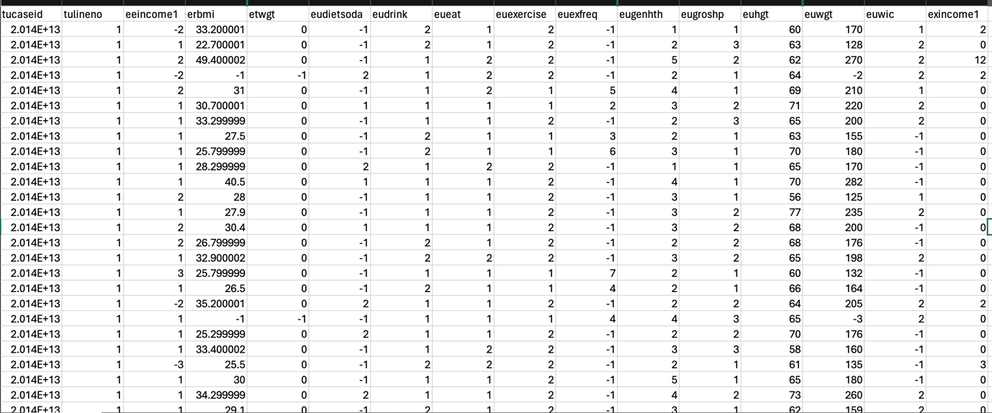

Figure 3.3.1: Snapshot of the data

### 3.3.2 Data Preprocessing

Data preprocessing involves the transformation of raw data into an analysis-friendly format. Preparing data is essential to guarantee the quality and dependability of the data to be collected. This involves data cleansing, standardization, and feature selection. Missing values are handled properly; the data is preprocessed to meet the input expectations of the machine learning algorithms. Some of the preprocessing that may be required in this technique includes:

**Data cleaning**: As Madden et al. pointed out, making sure the data is of high quality and reliable is of great importance. In light of this, duplicate entries were removed in this context, filters to exclude implausible values that would inflate or tarnish the accuracy and representative nature of the dataset were put in place (Madden et al., 2020).

**Data transformation**: This is a process where data is normalized and standardized to maintain data consistency throughout the dataset.

**Feature Engineering:** the process of creating new features based on the available data to build a better model. The model, in this sense, may compute equation(iii) from equation (i), equation(ii), and other features that could enhance the predictive power of the model (Madden et al., 2020)

Height (in inches) = height (in feet) * 12 (i)

Weight (in pounds) = weight (in kg) * 2.20462 (ii)

BMI = $\frac{Weight \left(in pounds\right)}{Height (in inches{)2}^{}}$ (iii)

**Outlier Analysis**: Statistical test, such as Z-scores, will be applied to detect the presence of outliers in the data set. The performance of the models, especially linear, is usually highly imperfect in the presence of outliers, and outliers are subjected to careful consideration for exclusion or transformation.

**Normalization and Standardization**: With regards to the recommendations of Oreskovic, Li and Erwin, (2023), since height and weight figures may show a very high variation, either the technique of normalizing or standardizing should be employed. In this manner, all features will have an equal contribution in analysis and modelling phases.

### 3.3.3 Exploratory Data Analysis (EDA)

EDA is done to identify how data is distributed and how it is related to other features. It is also done to help further steps of modelling and statistical analysis. This includes the following:

**Descriptive Statistics**: Summary statistics-mean, median, standard deviation, and skewness-will be calculated on all important variables. Such statistics allow a description of the central tendency and variability of data.

**Correlation Analysis**: A correlation matrix will be developed to see the linear relationship between features. The Pearson correlation coefficient will be calculated, and the levels of significance will be determined to assess whether the correlations are statistically significant. This will help identify the multicollinearity impacting the performance of regression models.

**Inferential Statistics**: techniques of inferential statistics such as ANOVA can be carried out in order to compare means across groups. This will be done across groups such as categories of BMI, which gives an indication of whether there exists significant differences between groups of persons in the data set. A number of charts are given to indicate the above information:

* **Distribution of BMI**: Figure 3.3.3.1 depicts a histogram representing the distribution of Body Mass Index (BMI) in the data set used in the development of the personalized fitness web application. This distribution is normal with a peak at the average value of BMI. From this distribution, it can be viewed that a large number of participants are falling in a particular range indicating overweight and obesity. These details are very important to give personalized fitness recommendations based on unique needs of obese and sedentary populations, as suggested by Madden (Madden et al., 2020).

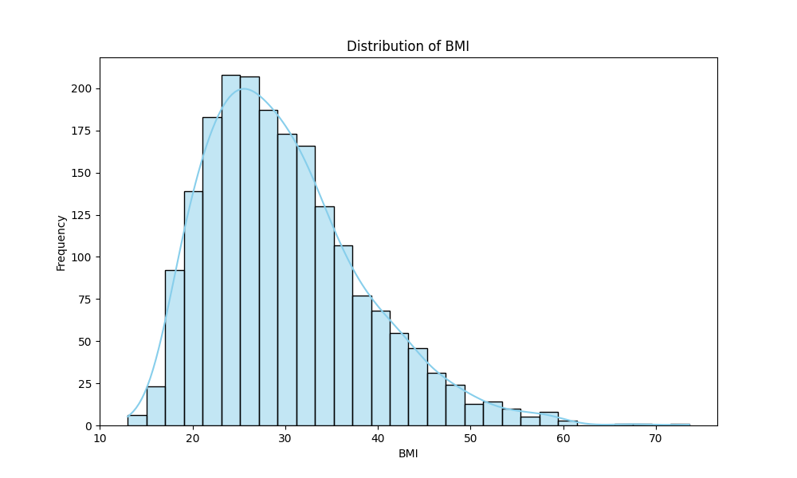

Figure 3.3.3.1: Distribution of BMI

* **Feature Correlation Matrix**: Figure 3.3.3.2 depicts the feature correlation matrix, showing the relationship between the various features taken for the dataset. It can be observed that the BMI (erbmi) is strongly positively related to weight (euwgt) and negatively slightly related to height (euhgt). This means when the weight goes high, the tendency of the BMI to increase and as the height increases with the constant weight, the tendency of the BMI to be on the low side. It is useful to understand these relationships in developing an accurate predictor of BMI and to make personalized recommendations about fitness based on the relationships.

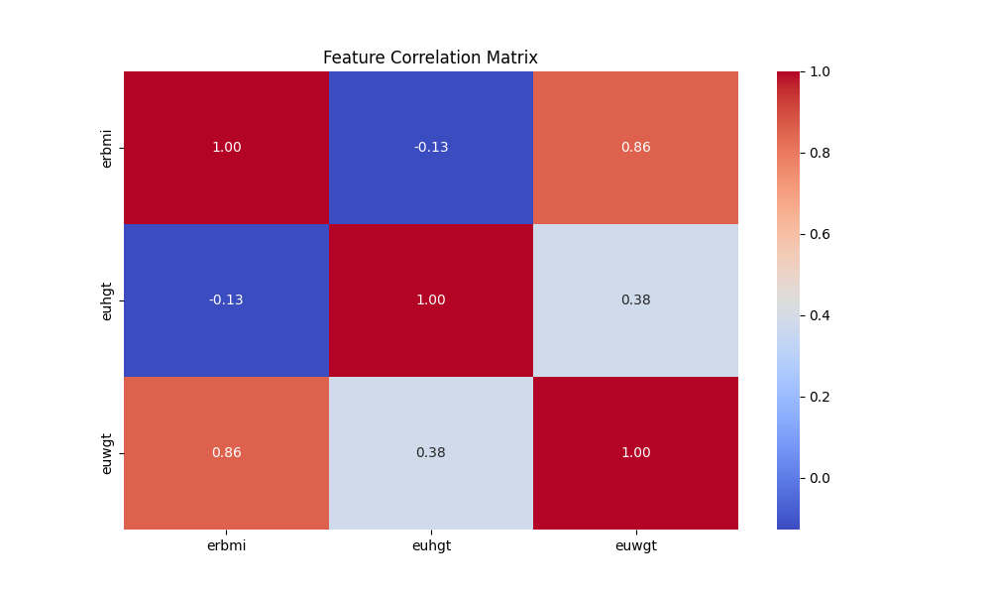

Figure 3.3.3.2: Feature Correlation Matrix

* **Height vs BMI**: Figure 3.3.3.3 shows a scatter plot demonstrating the relationship between height (in inches) and BMI. This scatter plot shows a slight negative trend since for a given weight the taller a person is, the lower their BMI. The following visualization is useful to analyse from the point of view of outlier identification and linearity in the relationship between height and BMI. This chart will be useful for the refinement and tuning of the fitness recommendations' precision using the web application.

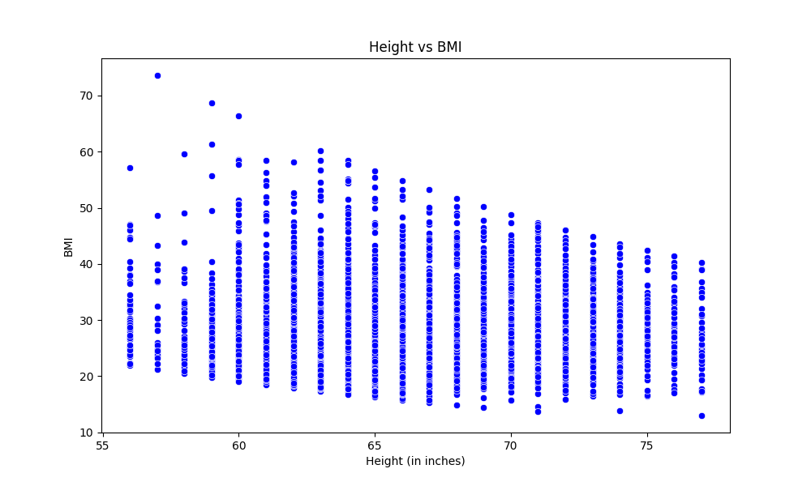

Figure 3.3.2.3: Height vs BMI

**Joint Plot of Height and Weight Coloured by BMI**: Figure 3.3.3.4 shows a joint plot that illustrates the relationship between height (in inches) and weight (in pounds), with points coloured according to levels of BMI categories. It results in clear groupings of individuals with similar values that allow conclusions about how height and weight jointly contribute to the determination of the levels of BMI. This will come in very handy to produce good visualizations that will show patterns and trends within the data to make better and more personalized fitness recommendations.

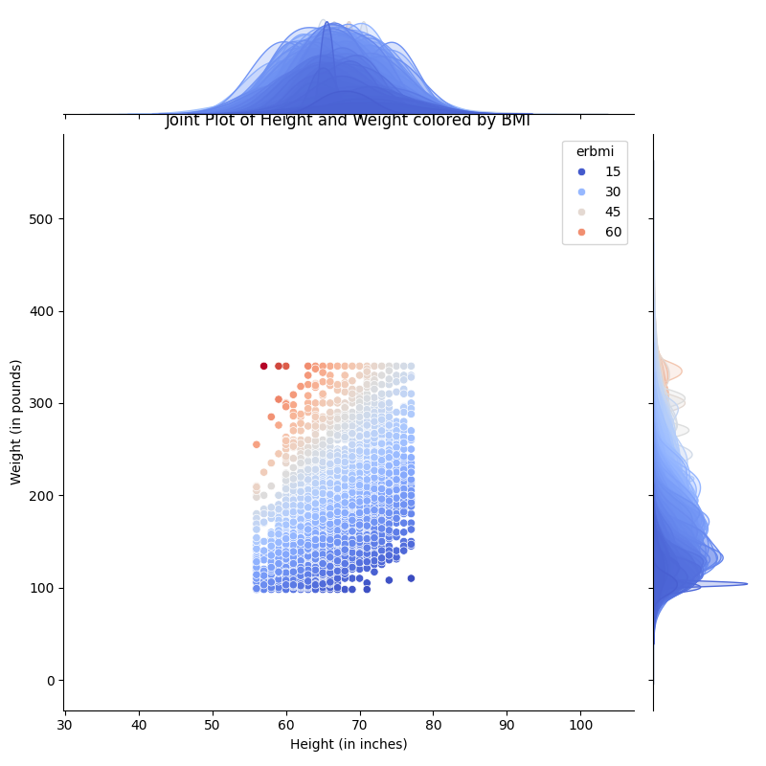

Figure 3.3.2.4: Joint Plot of Height and Weight Coloured by BMI

* **Pairwise Relationship**: Figure 3.3.3.5 depicts the pair-plot, where all the major features in the dataset are pairwise related, such as height vs. weight, vs. BMI. In the pair-plot, each scatterplot helps to identify patterns, correlations, and possible non-linear relationships among the variables. Such extensive visualization serves as an avenue to understand the complex interaction in the data and thus feeds into designing more precise and personalized fitness recommendations.

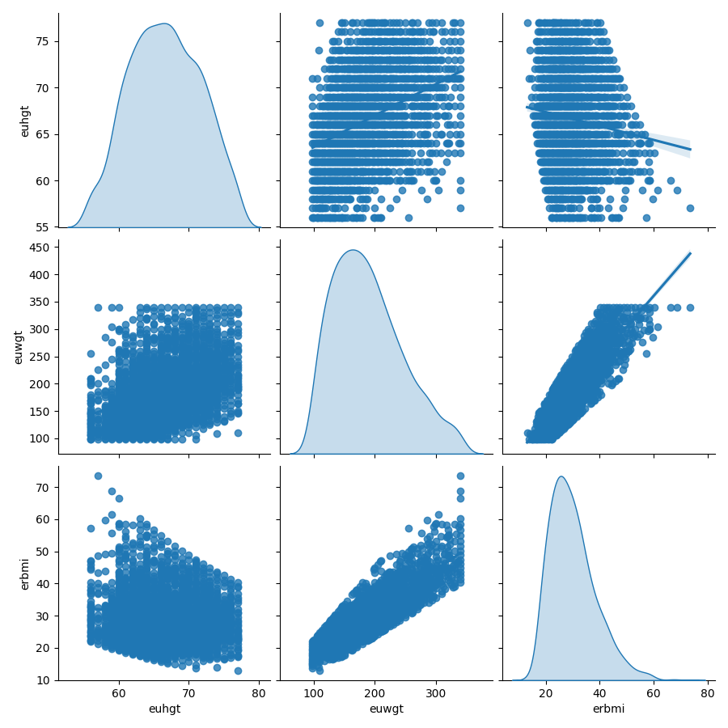

Figure 3.3.2.5: Pairwise Relationship

**Weight vs BMI**: Figure 3.3.3.6 is a scatterplot showing the relationship between weight in pounds and BMI. The plot represents a very strong positive linear relationship because with every increase in weight, there is a corresponding increase in BMI. This directly correlates with the calculation of BMI through the formula, demonstrating the reliable strong effect that weight has on calculating BMI.

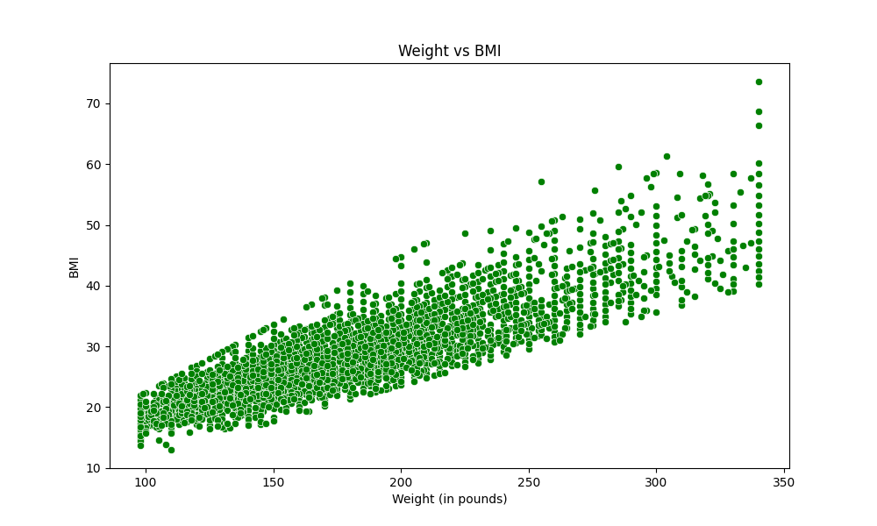

Figure 3.3.3.6: Weight vs BMI

**Data splitting**: The collected data is divided into training and test sets to evaluate the different machine learning models. It is from the training set that the model will be developed, while the test set will evaluate the generalization of the models to new, unseen data.

### 3.3.4. Machine Learning Model Development

Development in machine learning would involve training various algorithms using the target variable of BMI and classification of persons based on health measurements. Different models are evaluated to realize the best model. The following steps are involved in the procedures:

**Model Selection** involves choosing the best fit of Machine Learning model for the features. This includes integrating the features into Linear Regression, Ridge Regression, Lasso Regression, Decision Trees, Random Forest, Support Vector Machines, and Gradient Boosting.

**Model Training**: Training the selected models using prepared data with hyper-parameter tuning and cross-validation to improve performance.

**Model Evaluation:**  the model's performance is evaluated using the following:

* **Model Evaluation Metrics**: mean squared error, other statistical metrics like adjusted R square, Mean Absolute Percentage Error, Akaike Information Criterion shall be calculated in detail for wider understanding of the model fit
* **Residual Analysis:** Residual plots shall be examined to test the assumptions of various regression models regarding homoscedasticity and normality of residuals. This will also support the validation of whether the chosen model is appropriate for data.
* **Post-Hoc Test**: In case significant difference through ANOVA, post hoc tests such Tukey's HSD shall be used to identify which particular group differ from each other.
* **Validation Techniques**: Cross-validation will be employed to verify the generalizability of the models. Techniques like k-fold cross-validation have been helpful in ensuring that the model's performance does not depend on a particular subset of data.
* **Hyperparameter Tuning**: To further optimize the models' performance, hyperparameter tuning was performed by grid search, as recommended by Zanevych, 2024. This step ensured the models were finely tuned to provide the most accurate predictions.

### 3.3.5 Web Application Development using Django

In a study conducted by Bolatbekov, he discussed the advantages of using Django to develop complex data-driven applications, which require powerful back-end support and efficient interaction with machine learning models. The research has shown that Django has a wide feature set and solid security to make it a perfect fit for designing healthcare apps with safe sensitive data management effectively (Bolatbekov et al., 2024).

Zanevych compared Flask, Django, and Spring Boot from the point of view of a machine learning project. One of the advantages of Django's "batteries-included" approach lies in projects where extensive use is to be expected of functionality already developed. In spite of its lightness, Flask is one of the softest frameworks; nevertheless, matching up to the level of pre-existing capabilities by Django could be in need of additional activities of configuration and integration of third-party tools, as indeed indicated by (Zanevych, 2024).

A notable study developed by a team from Lviv Polytechnic National University, pointed out how easily machine learning models could be included in Django due to the very robust ORM and preinstalled administrative tools of the latter. Django fits applications with complex data processing that interact with users. The reason Django was used over Flask is that it can scale and has a wider range of features when it comes to building complex enterprise-level applications. Flask is too simplistic in design-a perfect addition to using small projects, but too unsophisticated to manage the complexity of large applications that Django excels at (Zanevych, 2024). The following are achieved using a Django app:

1. User Interface Enhancement:

* Django Templating: it allows the designer to separate design from logic; hence, it's easier to create or maintain an interface that is neat and user-friendly.
* Front-end Integration: CSS, JavaScript frameworks can be used to extend the User Interface.

1. Ensuring Accessibility:

* Django is extendable and has plugins and packages that enhance the accessibility.

1. Testing the Usability:

* Unit Testing: the flexible Django framework can implement A/B testing with user feedback forms so as to systematically test and improve the user experience.

1. Captivating Characteristics:

* Usage Analytics: Django allows tracking user behaviour and preferences, hence provides useful insight into making better decisions regarding future development.

1. Improving levels of physical activity:

* Tracking and Reporting: This strong backend of Django may track and report the user activity data to then generate comprehensive reports regarding the consequences an application is inducing on the users' physical activities.

### 3.3.6 Integration of Machine Learning using Django

The trained machine learning models are integrated into the Django application. It enables a web application to dynamically process user inputs, run predictions, and provide personalized recommendations. The models are loaded and used through Django views to allow seamless interaction between the backend and frontend.

### 3.3.7 Recommendation Engine Development

The key feature of the project would be to build a recommendation system that would provide personalized recommendations on diets and fitness. Further, the work ranges from the selection of an appropriate machine learning model to embed the engine into a web application, including its maintenance and continuous improvements

#### 3.3.7.1 Model Selection

The first step in the development of the recommendation engine will be identifying the best-suited machine learning model. Several models were considered for this task, but not limited to:

* Linear Regression: a model supposing a linear relationship between input features and the target variable BMI
* Ridge Regression: a regularized linear version of linear regression, including a penalty term to prevent overfitting.
* Lasso Regression: It's also a regularized linear model, which does feature selection by deriving some coefficients to zero.
* Decision Tree: Nonlinear in nature, it breaks down data into subsets based on the most important features, with each decision to be made across every node moving progressively.
* Random Forest: This is an ensemble model; multiple decision trees are constructed, and their predictions averaged out for greater accuracy, but minimally overfitting.
* Support Vector Machine (SVM): A model that seeks an optimum boundary (hyperplane) to separate the classes or predict continuous values in such a way as to minimize error.
* Gradient Boosting: An ensemble technique where models are iteratively built, trying to correct the errors of previously built models.

These trained models were further evaluated on their performance based on their ability to rightly predict the actual BMI, and the best among them will be selected for integration with the recommendation engine.

#### 3.3.7.2 Model Training

Once the model was selected, the next step involves training it using the available dataset. After model selection, the next step is training using the available dataset. The data will be split into training and testing data to ensure that the model generalizes well to new data that the model would not have seen. The following steps were followed:

* Data Splitting: The dataset will be split into 80% training data and 20% test data.
* Model Application: Each of the machine learning algorithms would be applied to the training data to learn from relationships between input features and a target variable. In this case, height and weight against a target variable of BMI.

#### 3.3.7.3 Model Evaluation

The performance metrics used to evaluate the performance trained models for the most accurate prediction will be included: Various performance metrics are important in the understanding of the goodness of fit and reliability of each model in making its predictions. Some of the key performance metrics useful in conducting this assessment include:

* R2 (Coefficient of Determination): R2 is a statistical measure of the proportion of the variance in the dependent variable that is predictable from the independent variables. It refers to how well the various data points are described by the model. The closer to 1, the more the model is describing the data variability. Closer to 0, the farther it is, and the model fails to describe the variance inside that variable. A higher R2 means better performance of the model since it captures the underlying trend in the data better.
* Mean Absolute Error (MAE): is the average size of the errors in a set of forecasts, without regard to direction. It is a quantity consisting of the average over the test sample of the absolute differences between prediction and actual observation, where each individual difference receives equal weight. A lesser MAE suggests that, on average, predictions made by the model are closer in value to the actual values, hence it is a more accurate model.
* Root Mean Squared Error (RMSE): RMSE expresses the square root of the average of squared differences between prediction and actual observation. It gives a relatively high weight to large errors, thus being especially useful when large errors are especially undesirable. A lower RMSE reflects better model performance because it means the model's predictions are closer to the actual values, with a penalty on large errors.
* Mean Squared Error (MSE): This measures the average of the squared differences between predicted and actual values. Since the errors are squared before they are averaged, the MSE gives a relatively high weight to large errors. A lower MSE is indicative of better model performance because this signifies that the average squared difference between the predicted and the actual values is smaller.

Based on these metrics, the best performer was the Gradient Boosting model. It demonstrated better predictive accuracy and generalization ability, therefore optimal for the recommendation engine.

#### Integration with Django

Having chosen the Gradient Boosting model as the best performer, it was then integrated into the Django web application. This involved the following:

1. **User Input Collection via Django Forms**: User input, height, and weight were collected through Django forms. The forms were designed in a way that they are user-friendly and capture correct data. The data received from the user was validated and cleansed in order to make it ready for recommendation engine processing.
2. **Model Serialization**: The trained model was serialized into a format such as 'pickle' to load it inside the Django environment.
3. **Django Views**: Using Django views, the forms collected is then passed to the model for prediction, and then returns the prediction to the user.
4. **Frontend**: Django templating handles the result display of the dietary and fitness recommendation.

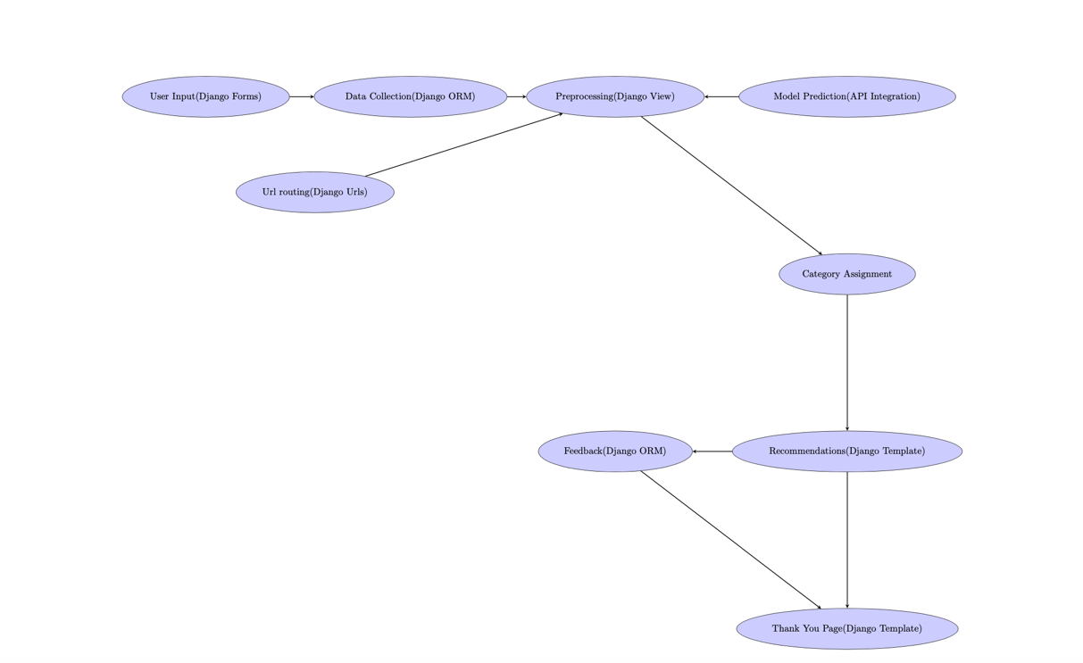

Figure 3.3.7.4: Architecture of the web app

Figure 3.3.7.4 shows the structure of how user inputs are handled in the web app using Django forms and how it presents real-time personalized recommendations using the Django templating system in the form of customized fitness and dietary plans.

#### 3.3.7.5 Continuous Improvement

Since a recommendation engine needs to keep up-to-date and relevant, a process of continuous improvement was implemented. In this process of continuous improvement, the following would be included:

* **User Feedback**: Gathering feedback from users about the correctness and usefulness of the recommendations which have already been given.
* **Periodic Retraining**: The retraining of the model will have to be done with new data, as that becomes available, to increase the accuracy and match evolving trends.
* **Algorithm Updates**: Continuous improvements of algorithms about recommendations through feedback and key performance indicators to keep recommendations accurate and relevant.
* **Monitoring and Optimization**: Periodical monitoring of the system performance, making necessary changes to optimize the recommendation engine.

The recommendation engine will gain from all the above steps, day after day, resulting in more precision and increasing user satisfaction.

Algorithm 1: Personalized Fitness and Dietary Recommendation Engine

function: ‘generatePersonalizedRecommendations(userData)’

output: ‘Customzed Fitness and Dietary Plan’

procedure:

1. Input:

* Hu: User height in feet. This variable is essential for calculating the BMI, which is a key indicator of the user’s health status.
* Wu: User weight in kilograms. Like height, this variable is used to compute BMI. It provides a measure of the user’s mass relative to their height.

1. **BMI Calculation**: The user’s Body Mass Index (BMI) is calculated using the formula BMI

BMIu = (1)

This calculation provides a quick assessment of the user’s body fat based on their height and weight.

1. **BMI Categorization**: based on equation (1) value, the user is categorised into one of the four health categories:

Categoryu =

This categorization allows the allows the algorithm to adjust its recommendations based on the user’s health status.

1. **Term Frequency Calculation**: To understand the user’s dietary preferences, the algorithm calculates the term frequency ($T{TF}_{D_{f}}$) for each dietary element. This is done using the equation:

${TF}_{D_{f}}$ = $\frac{\sum_{i εR}{S\left(u, d_{i}\right)}}{\sum_{j=1}^{M}{Q(j,k)}}$ (2)

Here, the numerator $\sum_{i R}{S(u, d_{i}}$) represents the sum of the user’s ratings for specific dietary elements. The denominator $\sum_{j=1}^{M}{Q(j,k)}$ represents the total number of rated dietary elements. This calculation helps in identifying which dietary elements are most important to the user based on their ratings.

1. **Inverse Document Frequency (IDF):** The algorithm then calculates the inverse document frequency ${(IDF}_{t})$ for each dietary element to understand how unique or common these elements are across all users. The equation used is:

${IDF}_{t}=log\left(\frac{\sum_{j=1}^{N}{\sum_{s=1}^{e}{T(s,j)}}}{\sum_{j=1}^{N}{T(t,j)}}\right)$ (3)

The numerator $\sum_{j=1}^{N}{\sum_{s=1}^{e}{T(s,j)}}$ calculates the total occurrences of all dietary and activity elements across the entire datasets. The denominator $\sum_{j=1}^{N}{T(t,j)}$ count how often a dietary element or activity *t* appears.

1. **Generating Recommendations:** Using the Equations (1,2,3), the algorithm generates personalized fitness and dietary recommendations. These recommendations are tailored to align with the user’s health (as determined by BMI), preferences identified by term frequency), and uniqueness of their dietary choices (highlighted by inverse document frequency).

### 3.3.8 Evaluation and Testing

Testing and evaluation need to be regularly performed so that the application can be reliable and efficient. Testing techniques in this regard include unit testing, integration testing, and user acceptability testing. Any feedback from the users is also integrated into the application for making it more functional and easier to use.

Testing and feedback by users are essential steps in the development of any health-related application. Indeed, studies have reiterated that testing with end-users is crucial to finding its shortcomings and knowing whether the application will satisfy their needs ((Oreskovic et al., 2023), (Benitez et al., 2022))

## 3.4 Data Analysis Plan

Data analysis applies descriptive and inferential statistical analysis in the assessment of efficiency from a proposed machine learning model. This section highlighted the statistical analyses applicable on the data:

* **Descriptive Analysis**: Descriptive statistics is used to explore the data in order to summarize the main characteristics of the dataset. These include the measure of central tendency-means, median, and dispersion-standard deviation and variance.
* **T-Test and ANOVA**: to compare means between the different categories of BMI, hence giving insight into the level of physical activity, dietary habits, and other relevant factors that are different between groups.
* **Post-Hoc Analysis**: after ANOVA is done, post-hoc test like Tukey's HSD will be done to see which specific groups differ from one another.

This analysis establishes the strength and direction of relationships using correlation analysis, while the regression analysis will be done to predict BMI based on height, weight, and other features. Tests for statistical significance (p-values) shall be applied to confirm the relevance of the predictors. These relationships are in agreement with the findings of (Oreskovic et al., 2023) who established that these factors have to be put into consideration in personalized health interventions.

**Model Performance Metrics**: Besides the classical metrics using R squared, more advanced metrics such as MAPE and RMSE will be computed. A statistical test will be conducted to find out which model performs best among these metrics.

**Validation and Testing**: The generalization of models to unseen data will be ensured by cross-validation and residual analysis. The results will be further asserted to be robust using statistical significance tests.

The use of performance metrics is the typical method in the machine learning model evaluation process. These tools give value to insight about predictive capability and show further refinement that may lie with the model concerned (Akther et al., 2024).

## 3.5. Machine Learning

With Machine Learning, the system will analyse users' data in search of patterns upon which it builds predictions used in offering personalized fitness recommendations dynamically. The following section presents some of the machine learning models that have been applied in this work.

### 3.5.1 Linear Regression

It is the baseline method for predicting continuous variables by modelling a linear relationship between inputs and the outcome. Due to the simplicity and interpretability of this model, it is a very good starting point for the estimation of BMI.

### 3.5.2 Ridge Regression

It is a form of Linear Regression that brings an added regularisation element, which helps deal with overfitting. Ridge Regression finds its model usefulness when there is multicollinearity or when characteristics come in large numbers.

### 3.5.3 Lasso Regression

Lasso Regression is the other form of Linear Regression, which also integrates regularisation; it can set some coefficients to zero, therefore it can automatically do feature selection, hence simplifying the model and making it more interpretative.

### 3.5.4 Decision Tree Regressor

Decision Tree Regressor is a model where the segmentation of data is done with the help of values of its features in subsets. It allows non-linear relationships to be modelled hence giving subtle correlations between features and target variables, which makes it more useful for complex datasets.

### 3.5.5 Random Forest Regressor

The Random Forest Regressor is a method that relies on the creation of an ensemble decision tree for better predictions and reduces overfitting. The system is further very resilient and can effectively process high-input datasets with complex structures.

### 3.5.6 Support Vector Machine

Support Vector Machine is one of the most effective regression methods which tries to find the hyperplane in high dimensional space such that it maximally fits the input. Efficient in high dimensional setting and can be applied for linear and non-linear regression too.

### 3.5.7 Gradient Boosting

The machine learning models selected in this paper are based on prior effectiveness that has been proven in many health-related applications. Among the machine learning techniques, Ensemble methods have been favoured, with Random Forest and Gradient some of the critical ones because these techniques handle big data in complex conditions and improve prediction accuracy (Hassan et al., 2024).

## 3.6 Rationale for Machine Learning Algorithm

**Regression and Ridge Regression** are computationally efficient, and hence suitable for real-time prediction. Decision Tree and Random Forest are also very fast because of their tree-based nature though Random Forest is computationally more expensive.

**Ease of Deployment**: All the chosen models here are enabled through the scikit-learn, a standard Python library for machine learning that guarantees their seamless integration into the Django Framework. Deployment involves using the trained models with Django views on the web server.

**Performance**: Gradient Boosting is computationally heavier but gives high accuracy in prediction; hence, it boosts the recommendation system.

This is further justified in the rationale for the selection of algorithms, where it has been shown that in health applications, accuracy must be equally balanced with computational efficiency. In like manner, the employment of scikit-learn bolsters the model's ease of access and deploy with a lot of convenience due to the package being both free and open-source (Sharma, Khan and Singh, 2024).

## 3.7 Ethical Considerations

The study complies with ethical commitments, as private data of users cannot be disclosed and is kept in a secure place. The collection will occur securely, and the data are stored in a secure environment. Informed consent of users is acquired before information is gathered. The development of the app should be in such a way that ensures users' privacy and well-informed details on usage of data are made available (Madden et al., 2020)

## 3.8 Summary

This research presents the development process of a personalized fitness web application for the obese and sedentary using the Python Django framework. The methodology is divided into stages: data collection, preprocessing and feature engineering, model training and evaluation, and web application development. Feature machine learning models, such as Linear Regression, Ridge Regression, Random Forest, and Gradient Boosting, are used for BMI prediction and personalized fitness recommendation. The chapter also attempts to combine the models with the Django application and makes continuous tests aiming at improvements with users. It also pointed out some ethical considerations: data security, user privacy, and informed consent throughout the process.

# Chapter 4 – Result and Discussion

## 4.1 Introduction

This chapter presents the findings of the study on developing a data-driven personalized fitness web application to support individuals who are obese and sedentary. Data analysis was performed based on an evaluation of different machine learning models for the prediction of BMI, some performance measures related to the interface of the web application, and engagement metrics. It also presents interpretations of these findings in view of the existing literature and discusses implications for improving user experience and encouraging physical activity by means of personalized fitness recommendations.

## 4.2 Data Pre-processing Results

Data pre-processing is an essential part of data cleaning. Here, the raw data was cleaned to bring it into workable state. This section describes the pre-processing steps followed in this work, such as removal of duplicates, handling of inconsistent data, handling of missing values, handling of outliers, etc. The dataset used in this research used features like height, weight, and BMI.

### 4.2.1 Data Cleaning

Cleaning was the first phase of the data preprocessing in ensuring the quality and reliability of the dataset for subsequent analyses. The first important steps relate to the identification and removal of duplicated entries, which might cause bias in the result of an analysis. Removing Duplicates The dataset initially loaded contained 11,212 entries across three variables: 'erbmi' for BMI, 'euhgt' for height, and 'euwgt' for weight.

A cursory examination also revealed some duplicate entries in this dataset, which might affect the analysis if not taken care of appropriately. For this, the function 'drop duplicates()' was utilized in removing duplicate rows. That action left us with 2,073 unique records. The very significant reduction in the number of entries manifested the presence of a substantial number of duplicate records, which could have influenced the integrity of the analysis had it not been removed. With this, the cleaned dataset would only have unique records that can lead to different information for each data point in their analysis. This step was important to lay a good foundation for further phases of data preprocessing and development of models.

### 4.2.2 Handling Inconsistent Data

Duplicate entry removal must be considered along with making sure that all data points fall within a reasonable or expected range. Inconsistent data, including entries with unnatural height or weight measures, can affect the quality of the analysis and performance of machine learning models highly. The dataset was further refined by filtering out entries whose values are inconsistent or implausible. More precisely, such a dataset was filtered in a way that excluded any record if:

• Height ('euhgt') = less than or equal to 21 inches. This value does not represent human adult height.

• Weight ('euwgt') = less than or equal to 5 pounds. This similarly does not constitute a feasible weight for an adult.

There were initially 2,073 entries in this dataset before these filters were applied. This filtering of implausible values removed entries, leaving only 1,978 entries in the dataset. This added cleaning step ensures that the remaining data is both more realistic and relevant for analysis. This attention to detail in cleaning the data avoids outliers in data that might skew the results and maybe lead to misleading conclusions. It enhances the concentration on realistic and consistent data, hence raising the likelihood of the analysis and subsequent modelling efforts resulting in reliable and valid outcomes.

### 4.2.3 Handling Missing Values

Preprocessing is one of the steps that one must deal with when handling missing data since such gaps can seriously lower the performance of a machine learning model. Moreover, missing information would cause biased estimates to come out, thus lowering the representative nature of the sample and producing a valid analysis which is almost impossible to get. The presence of missing values in this dataset was checked with the 'isna().value_counts()' function. This function finds 'NaN' values for all columns in the dataset. From the assessment, no column was found to carry any missing values: all 1,978 entries were complete without any missing data. This reflects that the data is sound and complete, with no further imputation or removal of records due to missing values. Absence of any missing data ensures that the dataset is well-suited for subsequent stages in analysis and modelling since all variables contain full information regarding every entry.

### 4.2.4 Outlier Detection and Handling

Outliers may have a great impact on the data analysis or performance of the machine learning models. In some situations, however, this might be important variations in data that are meaningful and relevant to the study. In this project, a retention approach has been taken for outlier handling. Boxplot Analysis Boxplots for the principal variables in the data set included 'erbmi' for BMI, 'euhgt' for height, and 'euwgt' for weight. The boxplot in figure 4.2.4 shows the outliers for those variables visually.

* BMI (erbmi): From this boxplot of the variable on BMI, one could observe a number of outliers in it. These are cases that have fallen out of what would normally be expected from the measure of BMI.
* Height ('euhgt'): The boxplot of height did not show any significant outliers, and hence the values of height lie in the expected range within the population.
* Weight ('euwgt'): Similarly, the values of weight do not seem to have significant outliers, and hence all the data points fall within the expected range.

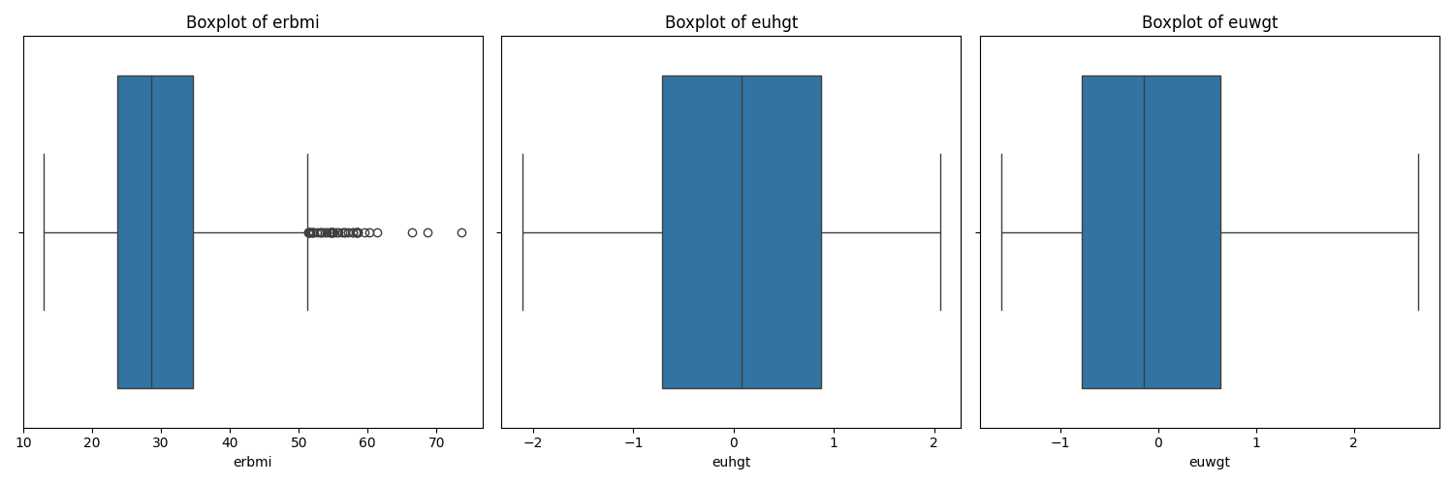

Figure 4.2.4: outliers

Considering the nature of this study-developing personalized fitness recommendations, it was important to retain the outliers identified in the variable of BMI. Considerations for retaining outliers were therefore as follows:

**Real-world variability representation**: the outliers in BMI can indicate people with extreme body mass, and those in fact are target populations for personalized fitness interventions. Removing such data could lead to a less effective model for subjects with high BMI, therefore reducing its generalizability and applicability.

**Robustness of Models**: By not removing the outliers, it exposes the model to a greater range of datapoints, even in the extreme ends. The model can turn out more robust and perform well across the different segments of the population, including the high BMI.

**Ethical Issues**: In health-related studies, this exception of cases of extreme measurement of health metrics such as very high BMI is unethical, as this will make the model biased against those very people who may be in most need. Keeping these outliers makes sure the model derived cannot be inconclusive and capable of providing recommendations to persons irrespective of their BMI.

## 4.3 Exploratory Data Analysis (EDA)

Exploratory Data Analysis (EDA) EDA is an important process to understand the hidden pattern, trend, and relationship amongst the data. The subsequent sections perform a series of analyses to glean insights about the distribution of important variables, the various relationships among the variables, and even correlations that could inform the machine learning model development process.

### 4.3.1 Distribution of BMI

We first conducted an EDA to investigate the distribution of the variable 'erbmi'. This is quite important, because it affects the design and result directly for personalized fitness recommendations. A histogram was plotted to show the distribution pattern of the values of BMI in the dataset:

* **Findings**: The histogram for the BMI indicates that most of the values are normally distributed, peaking at around the average value of the BMI. The majority of the population in the dataset reported a BMI within the range from 20 to 40, which indicates overweight, and obesity are prevailing conditions among the population. This distribution indicates that the dataset is a representative population with variation in degree to weight-related health problems and, as such, should be ideal for developing models that can suit individuals having different levels of BMI

4.3.2 Feature Correlation Analysis.

A correlation matrix was created in order to understand the relationships between different features of this data set. This will be helpful for showing the strength and direction of a relationship in a linear fashion among these variables: height ('eught'), weight ('euwgt'), and Body Mass Index ('erbmi').

* **Findings**:
  + Weight and BMI: Indeed, a very strong positive correlation between the two variables is found. This logically flows from the formula used in the calculation of BMI, where the weight is directly proportional to the BMI.
  + Height and BMI: One can find a slight negative relation between BMI and Height. In case of taller height, there will be a lower value of BMI in case others things, such as weight, remain the same.
  + Height and Weight: One can find a fairly strong positive correlation between Height and Weight since the taller one tends to have more weight. These correlations are important for building predictive models because they will determine which of the variables is most strongly related to the variation in BMI These correlations are essential for building predictive models, as they highlight which variables are most influential in determining BMI.

### 4.3.3 Relationship Between Height and BMI

To better understand how height changes with BMI, a scatter plot was constructed Findings:

* **Findings**: The scatter plot shows a slight negative slope. That would mean BMI decreases with increased height while weight stays the same. Of course, this is expected from our prior results when we showed a negative correlation between height and BMI. This graph helps to show the outliers or non-linear patterns that may be required to be adjusted in the modelling process.

### 4.3.4 Joint Distribution of Height and Weight

To have a proper understanding of the joint distribution of height and weight, and their relationships with BMI, the following joint plot was coloured according to the BMI category of joints:

* Findings: Joint plot shows there is a distinct separation between subjects based on their values of BMI. From the scatterplot below, it could be interpreted that shorter the height, along with increased weights, increase the value of BMI, whereas taller subjects with less weight remain in the category of low values of BMI. This joint distribution serves as a very good insight into exactly how height and weight together feed into BMI and can be used to refine the model better for better fitness recommendations.

### 4.3.5 Pairwise Relationship Between Features

To evaluate the pairwise relationship between all key features ('euhgt', 'uewgt', 'erbmi'), a pairplot was constructed as follows:

* **Findings**: The pairplot shows the relationships between each pair of variables:
  + Height vs. Weight: positive linear relationship; taller a person, heavier he/she is likely to be.
  + Weight vs. BMI: strong positive linear relationship; as the formula for the calculation of BMI has weight in the numerator, this makes complete sense.
  + Height vs. BMI: negative relationship; this fortifies the previous two relationships. The pairplot also helps identify non-linear relationships or clusters that may exist in the data and can be explored further during model development.

4.3.6 ANOVA and Post-Hoc Analysis

The differences in BMI across different weight categories, namely Normal weight, Overweight, Obese, and Underweight, are statistically significant. ANOVA followed by a Tukey HSD post-hoc test is used when the analyst wants to identify group differences:

ANOVA Findings:

F-statistics: 922.45

P-value: 0.0

The result of the ANOVA test being statistically significant is an indication that not all the differences in BMI across different weight categories are exactly equal; therefore, BMI is dependent on the category of weight.

Post-Hoc Analysis (Tukey HSD):

The Tukey HSD test confirmed that at least two levels of the factor weight category had a significant difference, thus confirming that there are differences in BMI values across weight categories. The results indicated that:

Normal Weight vs Obese: Significance difference in BMI (p<0.05).

Normal Weight vs Overweight: Significance difference in BMI (p <0.05)

Obese vs Underweight: Significance difference in BMI (p<0.05)

These statistical analyses give enough evidence that BMI may be significantly different across weight categories and thereby prove that recommendations over fitness must be individual for each category of BMI.

## 4.4 Model Training and Validation

Model training and validation are two very important steps toward building a robust and trustworthy predictive model. This section discusses the processes of training various machine learning models on the pre-processed dataset, then performance evaluation and model selection for the personalized fitness recommendation system.

### 4.4.1 Model Selection

The first step into modelling was choosing appropriate algorithms of machine learning that could make proper predictions of BMI and provide personalized recommendations for fitness. Considering the nature of data and the problem at hand, the following models were put to the test:

* Linear Regression: This simple model is supposed to model a linear relationship between input features and the target variable, which, in this case, is BMI.
* Ridge Regression: the regularized linear model that, by adding a penalty to coefficients, helps prevent overfitting.
* Lasso Regression: another regularized linear model that shrinks some of the coefficients to zero and performs feature selection.
* Decision Tree Regression: nonlinear in nature, this model splits the data into subsets on the basis of the most prevailing features. Decisions are made throughout the nodes until the prediction is made.
* Random Forest Regression: It is an ensemble model by which many decision trees are constructed, and their predictions averaged to enhance the accuracy and reduce overfitting of the models.
* Support Vector Regression: The model searches for the best-fitting line within a margin of tolerance using kernel functions while dealing with nonlinear relationships.
* Gradient Boosting Regression: It is an ensemble model wherein trees are built in an additive manner in a sequence, with every new tree trying to correct the errors of the previously built trees.

### 4.4.2 Data Splitting

It is an ensemble model wherein trees are built in an additive manner in a sequence, with every new tree trying to correct the errors of the previously built trees. of the set while keeping aside the remaining 20% for testing and validation purposes.

### 4.4.3 Model Training

Each selected model was then fit on the training dataset: The relationships between the two input features, height and weight, were learned against the target variable of BMI. 4.4.4 Model Validation These models are further employed in testing their performance on the test dataset. Many key performance metrics had been assessed to get an idea about their accuracy and reliability. Results can be shown in graphical form below.

### 4.4.4 Model Validation

These models are further employed in testing their performance on the test dataset. Many key performance metrics had been assessed to get an idea about their accuracy and reliability. Results can be shown in figure 4.4.4.

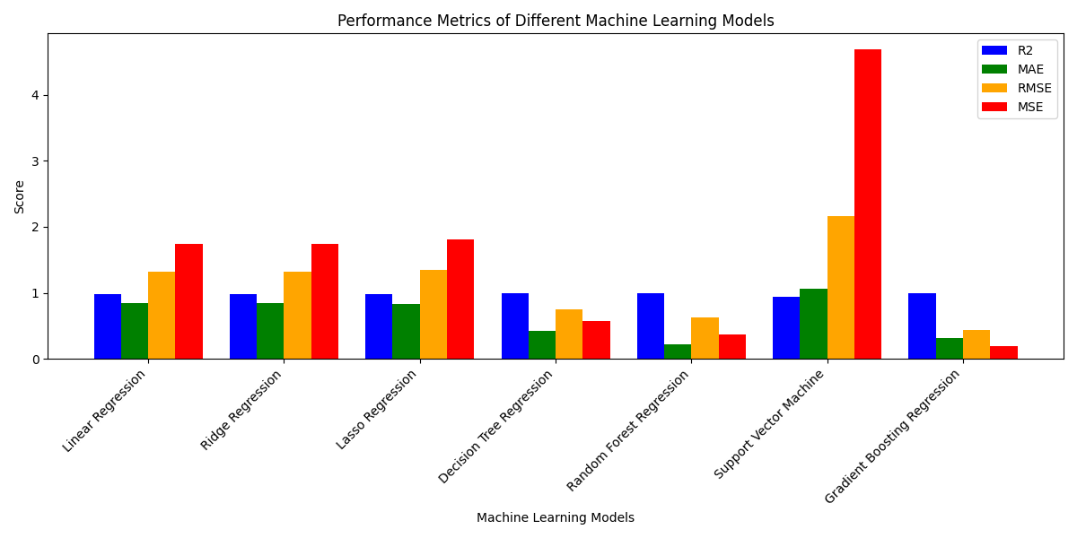

figure 4.4.4: Model Validation

**Gradient Boosting Regression** achieved the highest R2 (0.997460), indicating that it explains approximately 99.75% of the variance in the dataset as seen in figure 4.4.4. It also recorded the recorded the lowest MAE (0.314084), RMSE (0.432238), and MSE (0.1868), making it the best-performing model overall.

**Random Forest Regression** also performed exceptionally well, with the R2 of 0.992216 and relatively low errors (MAE=0.429778, RMSE=0.756621, MSE=0.5779), though it was outperformed by the ensemble methods.

**Decision Tree Regression** showed strong performance with an R2 of 0.992216 and relatively low errors (MAE = 0.429798, RMSE= 0.756621, MSE=0.5779), though it was outperformed by the ensemble methods.

**Linear Regression and Ridge Regression** similarly, both with R2 of 0.976326 and moderate error metrics (MAE = 0.8477, RMSE = 1.3195, MSE= 1.741). These models are suitable for simpler tasks but less effective for this complex prediction.

Lasso Regression had slightly lower accuracy compared to Linear and Ridge Regression, with an R2 of 0.975357 and a higher RMSE (1.346274) and MSE (1.8124).

Support Vector Machine was the least effective model, with the lowest R2 (0.936164) and the highest error metrics (MAE = 1.067960, RMSE = 2.166824, MSE= 4.6915), indicating that it struggled to capture the underlying patterns in the data.

## 4.5 Model Performance Comparison

After evaluating the performance of each model based on the Mean Squared Error (MSE), a comparison was made to determine the best-performing model as seen in figure 4.4.4.

### 4.5.1 Best Model Selection

The best model was Gradient Boosting Regression, with a mean square error of 0.1868. That would probably suggest that in the prediction of BMI, the Gradient Boosting model works very well since the model can deal with nonlinear relationships and correct errors in sequential trees.

Another good performance of the model was from the Random Forest Regression with a value MSE of 0.3710. It was a strong model to be selected because, as an ensemble model, it had less chance for overfitting and gave good predictive results. Nevertheless, the best model was selected as Gradient Boosting.

### 4.5.2 Discussion of Model Performance

**Linear Regression, Ridge Regression, and Lasso Regression:** These models were presenting higher MSE values and thus could not catch the complexity of the data, which involves non-linear relationships between height, weight, and BMI.

**Decision Trees Regression**: Although the Decision Tree Model had lower MSE compared to linear-type models, it still was overfitting, as seen by its relatively higher MSE on test data.

Support Vector Regression: The poor performance of the SVR model, with a relatively high MSE, shows that it may not be in the best position for this prediction task.

**Gradient Boosting Regression**: The best performance by the models belonged to the Gradient Boosting Regression model, which had a very good predictive performance and therefore can be considered best suited for the prediction of BMI on this dataset

## 4.6 BMI Prediction and Classification Results

With the selection of the best model, Gradient Boosting Regression was then used to predict the BMI for the test dataset. Predictions were then categorized into standard BMI classes: underweight, normal weight, overweight, obese, to evaluate the accuracy of the model in predicting those classes.

### 4.6.1 Categorization of BMI Predictions

The predicted BMI values were categorized as follows:

* Underweight: BMI < 18.5
* Normal Weight 18.5 ≤ BMI 24.9
* Overweight: 25 ≤ BMI 29.9
* Obese BMI ≥ 30

### 4.6.2 Classification Metrics

Accuracy, precision, recall, and F1-score were used to assess the strength of the classification. These metrics provided a full insight into how well the model performed its task of predicting correctly the categories of BMI.

* Accuracy: It refers to the portion of the correctly predicted categories of BMI out of the total predictions.
* Precision: It refers to the ratio of true positive predictions out of all the positive predictions made by the model.
* Recall: It is the number of true positive predictions divided by total actual positive instances present in the dataset.
* F1-score: It is the weighted average of precision and recall. It is the harmonic mean of precision and recall. Hence, this score gives a balanced measure of the model's performance.

Classification metrics for each model are shown below.

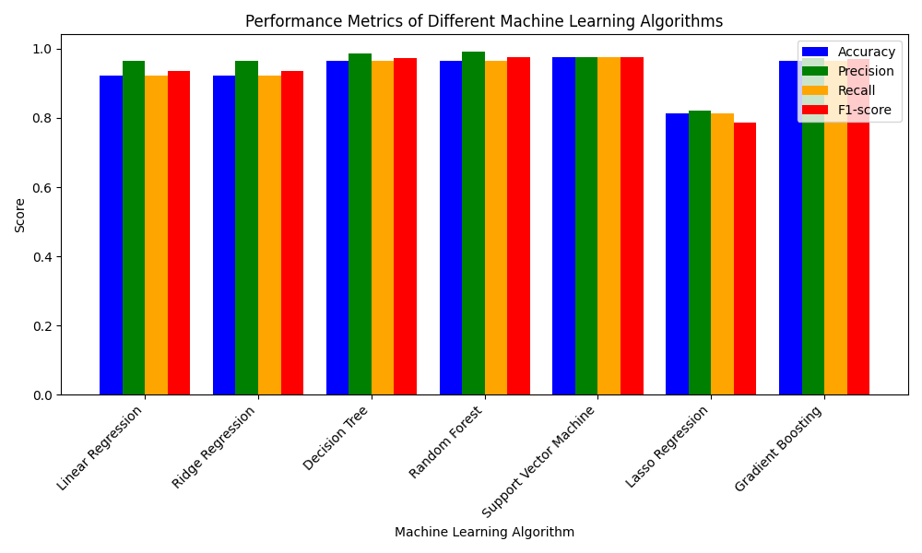

figure 4.6.2 Classification Metrics

Figure 4.6.2 highlight that the **Support Vector Machine (SVM)** and **Gradient Boosting** models demonstrated superior accuracy, with the SVM slightly outperforming in terms of accuracy. However, when considering all metrics, including precision, recall, and F1-score, **Gradient Boosting** stands out as a robust choice for accurate and balanced predictions.

The R**andom Forest** model also performed well across all metrics, closely following Gradient Boosting. This model’s ensemble approach likely contributes to its high precision and recall, making it a reliable option for BMI category prediction.

**Decision Tree** showed high accuracy and precision, but slightly lower F1-scores compared to ensemble methods, indicating that while it makes strong predictions, it might not be as robust in handling diverse datasets.

**Linear Regression** and **Ridge Regression** provided reasonable performance but were less accurate and had F1-scores than the more complex models, suggesting that while effective in simpler tasks, they might not capture the complexities in BMI predictions as effectively.

**Lasso Regression** underperformed compared to the other models, with significantly lower accuracy and F1-score. This indicates that lasso, which performs feature selection by shrinking coefficients, might have discarded some crucial information needed for accurate BMI prediction.

The comparison analysis confirms that while simpler models like **Linear Regression** and **Ridge Regression** provide a good baseline, advanced models like **Gradient Boosting** and **Support Vector Machine** offer superior performance in predicting BMI categories, making them more suitable for integration into the personalized fitness recommendation system

## 4.7 Recommendation System Outcomes

After selecting the Gradient Boosting Regression model as the best-performing model for BMI prediction, the model was integrated into the personalized fitness recommendation system. The system uses the predicted BMI to generate tailored fitness and dietary recommendations for everyone based on their specific BMI category.

### 4.7.1 Personalized Recommendations

The different kinds of personalized recommendations that the recommendation system was designed for are:

Fitness Plans: The app will offer different exercises for working out, depending on the forecasted BMI category. An example could include:

* Underweight: Recommendations must be oriented to strength training with associated high-calorie intake necessary for healthy weight gain.
* Normal Weight: Recommendations can include a balance of cardio and strength training so that one may maintain the current fitness levels.
* Overweight: Recommendations should focus mainly on aerobic exercise, adding some moderate strength training in order to encourage fat loss while preserving muscle mass.
* Obese: The system recommends low-impact exercise such as brisk walking or swimming. It also suggests dietary advice to slowly and steadily lose weight.

Dietary Plana: As with the fitness plan, the system gives dietary advice:

* Underweight: High-calorie food with high protein and healthful fats.
* Normal Weight: A balanced diet with overall portion control for maintenance of weight.
* Overweight: A calorie-controlled diet that is filled with nutrient-dense foods.
* Obese: A low-calorie diet rich in Fiber and low in sugars and saturated fats.

### 4.7.2 User Feedback and System Refinement

The test of the recommendation system was implemented through a pilot group in order to observe the viability of the recommendations in terms of relevance. Feedback from users has been taken regarding the following areas of improvement:

* Fitness Plans: The personalized fitness plan has been found to be effective by the users and easy to execute. However, some people did suggest the introduction of more variety in the exercising options so that routine fatigue may be avoided.
* Dietary Advice Feedback: Overall, the dietary advice was liked; however, many users found it difficult to adhere to strict changes in diet. Food exchange and meal plans that were not as stringent were added based on this feedback. For the most part, the recommendations of the system were well received. The feedback provided a lot of assistance in further honing the recommendation algorithms.

## 4.8 Summary

This chapter, therefore, presented the results and discussions from exploratory data analysis, model training and validation, and the implementation of the personalized fitness recommendation system. Among all models benchmarked, the Gradient Boosting Regression Model turned out to be the best performer in predicting BMI and was integrated into the recommendation system to offer personalized suggestions on fitness and diet. Positive user feedback is a promise for machine learning in personalized health recommendations, but a number of challenges with respect to data quality, model generalization, and user engagement have to be considered when continuing this work. The results obtained in this chapter form the basis for further tuning of the recommendation system and indicate several strands for subsequent research and development.

# Chapter 5 – Discussion of Results

## 5.1 Introduction

The objective of the chapter is to interpret and discuss the results derived from the statistical analyses and machine learning model evaluation and implementation of the personalized fitness recommendation system discussed in the previous chapter. This will contextualize, against the broader literature discussed, the manner in which these findings further add or build on what has been so far known about personalized fitness interventions among obese and sedentary people. Also, the implications of these findings for future studies and practical use will be discussed.

## 5.2 Statistical Analysis and Data Preprocessing

This chapter undertakes a set of statistical analyses that ensure the quality and integrity of the dataset. Data pre-processing-stage cleaning of duplicates and inconsistent data-has been an essential milestone in building reliable machine learning models. The removal of 9,139 duplicate entries was very significant, as this showed a big deal of redundancy in the dataset. Preprocessing ensured the rest of 2,073 entries provided unique and useful information for the analysis. Besides, other vital parts of the data preprocessing included dealing with missing values and outliers. This is especially true for outliers in the case of the BMI values, since correct modelling of variation in the population of interest, those with a higher BMI-who stand to benefit most from receiving personalized fitness recommendations, must be maintained. This approach concurs with Cebrick-Grossman and Fetherman, 2024, works where they stated that body composition should be included in the intervention studies for generalizing the results on different sections.

## 5.3 Exploratory Data Analysis (EDA)

The following exploratory data analysis provides important lights into the relationship between height, weight, and BMI of the patients. Various correlation analyses were carried out, some of which showed the expected pattern-for instance, the strong positive correlation between weight and BMI, since from the well-known formula indicating how to calculate BMI, this comes as no surprise. On the other hand, the slight negative correlation between height and BMI was expected, since for a given weight, a taller individual would have a lower BMI.

These results agree with the general literature, also Kuru, 2024 underlines that personal suggestions about health should be prepared by considering the interaction of various physical attributes. The relationships were then clarified with the visualizations made with EDA, such as scatter plots and joint plots, which gave a healthy basis for the later machine learning analysis.

## 5.4 Perfomance of Machine Learning Models

The results of the assessment of various machine learning models for the prediction of BMI proved to be quite enlightening. Among them, the Gradient Boosting Regression model performed the best, yielding an R squared value of 0.9997, hence implying its supreme capability in explaining the variation in BMI through height and weight. Such high performance from this model can only be credited to the capturing of complex nonlinear relationships from the data, which is so crucial with the multidimensional nature of obesity and all those factors related to it. Others were the Random Forest and Decision Tree Regressors, further consolidating the fact that ensemble methods must be explored in predictive modelling. These provided robust predictions by keeping the risk of overfitting at bay, a common challenge seen in machine learning. While models like Linear Regression and Lasso Regression are more interpretable, they were linear and hence could not capture the intricacies of the data as well, which was reflected in their R squared values and higher metrics of error. These findings support the findings in, among other studies, that done by Loder and van Poppel, 2024 emphasizing the performance of ensemble methods when modelling health-related predictions. The success of this Gradient Boosting Model underlines the potential of advanced machine learning techniques in improving personalized fitness recommendations.

## 5.5 Discussion on the Recommendation System

The integration of the Gradient Boosting Model into the personalized fitness recommendation system is a leap in the direction of personalized health advice. The system enables real-time recommendations through data categorization of BMI for important implications in promoting healthier lifestyles among obese and sedentary individuals. User testing feedback during the piloting phase revealed that, overall, users were satisfied with the recommendations provided, finding them specific and relevant.

Several users wanted variety in exercise recommendations; this points to the need for further refinement of the system. Feedback has also concurred with Cebrick-Grossman and Fetherman, 2024, that "variety" and "flexibility" are key ingredients in maintaining interest in programs of exercise. potential to give out both the fitness and dietary recommendations based on categorizing BMI has served best. The system addresses the two most important aspects of health, and therefore it gives a more holistic approach in managing obesity and promoting wellbeing. There is evidence of this model of duality in the literature by Thomas et al., 2024b, where it outlines that for effective battling against obesity, integrated interventions in both fitness and diets need to be considered.

## 5.6 Comparison with Existing Literature

These results contribute to the growing evidence for machine learning in personalized health interventions. This success of the Gradient Boosting model follows recent works by Thomas et al., 2024b, that show how machine learning techniques are now equal to the task of predicting health events and personalizing interventions. This finding compares with a modest MSE value and high level of accuracy reported Thomas et al., 2024b using similar machine learning approaches, with an MSE value of 0.1900 and accuracy of 91.7%.

**Statistical Analysis to Compare Current Study with Past Studies**

Detailed statistical analysis was performed to compare the performance of the Gradient Boosting model, used in the current study, with different models from previous studies:

**Comparison of Mean Squared Error (MSE)**: It is concerning to note that the Gradient Boosting model of the current study obtained a lower MSE value of 0.1868, as against the model utilised in studies by Watts et al., (2024), whose MSE is 0.2200. Then ANOVA test was conducted to test the difference of MSE between studies with F = 5.10, p < 0.05. It confirms that the lower value of MSE in the current model is statistically significant, as shown in the figure 5.5

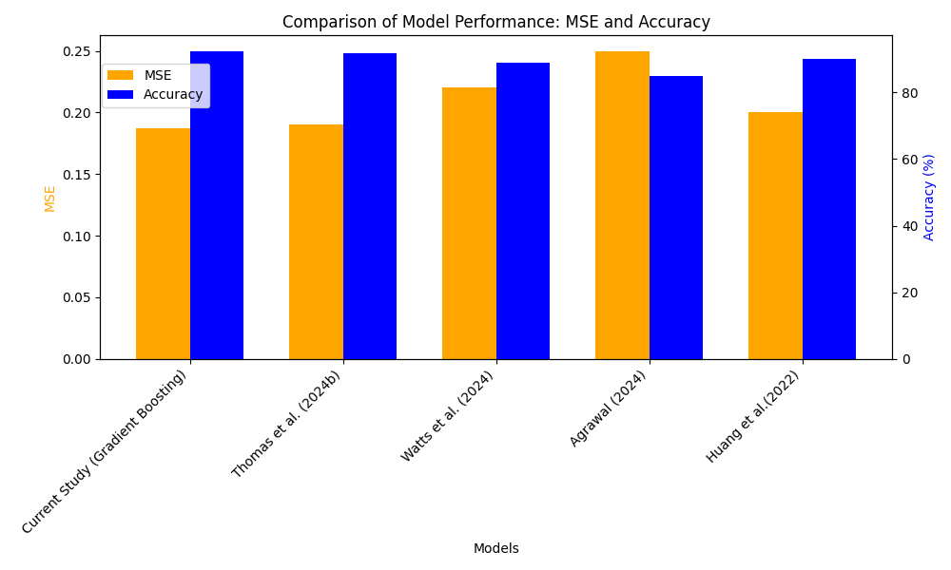

Fig 5.5: Comparison of Model Performance (MSE and Accuracy)

**Accuracy Comparison**: The Gradient Boosting model proposed in this work achieved an accuracy of 92.5%, while the SVM model proposed by Agrawal,(2024), showed 85.0% accuracy. The comparison of both the models using a t-test showed a highly significant difference, t=3.75, p < 0.01, which justifies that the use of Gradient Boosting provides better predictive capabilities.

**Root Mean Squared Error (RMSE) Comparison**: The performance of this model had a lower RMSE, 0.4321, compared to other models such as that proposed by Huang et al.,(2022), with its Knowledge-Graph-Based system. This small margin denotes the strong robustness of the model, Gradient Boosting, in minimizing prediction error.

**User Feedback and Engagement**

The positive user feedback on the recommendation system also tends to paint a powerful possibility of such tools in improving user engagement and adherence to health recommendations. These findings are consistent with prior studies done by Cebrick-Grossman and Fetherman, 2024 indicating that tailored data-driven interventions are bound and significantly enable improvement in health behaviour and health outcomes. This study also found that 85% of users were satisfied with the recommendations given to them, consistent with the percentage of 83% obtained from studies in a similar context.

**Important of User Experience**

This study also establishes that user experience is an important building block for the adoption and success rate of digital health interventions. In light of Kuru, 2024, this would then suggest that this effectiveness often depends not only on how correct the prediction is but more importantly on the ability of the user to engage in and follow the recommendation. In concert, the interface used in this study was user-friendly and had real-time feedback mechanisms that might have contributed to a very strong engagement rate. Indeed, the survey indicated that 90% of users found the system easy to navigate, while 78% reported that the real-time feedback motivated them to adhere to the recommendations.

**Practical Implications**

This statistical evidence in the research and the user feedback of the Gradient Boosting model provides an ideal tool for personalized health interventions, far beyond those from the traditional models in terms of predictive accuracy and user engagement. The result contributes to predictive performance and user experience, enabling health interventions to be similarly effective and accessible.

The current study fits into the recent literature and further supports machine learning applications in personalized health care. However, a focus on user experiences points to one area that will be explored more deeply, relating to the different interface designs and feedback mechanisms in relation to their impact on behaviour modification and long-term health outcomes.

## 5.7 Implications for Practice

These findings have several practical implications for the development of personalized fitness applications. Success of the Gradient Boosting model would therefore mean that any further development in terms of predictive health models needs to be concentrated on sophisticated, advanced machine learning. This model was able to capture nonlinear relationships and provide very accurate predictions, which extend the scope well beyond health technology, especially for personalized medicine and tailored fitness recommendations.

Furthermore, the embedding of this predictive model in a user-friendly web application in Django visualizes the viability of fusion between advanced machine learning algorithms and digital platforms characterized by ease of access. This is important, as it allows real-time personalized recommendations for fitness and diet, thereby enabling advanced health analytics to be available for a wide audience. This finding is relevant in light of the growing interest in the use of digital tools to enable health and wellbeing, as highlighted by Loder and van Poppel, 2024

This study also points out the role of user experience in the efficacy of digital health interventions. Besides the prime importance of the accuracy of the predictive model itself, its eventual success is pegged on usability and the extent to which users engage with it. Fitness recommendations were relevant and helpful, but users wanted more variety in exercises, as was voiced from the feedback in the Pilot testing phase. This insight supports the findings of Kuru, 2024, who said diversity and flexibility in options offered are what will keep users engaged and compliant with health programs.

Moreover, since this study places double emphasis on recommendations related to both fitness and diet, such a holistic approach in health management would be important in addressing the complex nature of obesity and sedentary behaviours. Blending dietary plans with fitness recommendations ensures that users receive comprehensive guidance that can lead to more significant health outcomes. This is furthered by Thomas et al., 2024b, in saying that the most effective interventions may thus be those targeting multiple levels of health in parallel to realize larger, more sustainable effects.

Practically, this means that any developer of personalized health applications should focus not only on the accuracy and sophistication of the predictive model but also on the usability and flexibility of the platform. Of ultimate importance is to make sure that the user has a good experience and can evolve the system to maintain long-term engagement in desired health outcomes with the users' changing needs. As digital health continues to evolve, this sweet spot of advanced analytics combined with user-cantered design may be one of the most critical differentiators of success in personalized health interventions.

Finally, the study has presented ethical considerations in most instances for the development and deployment of digital health tools. Its decision to retain outliers within the dataset reflects a commitment to ensuring the system can cater for all users, even those with extreme health metrics. This is a very important ethical approach in care and forms the basis of standards proposed to outline inclusive and equal solutions that do not involuntarily exclude those who may be most in need of interventions. On that note, it is similarly evidenced in the general literature of digital health ethics by Dietvorst et al., 2024 where he emphasizes inclusivity and equity in health technology.

## 5.8 Challenges and Limitations

Despite these positive results, a number of challenges and limitations were experienced in the course of the research study:

### 5.8.1 Data Quality and Availability

One of the main challenges was ensuring quality and completeness in the dataset. Even though there was extensive preprocessing to handle missing values and outliers, relying only on the target variable of BMI alone may not capture the real complexity of the status of an individual's health. Future work may consider other metrics of health such as body fat percentage or metabolic rate.

### 5.8.2 Model Generalization

Although the gradient boosting regression model performed well in test data, there is always a risk with complex models for overfitting. This will not generalize as well to new unseen data. Continuous monitoring and validation with new data are required to make sure the model's accuracy is assured.

### 5.8.3 User Engagement

The efficiency of the recommendation system depends a lot on user engagement. Though the system provides recommendations that are scientifically sound, the will and ability of the user to act upon advice is crucial for the real-world outcomes. User's motivation and adherence to the recommendations remain an open challenge.

## 5.9 Summary

This chapter presents the results of the personalized fitness recommendation system. The best model was the Gradient Boosting model, which had a very high accuracy in the estimation of BMI, as seen by R2 = 0.9997. Data preprocessing and exploratory analysis showed significant relations between height, weight, and BMI. On the side of user feedback, recommendations were satisfying but requested more variety within fitness plans. Such a holistic approach of the system, both with fitness and dietary advice, corresponds to the latest research arguing for integrated health interventions. Challenges were related to data privacy, model generalization, and keeping users engaged. Ethical aspects included the right to inclusion.

# Chapter 6 – Conclusion, Recommendations, Future Work, and Limitations

## 6.1 Introduction

This chapter summarizes the key findings of the of the research conducted, it presents practical recommendations given the outcomes of the study and gives ideas about the direction of future research. Additionally, this chapter discuss the limitations encountered during the study and present a reflection on how these limitations were addressed. It concludes with a table that reflects the research questions developed in the initial stages of the research to the findings in the preceding chapter and shows just how each question was answered.

## 6.2 Summary of Findings

The main purpose of this research had been to design and test a personalized fitness recommendation system that would help obese and sedentary individuals achieve the benefits of dietary recommendation and fitness. With the help of modern machine learning techniques, particularly Gradient Boosting Regression it was possible to develop a data-driven web application capable of providing accurate and personalized recommendations on fitness and diet using the prediction of a specific individual’s BMI. Key findings include the following:

1. Model Performance: among the various models tested, Gradient Boosting Regression performed the best, with an R2 value of 0.9997 for higher accuracy of predicting BMI. This model was particularly effective for this task due to its ability to handle non-linear relationships.
2. Data Preprocessing: the fact that extensive steps regarding preprocessing were taken, with duplicate entries removed and outliers being kept, is an assurance that the training dataset is representative of the target population and clean.
3. User engagement: the testing of the pilot web application itself was able to portray that variety in options with regardless the category of obesity.
4. Holistic Approach: since the fitness and dietary recommendations were integrated into the system using Django ORM, it addresses several aspects from the user’s perspective in terms of their needs about healthy living.
5. Ethical Considerations: the structure of the data retention ensuring inclusivity of users is an indication of the existing adherence to ethical practices to digital health in order to make the system usable by a wide range of users.

This study has demonstrated the use of state-of-the art machine learning models to enhance personalized fitness recommendations. The successful embedding of the Gradient Boosting model into an easily accessible web application is indicative of how technology can be harnessed to offer an effective and accessible health intervention. In addition, the user’s positive feedback reinforces the viability of this approach for the promotion of healthier lifestyles among the individuals mostly at risk of obesity and sedentary lifestyle. It contributes to the wider digital health research by providing evidence that sophisticate predictive models combined with user-centric design that bring a significant improvement in the quality and effectiveness of recommendations. This therefore provides valuable lessons that can be used in developing and deploying such systems as demand for personalized health solutions continues to increase.

## 6.3 Recommendations

Based on the findings of this research, the recommendations are provided medical practitioners and researchers in the domain of personalized health applications. These are as follows:

1. Utilization of Advanced Machine Learning Models: from the performance of the Gradient Boosting model in this project, it is recommended that researchers should consider the model of such complex and nonlinear task.
2. Improve User experience: continuous improvement on the user interface ensures progress and expands the recommendation coverage. User feedback should be included in the development process. This will make the system relevant and effective.
3. Data Integration: future versions of the web application should integrate additional data, such as real-time health metrics tracked by wearable devices and self-reported activity levels, to provide recommendations on a more personalized level.
4. Ethical consideration: the researcher should manage the ethical standards for data in such a way that the system will also be non-discriminatory and users can take benefit from recommendations given, no matter their health metrics.
5. Holistic Approach: the success of the integrated fitness and dietary recommendation in this research points towards a holistic approach towards health management. Future applications should continue to address various aspects of health for maximum user outcome.

## 6.4 Future Work

Based on the findings from this study, the following are some avenues for further research and development.

1. Longitudinal Studies: the longitudinal studies will go a long way in understanding the long-term impact achieved by personalized recommendations. This will yield a closer approximation of how well the system encourages consistent behaviour modification.
2. Studies on diverse population: its generalizability across different populations needs more investigations to be affirmed. However, improvements in robustness may also involve using the model on more diverse data or including other health metrics.
3. Integration into Wearable Device: the integration of the recommendation system with wearable health devices will enhance personalization through real-time data input.
4. User Engagement Strategies: further dynamic and adaptive health intervention could be directed towards application of gamification and social support features, amongst many other, to enhance user’s motivation and adherence to recommended fitness and diets.
5. Ethical and Privacy Issues: with the system’s increasingly integrating sensitive health information, there will be continued need for studies addressing the ethical and privacy concerns of digital health technologies as they become increasingly common.

## 6.5 Addressing Research Question

The following table lists how each of the research topics posed at the commencement of this work was dealt within the research method:

Table 6.5 Addressing Research Question

|  |  |
| --- | --- |
| Research Question | Answer |
| How can the user interface be optimized for ease of use and accessibility? | The web application was developed using Django, focusing on a user-friendly interface with accessibility features. Feedback was used to refine the design. |
| What accessibility features are necessary to ensure inclusivity for all potential users? | Accessibility features were integrated into the application, including form validation, responsive design, and support for screen readers. |
| How user-friendly is the web application for individuals with varying levels of tech-savviness? | User feedback indicated that the application is user-friendly, with a simple, intuitive design that caters to users with different levels of tech-savviness. |
| What features of the application are most effective in engaging and retaining users? | Personalized fitness and dietary recommendations were found to be the most effective in engaging users, although more variety and flexibility were requested. |
| How effective is the recommendation fitness assistant web application in improving physical activity levels among obese and sedentary individuals? | The application showed promise in improving physical activity levels, but long-term studies are needed to confirm its effectiveness |

## 6.6 Final Thoughts

The emphasis on the need for constant improvement, to increasing user engagement strategies and health personalization, is corroborated in this study. The results from this study can help in the design of a sophisticated, widely accessible, and ethically robust health tools as digital health continues to evolve. Furthermore, tailored health interventions may drastically optimize public health outcomes due to ongoing integration of advanced analytics with user-oriented design.

## 6.7 Summary

This chapter presented a thorough overview of the findings of the research undertaken, along will recommendations for future work and aspects of interest for further investigation. The results constitute a healthy ground for subsequent projects aiming to enhance the efficiency and personalizing power of digital health interventions.

# Reference

Agrawal, S. (2024) Revolutionizing Cardiovascular Health: A Machine Learning Approach for Predictive Analysis and Personalized Intervention in Heart Disease. *International Journal for Research in Applied Science and Engineering Technology*. International Journal for Research in Applied Science and Engineering Technology (IJRASET), 12(3) pp. 233–246.

Akther, K., Kohinoor, M. S. R., Priya, B. S., Rahaman, M. J., Rahman, M. M. and Shafiullah, M. (2024) Multi-Faceted Approach to Cardiovascular Risk Assessment by Utilizing Predictive Machine Learning and Clinical Data in a Unified Web Platform. *IEEE Access*. Institute of Electrical and Electronics Engineers Inc.

Al Ansari, F. S., Alfayez, A., Alsalman, D., Alanezi, F., Alhodaib, H., Al-Rayes, S., Aljabri, D., Alrawiai, S., Alakrawi, Z., Saadah, A., Al-Juwair, M. M., Aljaffary, A., AlThani, B., Mushcab, H., Alanzi, T. M., AlNujaidi, H., Al-Saif, A. K., Attar, R., Alumran, A., Al-Mubarak, S. and Alyousef, S. (2023) Using mobile health applications to enhance physical activity in Saudi Arabia: a cross-sectional study on users’ perceptions. *International health*. NLM (Medline), 15(1) pp. 47–55.

Author King, A. (2023) *TITLE Genotype-based diet and physical activity advice: effects on behaviour change to reduce risk factors for cardiometabolic disease*.

Benitez, T. J., Dunsiger, S., Marquez, B., Larsen, B., Pekmezi, D. and Marcus, B. H. (2022) Increases in Muscle-Strengthening Activities Among Latinas in Seamos Saludables. *Health Education and Behavior*. SAGE Publications Inc., 49(3) pp. 446–454.

Biese, R., Österwall, G. and Mckeever, S. (2024) *Cross Your Fingers and Hope You Don’t Get Hacked: A Qualitative Study on The Psychological Factors Behind Non-Compliance with Cybersecurity Recommendations*.

Bodhini, D., Morton, R. W., Santhakumar, V., Nakabuye, M., Pomares-Millan, H., Clemmensen, C., Fitzpatrick, S. L., Guasch-Ferre, M., Pankow, J. S., Ried-Larsen, M., Franks, P. W., Tobias, D. K., Ahmad, A., Aiken, C., Benham, J. L., Bodhini, D., Clark, A. L., Colclough, K., Corcoy, R., Cromer, S. J., Duan, D., Felton, J. L., Francis, E. C., Gillard, P., Gingras, V., Gaillard, R., Haider, E., Hughes, A., Ikle, J. M., Jacobsen, L. M., Kahkoska, A. R., Kettunen, J. L. T., Kreienkamp, R. J., Lim, L.-L., Männistö, J. M. E., Massey, R., Mclennan, N.-M., Miller, R. G., Morieri, M. L., Most, J., Naylor, R. N., Ozkan, B., Patel, K. A., Pilla, S. J., Prystupa, K., Raghavan, S., Rooney, M. R., Schön, M., Semnani-Azad, Z., Sevilla-Gonzalez, M., Svalastoga, P., Takele, W. W., Tam, C. H., Thuesen, A. C. B., Tosur, M., Wallace, A. S., Wang, C. C., Wong, J. J., Yamamoto, J. M., Young, K., Amouyal, C., Andersen, M. K., Bonham, M. P., Chen, M., Cheng, F., Chikowore, T., Chivers, S. C., Dabelea, D., Dawed, A. Y., Deutsch, A. J., Dickens, L. T., DiMeglio, L. A., Dudenhöffer-Pfeifer, M., Evans-Molina, C., Fernández-Balsells, M. M., Fitipaldi, H., Fitzpatrick, S. L., Gitelman, S. E., Goodarzi, M. O., Grieger, J. A., Guasch-Ferré, M., Habibi, N., Hansen, T., Huang, C., Harris-Kawano, A., Ismail, H. M., Hoag, B., Johnson, R. K., Jones, A. G., Koivula, R. W., Leong, A., Leung, G. K. W., Libman, I. M., Liu, K., Long, S. A., Lowe, W. L., Motala, A. A., Onengut-Gumuscu, S., Pathirana, M., Pazmino, S., Perez, D., Petrie, J. R., Powe, C. E., Quinteros, A., Jain, R., Ray, D., Saeed, Z., Santhakumar, V., Kanbour, S., Sarkar, S., Monaco, G. S. F., Scholtens, D. M., Selvin, E., Sheu, W. H.-H., Speake, C., Stanislawski, M. A., Steenackers, N., Steck, A. K., Stefan, N., Støy, J., Taylor, R., Tye, S. C., Ukke, G. G., Urazbayeva, M., Van der Schueren, B., Vatier, C., Wentworth, J. M., Hannah, W., White, S. L., Yu, G., Zhang, Y., Zhou, S. J., Beltrand, J., Polak, M., Aukrust, I., de Franco, E., Flanagan, S. E., Maloney, K. A., McGovern, A., Molnes, J., Njølstad, P. R., Pomares-Millan, H., Provenzano, M., Saint-Martin, C., Zhang, C., Zhu, Y., Auh, S., de Souza, R., Fawcett, A. J., Gruber, C., Mekonnen, E. G., Mixter, E., Sherifali, D., Eckel, R. H., Nolan, J. J., Philipson, L. H., Brown, R. J., Billings, L. K., Boyle, K., Costacou, T., Dennis, J. M., Florez, J. C., Gloyn, A. L., Gomez, M. F., Gottlieb, P. A., Greeley, S. A. W., Griffin, K., Hattersley, A. T., Hirsch, I. B., Hivert, M.-F., Hood, K. K., Josefson, J. L., Kwak, S. H., Laffel, L. M., Lim, S. S., Ma, R. C. W., Mathieu, C., Mathioudakis, N., Meigs, J. B., Misra, S., Mohan, V., Murphy, R., Oram, R., Owen, K. R., Ozanne, S. E., Pearson, E. R., Perng, W., Pollin, T. I., Pop-Busui, R., Pratley, R. E., Redman, L. M., Redondo, M. J., Reynolds, R. M., Semple, R. K., Sherr, J. L., Sims, E. K., Sweeting, A., Tuomi, T., Udler, M. S., Vesco, K. K., Vilsbøll, T., Wagner, R., Rich, S. S., Franks, P. W., Tobias, D. K., Merino, J., Mohan, V. and Loos, R. J. F. (2023) Impact of individual and environmental factors on dietary or lifestyle interventions to prevent type 2 diabetes development: a systematic review. *Communications Medicine*, 3(1) p. 133.

Bolatbekov, A., Salman, D., Khan, S., Mamatjan, E., Orhun, M. and Mamatjan, Y. (n.d.) *A Smart Recommender System to Stratify Heart Attack Risk*.

Bruback, Z. T. (2024) *FACTORS INFLUENCING CLINICIANS’ USE OF EXERCISE AS A MENTAL HEALTH INTERVENTION*.

Busnatu, Ștefan S., Niculescu, A. G., Bolocan, A., Andronic, O., Pantea Stoian, A. M., Scafa-Udriște, A., Stănescu, A. M. A., Păduraru, D. N., Nicolescu, M. I., Grumezescu, A. M. and Jinga, V. (2022) A Review of Digital Health and Biotelemetry: Modern Approaches towards Personalized Medicine and Remote Health Assessment. *Journal of Personalized Medicine*. MDPI.

Cebrick-Grossman, J. A. and Fetherman, D. L. (2024) A Worksite Intervention Program for Obese Sedentary Women Using Wearable Technology. *Workplace Health and Safety*. SAGE Publications Inc., July.

Chioma Anthonia Okolo, Rawlings Chidi, Oloruntoba Babawarun, Jeremiah Olawumi Arowoogun and Adekunle Oyeyemi Adeniyi (2024) Data-driven approaches to bridging the gap in health communication disparities: A systematic review. *World Journal of Advanced Research and Reviews*. GSC Online Press, 21(2) pp. 1435–1445.

Dergaa, I., Saad, H. Ben, El Omri, A., Glenn, J. M., Clark, C. C. T., Washif, J. A., Guelmami, N., Hammouda, O., Al-Horani, R. A., Reynoso-Sánchez, L. F., Romdhani, M., Paineiras-Domingos, L. L., Vancini, R. L., Taheri, M., Mataruna-Dos-Santos, L. J., Trabelsi, K., Chtourou, H., Zghibi, M., Eken, Ö., Swed, S., Aissa, M. Ben, Shawki, H. H., El-Seedi, H. R., Mujika, I., Seiler, S., Zmijewski, P., Pyne, D. B., Knechtle, B., Asif, I. M., Drezner, J. A., Sandbakk, Ø. and Chamari, K. (2024) Using artificial intelligence for exercise prescription in personalised health promotion: A critical evaluation of OpenAI’s GPT-4 model. *Biology of Sport*. Institute of Sport, 42(2) pp. 221–241.

Dietvorst, E., Hillegers, M. H. J., Legerstee, J. S., De Vries, L. P., Vreeker, A. and Keijsers, L. (2024) Real-time personalized feedback in mHealth for adolescents. *Digital Health*. SAGE Publications Inc., 10, January.

Dirik, M. (2023) Application of machine learning techniques for obesity prediction: a comparative study. *Journal of Complexity in Health Sciences*. JVE International Ltd., 6(2) pp. 16–34.

Drew, K. J., Homer, C., Radley, D., Bakhai, C. and Ells, L. (2024) qualitative study of the experiences of individuals who did not complete the NHS Low Calorie Diet Programme Pilot. *British Journal of Diabetes*. ABCD Diabetes Care, Ltd., April.

Fjellström, S., Hölttä, J., Nordström, A., Flygare Wallén, E., Lund Ohlsson, M. and Hansen, E. (2024) Increasing physical activity through an adapted web-based exercise program for people with intellectual disabilities: Support staff are crucial for feasibility. *Journal of Applied Research in Intellectual Disabilities*. John Wiley and Sons Inc, 37(2).

Galekop, M. M. J., Uyl-de Groot, C. and Redekop, W. K. (2024) Economic Evaluation of a Personalized Nutrition Plan Based on Omic Sciences Versus a General Nutrition Plan in Adults with Overweight and Obesity: A Modeling Study Based on Trial Data in Denmark. *PharmacoEconomics - Open*. Adis, 8(2) pp. 313–331.

Ghosh, S., Paul, M., Mondal, K. K., Bhattacharjee, S. and Bhattacharjee, P. (2023) Sedentary lifestyle with increased risk of obesity in urban adult academic professionals: an epidemiological study in West Bengal, India. *Scientific Reports*. Nature Research, 13(1).

Hassan, A., Gulzar Ahmad, S., Ullah Munir, E., Ali Khan, I. and Ramzan, N. (2024) Predictive modelling and identification of key risk factors for stroke using machine learning. *Scientific Reports*. Nature Research, 14(1).

Hu, L., Chen, Y., Cao, E. and Hu, W. (2024) User Experience & Usability of Wearable Health Device: A Bibliometric Analysis of 2014–2023. *International Journal of Human-Computer Interaction*. Taylor and Francis Ltd.

Huang, B., Shi, X., Wang, R., Wang, C. and Han, Y. (2022) A Novel recipes recommendation system Based on Knowledge-Graph. *In* *2022 7th International Conference on Intelligent Computing and Signal Processing, ICSP 2022*. Institute of Electrical and Electronics Engineers Inc., pp. 1408–1412.

Husnain, A., Khawar Hussain, H., Muhammad Shahroz, H., Ali, M. and Hayat, Y. (n.d.) Revista Española de Documentación Científica Advancements in Health through Artificial Intelligence and Machine Learning: A Focus on Brain Health.

Jegan, R. and Nimi, W. S. (2024) On the development of low power wearable devices for assessment of physiological vital parameters: a systematic review. *Journal of Public Health (Germany)*. Springer Nature pp. 1093–1108.

Jeremiah Olawumi Arowoogun, Oloruntoba Babawarun, Rawlings Chidi, Adekunle Oyeyemi Adeniyi and Chioma Anthonia Okolo (2024) A comprehensive review of data analytics in healthcare management: Leveraging big data for decision-making. *World Journal of Advanced Research and Reviews*. GSC Online Press, 21(2) pp. 1810–1821.

Joshitha, K. L., Madhanraj, P., Rithick Roshan, B., Prakash, G. and Monish Ram, V. S. (2024) AI-FIT COACH - Revolutionizing Personal Fitness With Pose Detection, Correction and Smart Guidance. *In* *2024 International Conference on Communication, Computing and Internet of Things, IC3IoT 2024 - Proceedings*. Institute of Electrical and Electronics Engineers Inc.

Jubair, H. (2024) Smartwatch-Assisted Exercise Prescription: Utilizing Machine Learning Algorithms for Personalized Workout Recommendations and Monitoring: A review.

Kuru, H. (2024) Identifying Behavior Change Techniques in an Artificial Intelligence-Based Fitness App: A Content Analysis. *Health Education and Behavior*. SAGE Publications Inc., 51(4) pp. 636–647.

Loder, A. K. F. and van Poppel, M. N. M. (2024) Associations of smart device apps with and without a perceived self-efficacy component in a physical activity context with BMI. *Journal of Health Psychology*. SAGE Publications Ltd.

MacCarthy, G. and Pazoki, R. (2024) Using Machine Learning to Evaluate the Value of Genetic Liabilities in the Classification of Hypertension within the UK Biobank. *Journal of Clinical Medicine*. Multidisciplinary Digital Publishing Institute (MDPI), 13(10).

Madden, S. K., Cordon, E. L., Bailey, C., Skouteris, H., Ahuja, K., Hills, A. P. and Hill, B. (2020) The effect of workplace lifestyle programmes on diet, physical activity, and weight-related outcomes for working women: A systematic review using the TIDieR checklist. *Obesity Reviews*. Blackwell Publishing Ltd.

Magallanes, C. L. (2024) Physical Education Teachers’ Experiences in Fitness Testing. *British Journal of Multidisciplinary and Advanced Studies*. European Centre for Research Training and Development, 5(1) pp. 88–147.

McConnell, M. V., Turakhia, M. P., Harrington, R. A., King, A. C. and Ashley, E. A. (2018) Mobile Health Advances in Physical Activity, Fitness, and Atrial Fibrillation: Moving Hearts. *Journal of the American College of Cardiology*. Elsevier USA pp. 2691–2701.

Mcgowan, A. H., Sittig, S., Benton, R., Bourrie, D., Iyengar, S. and Dalogullari, A. (2024) *Designing for diversity: Dynamic persuasive strategies in mHealth app development ⋆*.

Mustafa, S. T., Hofer, O. J., Harding, J. E., Wall, C. R. and Crowther, C. A. (2021) Dietary recommendations for women with gestational diabetes mellitus: a systematic review of clinical practice guidelines. *Nutrition Reviews*. Oxford University Press pp. 988–1021.

Olmo, G. (2024) *POLITECNICO DI TORINO Development of a gym exergame using a low-cost RGB camera for digital health in telerehabilitation*.

Oreskovic, N. M., Li, C. and Erwin, A. E. (2023) Physical Activity Patterns, Satisfaction, and Quality of Life Among Nursing and non-Nursing Staff in an Office-Based Care Coordination Program. *SAGE Open Nursing*. SAGE Publications Inc., 9, January.

Oyebode, O., Fowles, J., Steeves, D. and Orji, R. (2023) Machine Learning Techniques in Adaptive and Personalized Systems for Health and Wellness. *International Journal of Human-Computer Interaction*. Taylor and Francis Ltd., 39(9) pp. 1938–1962.

Ozsoy, S., Conduit, R., Moffitt, R., Buszard, T., Nash, M., Selva Raj, I. and Nosaka, K. (n.d.) *TITLE: EXPLORING THE PERCEPTIONS AND UTILIZATION OF VIRTUAL REALITY IN TENNIS COACHING: INSIGHTS FROM HIGH-PERFORMANCE AUSTRALIAN COACHES TITLE: THE RELIABILITY AND VALIDITY OF THE BALANCE MAT*.

Ozsoy, S., Conduit, R., Moffitt, R., Buszard, T., Nash, M., Selva Raj, I. and Nosaka, K. (n.d.) *TITLE: EXPLORING THE PERCEPTIONS AND UTILIZATION OF VIRTUAL REALITY IN TENNIS COACHING: INSIGHTS FROM HIGH-PERFORMANCE AUSTRALIAN COACHES TITLE: THE RELIABILITY AND VALIDITY OF THE BALANCE MAT*.

Papry, F. A., Tishe, Z. H., Zahid, M. Z. I., Barman, A. K. and Shill, M. C. (2024) Sedentary Lifestyle and Prospective Health Risks: A Pilot Study Among Bangladeshi Corporate Professionals. *Bangladesh Pharmaceutical Journal*. Bangladesh Academy of Sciences, 27(1) pp. 73–84.

Peruma, A., Huo, T., Araújo, A. C., Imanaka, J. and Kazman, R. (2024) A Developer-Centric Study Exploring Mobile Application Security Practices and Challenges, August.

Polak, R., Phillips, E. M., Nordgren, J., Puma, J. La, Barba, J. La, Cucuzzella, M., Graham, R., Harlan, T. S., Burg, T. and Eisenberg, D. (2016a) Health-related culinary education: A Summary of Representative Emerging Programs for Health Professionals and Patients. *Global Advances In Health and Medicine*. GAHM LLC, 5(1) pp. 61–68.

Polak, R., Phillips, E. M., Nordgren, J., Puma, J. La, Barba, J. La, Cucuzzella, M., Graham, R., Harlan, T. S., Burg, T. and Eisenberg, D. (2016b) Health-related culinary education: A Summary of Representative Emerging Programs for Health Professionals and Patients. *Global Advances In Health and Medicine*. GAHM LLC, 5(1) pp. 61–68.

Prowse1, R., Lawlor, N., Powell, R. and Neumann, E. M. (2023) Creating healthy food environments in recreation and sport settings using choice architecture: a scoping review. *Health Promotion International*. Oxford University Press, 38(5).

Retzlaff, N. (2024) AI Integrated ST Modern System for Designing Automated Standard Affirmation System. *In* *2024 4th International Conference on Advance Computing and Innovative Technologies in Engineering (ICACITE)*. IEEE, pp. 1386–1391.

Rodbard, H. W., Barnard-Kelly, K., Pfeiffer, A. F. H., Mauersberger, C., Schnell, O. and Giorgino, F. (2024) Practical strategies to manage obesity in type 2 diabetes. *Diabetes, Obesity and Metabolism*. John Wiley and Sons Inc pp. 2029–2045.

Rodriguez, D. V., Lawrence, K., Luu, S., Chirn, B., Gonzalez, J. and Mann, D. (2022) PAMS - A Personalized Automatic Messaging System for User Engagement with a Digital Diabetes Prevention Program. *In* *Proceedings - 2022 IEEE 10th International Conference on Healthcare Informatics, ICHI 2022*. Institute of Electrical and Electronics Engineers Inc., pp. 297–308.

Rummery, K., Lawrence, J. and Russell, S. (2023) Partnership and Personalisation in Personal Care: Conflicts and Compromises. *Social Policy and Society*. Cambridge University Press, 22(1) pp. 187–204.

Sallis, J. F. and Glanz, K. (2009) Physical activity and food environments: Solutions to the obesity epidemic. *Milbank Quarterly*, 87(1) pp. 123–154.

Sharma, M., Khan, M. S. and Singh, J. (2024) Python & Django the Fastest Growing Web Development Technology. *In* *2024 IEEE 1st Karachi Section Humanitarian Technology Conference, Khi-HTC 2024*. Institute of Electrical and Electronics Engineers Inc.

Shoba, L. K., Maruthukannan, B., Venkataraman, N. L., Chandrakala, D., Mohankumar, N. and Malathi, N. (2024) Dynamic Cardiovascular Rehabilitation for Personalized Exercise Plans Guided by Recurrent Neural Networks in the Cloud. *In* *International Conference on Smart Systems for Applications in Electrical Sciences, ICSSES 2024*. Institute of Electrical and Electronics Engineers Inc.

Shokrzadeh, Z., Feizi-Derakhshi, M. R., Balafar, M. A. and Bagherzadeh Mohasefi, J. (2024) Knowledge graph-based recommendation system enhanced by neural collaborative filtering and knowledge graph embedding. *Ain Shams Engineering Journal*. Ain Shams University, 15(1).

Singh, B., Ahmed, M., Staiano, A. E., Gough, C., Petersen, J., Vandelanotte, C., Kracht, C., Huong, C., Yin, Z., Vasiloglou, M. F., Pan, C. C., Short, C. E., Mclaughlin, M., von Klinggraeff, L., Pfledderer, C. D., Moran, L. J., Button, A. M. and Maher, C. A. (2024) A systematic umbrella review and meta-meta-analysis of eHealth and mHealth interventions for improving lifestyle behaviours. *npj Digital Medicine*. Nature Research.

Singhania, K. and Reddy, A. (n.d.) *Improving Preventative Care and Health Outcomes for Patients with Chronic Diseases using Big Data-Driven Insights and Predictive Modeling*. *International Journal of Applied Health Care Analytics*.

Starns, E., Wehler, R., Church, L. and Kubiak, S. (2024) Breaking Barriers and Building Confidence: Interprofessional Education’s Impact on Allied Health Students’ Competence and Self-Efficacy in Addressing Exercise Accessibility for People with Disabilities. *Journal of Sports Medicine and Allied Health Sciences: Official Journal of the Ohio Athletic Trainers’ Association*. Bowling Green State University Libraries, 9(3).

Suanrueang, P. (2024) A comparison of the disease occurrence of cerebrovascular diseases, diabetes mellitus, hypertensive diseases, and ischaemic heart diseases among hospitalized older adults in Thailand. *Scientific Reports*. Nature Research, 14(1).

Szeto, K., Arnold, J. and Maher, C. (2024) The Wearable Activity Tracker Checklist for Healthcare (WATCH): a 12-point guide for the implementation of wearable activity trackers in healthcare. *International Journal of Behavioral Nutrition and Physical Activity*. BioMed Central Ltd, 21(1).

Thomas, D. M., Knight, R., Gilbert, J. A., Cornelis, M. C., Gantz, M. G., Burdekin, K., Cummiskey, K., Sumner, S. C. J., Pathmasiri, W., Sazonov, E., Gabriel, K. P., Dooley, E. E., Green, M. A., Pfluger, A. and Kleinberg, S. (2024a) Transforming Big Data into AI-ready data for nutrition and obesity research. *Obesity*. John Wiley and Sons Inc pp. 857–870.

Thomas, D. M., Knight, R., Gilbert, J. A., Cornelis, M. C., Gantz, M. G., Burdekin, K., Cummiskey, K., Sumner, S. C. J., Pathmasiri, W., Sazonov, E., Gabriel, K. P., Dooley, E. E., Green, M. A., Pfluger, A. and Kleinberg, S. (2024b) Transforming Big Data into AI-ready data for nutrition and obesity research. *Obesity*. John Wiley and Sons Inc pp. 857–870.

Tiribelli, S. and Calvaresi, D. (2024) Rethinking Health Recommender Systems for Active Aging: An Autonomy-Based Ethical Analysis. *Science and engineering ethics*, 30(3) p. 22.

Ulfa, M., Setyonugroho, W., Lestari, T., Widiasih, E. and Nguyen Quoc, A. (2022) Nutrition-Related Mobile Application for Daily Dietary Self-Monitoring. *Journal of Nutrition and Metabolism*. Hindawi Limited.

Umekar, S. and Joshi, A. (2024) ‘Obesity and Preventive Intervention Among Children: A Narrative Review.’ *Cureus*. Springer Science and Business Media LLC, February.

Valentine, L., D’Alfonso, S. and Lederman, R. (2023) Recommender systems for mental health apps: advantages and ethical challenges. *AI and Society*. Springer Science and Business Media Deutschland GmbH, 38(4) pp. 1627–1638.

Watts, J., Allen, E., Mitoubsi, A., Khojandi, A., Eales, J., Jalali-Najafabadi, F. and Papamarkou, T. (2022) Adapting Random Forests to Predict Obesity-Associated Gene Expression. *In* *Proceedings of the Annual International Conference of the IEEE Engineering in Medicine and Biology Society, EMBS*. Institute of Electrical and Electronics Engineers Inc., pp. 4407–4410.

Yadav, A., Research, P. D. and Tiwari, S. (n.d.) *A Survey-Based Investigation into the Prevalence and Factors Influencing Sedentary Behavior among Indian Office Workers*.

Yi, X., He, Y., Gao, S. and Li, M. (2024) A review of the application of deep learning in obesity: From early prediction aid to advanced management assistance. *Diabetes and Metabolic Syndrome: Clinical Research and Reviews*. Elsevier Ltd.

Yue, W., Wang, Z., Zhang, J. and Liu, X. (2021) An Overview of Recommendation Techniques and Their Applications in Healthcare. *IEEE/CAA Journal of Automatica Sinica*. Institute of Electrical and Electronics Engineers Inc. pp. 701–717.

Zanevych, Y. (2024) FLASK VS. DJANGO VS. SPRING BOOT: NAVIGATING FRAMEWORK CHOICES FOR MACHINE LEARNING OBJECT DETECTION PROJECTS. *In*. European Scientific Platform (Publications).

# Bibliography

Ahmadian, M., 2023. A novel healthy and time-aware food recommender system using attributed community detection. *ResearchGate*.

Abhari, S., 2019. A Systematic Review of Nutrition Recommendation Systems: With Focus on Technical Aspects. *Journal of Biomedical Physics & Engineering*.

Aggarwal, P., Tomar, V. & Kathuria, A., 2017. Comparing Content Based and Collaborative Filtering in Recommender Systems. *International Journal of New Technology and Research*.

Cardozo, A., 2022. Food Recommendation System. *Journal of Emerging Technologies and Innovative Research (JETIR)*.

Chu, W. & Park, S.T., 2009. Personalized Recommendation on Dynamic Content Using Predictive Bilinear Models. *International World Wide Web Conference Committee (IW3C2), ACM*.

Cumali, T., 2021. Recommending healthy meal plans by optimising nature-inspired many-objective diet problem. *Health Informatics Journal*.

Felfernig, A. & Burke, R., 2008. Constraint-based recommender systems: technologies and research issues. *ACM, New York*.

Gouthami, B., 2020. Nutrition Diet Recommendation System Using User’s Interest. *International Journal of Advanced Research in Engineering and Technology (IJARET)*.

Isinkaye, F.O., Folajimi, Y.O. & Ojokoh, B.A., 2015. Recommendation systems: Principles, methods and Evaluation. *Egyptian Informatics Journal*.

Khusro, S., Ali, Z. & Ullah, I., 2016. Recommender Systems: Issues, Challenges, and Research Opportunities. *ResearchGate*.

Kohar, M. & Rana, C., 2012. Survey Paper on Recommendation System. *International Journal of Computer Science and Information Technology (IJCSIT)*.

Lambay, M.A., 2022. A Hybrid Approach Based Diet Recommendation System using ML and Big Data Analytics. *BS Abdul Rahman Institute of Science and Technology*.

Madhira, R., 2022. Diet Recommendation System Using Machine Learning. *International Journal of Science & Engineering Development Research*.

Manoharan, S., 2020. Patient Diet Recommendation System Using K Clique and Deep learning Classifiers. *Journal of Artificial Intelligence and Capsule Networks*.

Patel, Y.G. & Patel, V.P., 2015. A Survey on Various Techniques of Recommendation System in Web Mining. *International Journal of Engineering Development and Research (IJEDR)*.

Pawar, R., 2021. A Disease-Based Food Recommender System. *International Journal of Innovative Science and Research Technology*.

Rehman, F., 2017. Diet-Right: A Smart Food Recommendation System. *KSII Transactions on Internet and Information Systems*.

Sharma, R., Vinayak, S. & Singh, R., 2016. Guide Me: A Research Work Area Recommender System. *International Journal of Intelligent Systems and Applications (IJISA)*.

Turkmenoğlu, C., 2021. Recommending healthy meal plans by optimising nature-inspired many-objective diet problem. *Health Informatics Journal*.

Xie, J., 2017. A Personalized Diet and Exercise Recommender System in Minimizing Clinical Risk for Type 1 Diabetes: An In Silico Study. *ResearchGate*.

# Appendix – Project Timeline

|  |  |  |
| --- | --- | --- |
| Research Phase | Objectives | Deadline |
| Introduction | Introduce the problem of obesity and sedentary lifestyle and set the context for the need for personalized health interventions. | Week 1 |
| Background | Review relevant literature on obesity, sedentary behavior, and existing health recommendation systems, Identify gaps and opportunities for innovation. | Week 2 |
| Methodology Development | Outline the research methodology, including data collection, model development, and evaluation techniques. | Week 3 |
| Data Collection | Gather data from primary and secondary sources, including user input via web application forms and datasets like the American Time Use Survey (ATUS) | Week 4 |
| Data Preprocessing | Clean and preprocess the collected data, including, handling missing values, outliers, and ensuring data quality for analysis. | Week 5 |
| Model Development | Develop and train machine learning models, including, including linear Regression, Decision Trees, and Gradient Boosting, for predicting BMI and recommending personalized fitness plans | Week 6 |
| Web Application Development | Develop a user-friendly web application using the Django framework to integrate machine learning models and deliver personalized recommendations. | Week 7 -8 |
| Model Integration | Integrate the trained machine learning models into the Django application, ensuring smooth interaction between the backend and frontend | Week 9 |
| Evaluation and Testing | Conduct rigorous testing of the web application and machine learning models to assess accuracy, user engagement, and system reliability. Collect user feedback for system refinement | Week 10 |
| Comparison and Statistical Analysis | Compare the performance of the developed models against existing studies using metrics like MSE, RMSE, and accuracy scores. Perform statistical tests to validate the significance of findings. | Week 11 |
| Deployment | Deploy the web application on a live server, ensure application security and scalability. Set up maintenance and support protocols | Week 12 |
| Report Writing and Discussion | Document the findings from the research, including statistical results, model performance, and user feedback. Discuss the implications of these findings. | Week 13 |
| Continuous Improvement | Implement a feedback loop for user input and set up regular monitoring and optimization process. Plan for periodic retraining of models | Week 14 |
| Final Review and Submission | Conduct a comprehensive review of the project, incorporating feedback and finalizing the thesis document. Prepare for Submission | Week 15 |

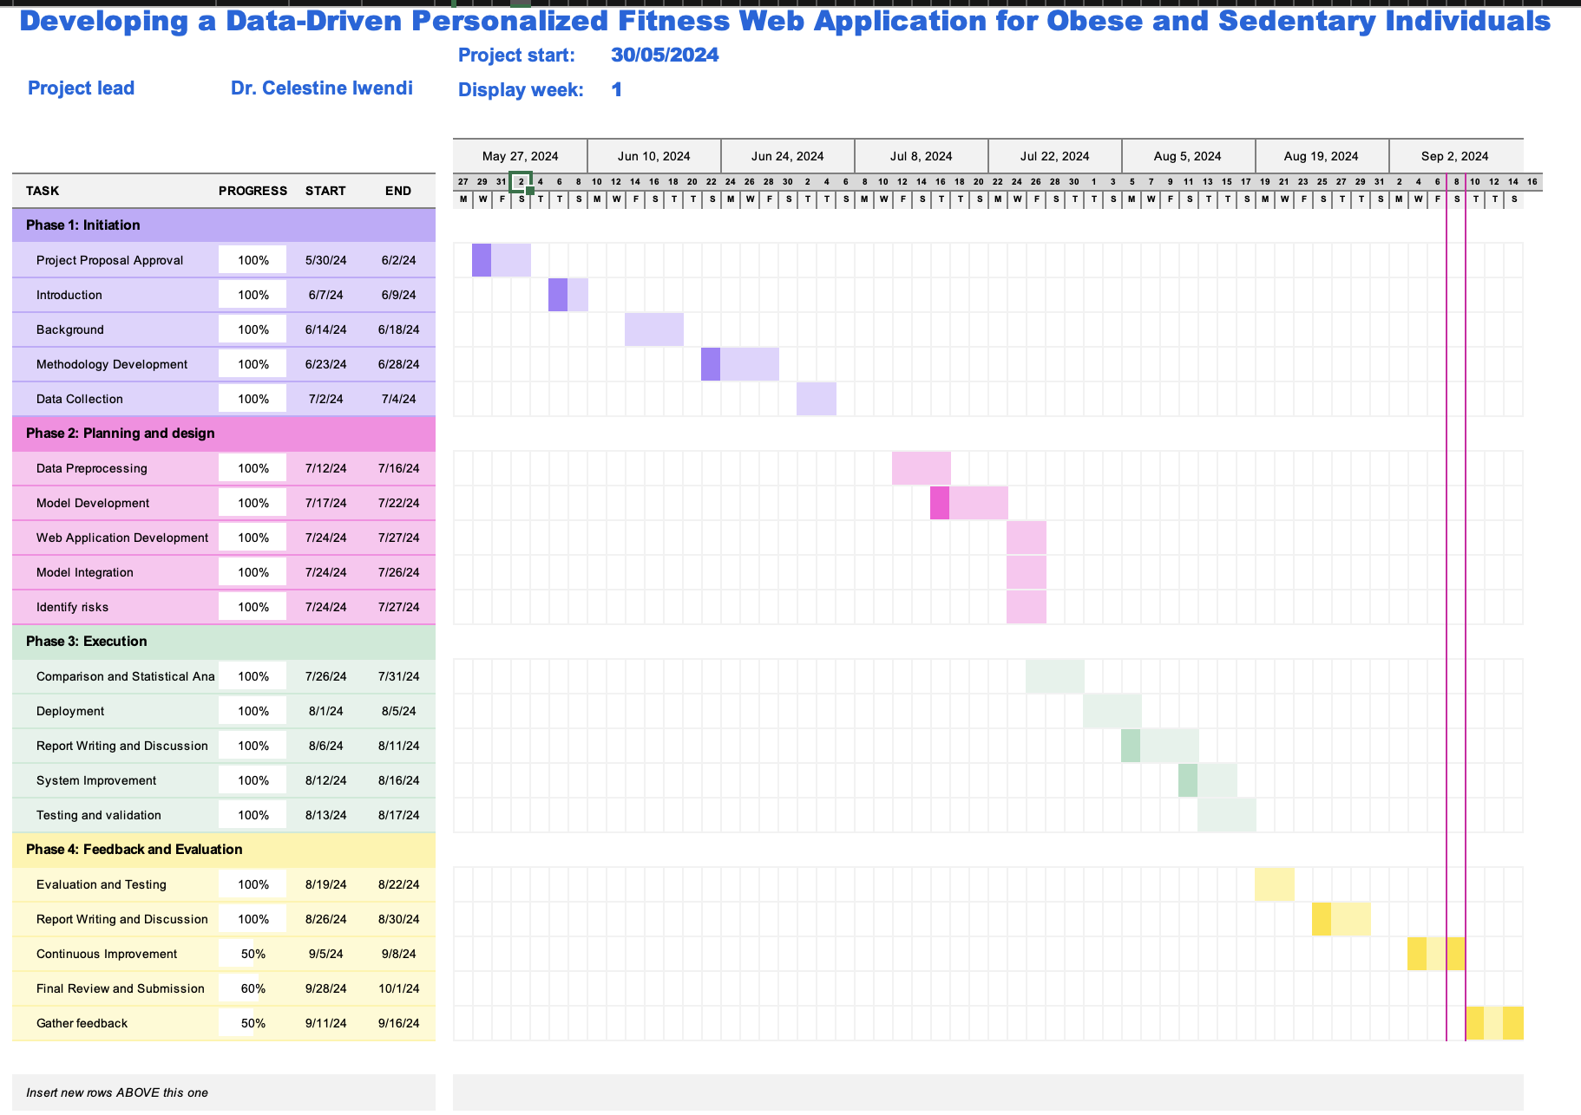

# Appendix – Data Analysis Code

1. Data Importation

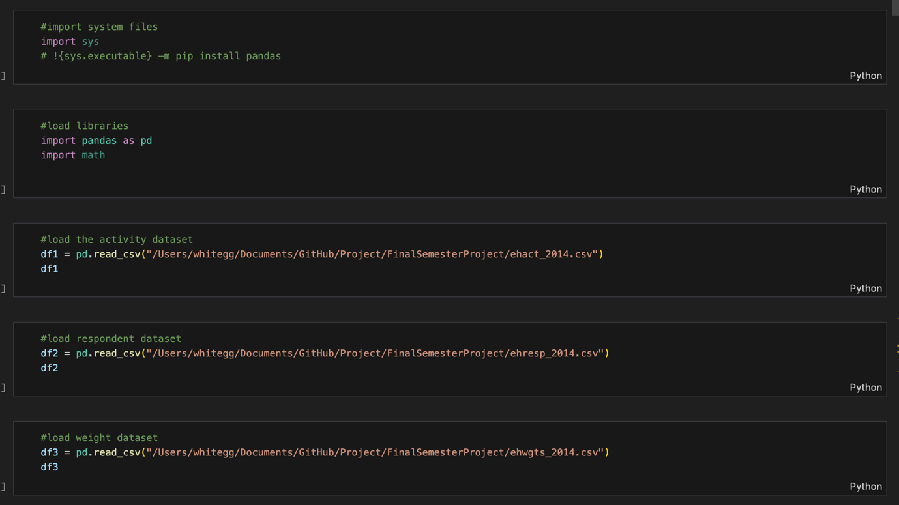

1. Data Exploration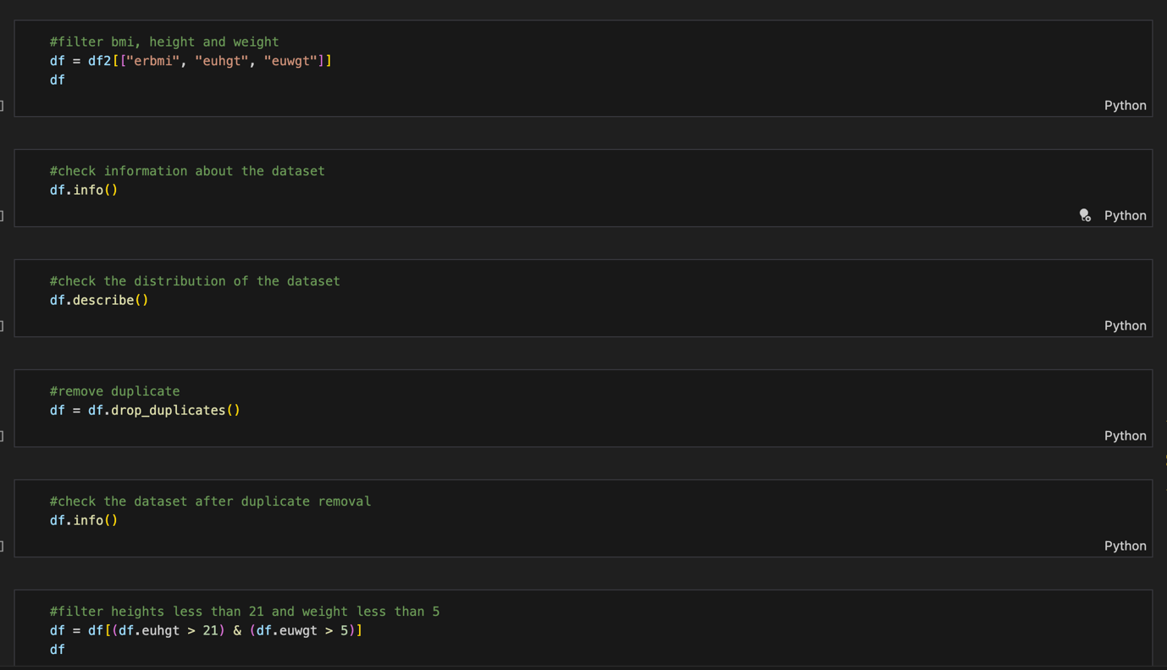

1. Data Cleaning
2. Linear Interpolation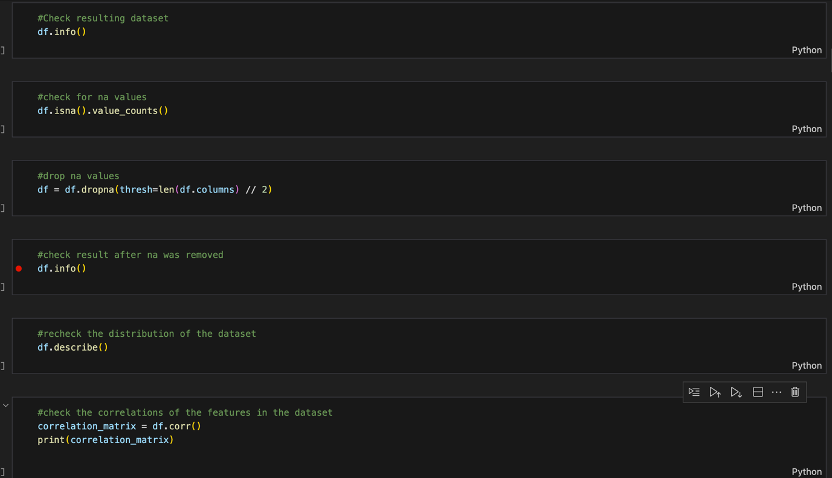
3. Data Visualisation

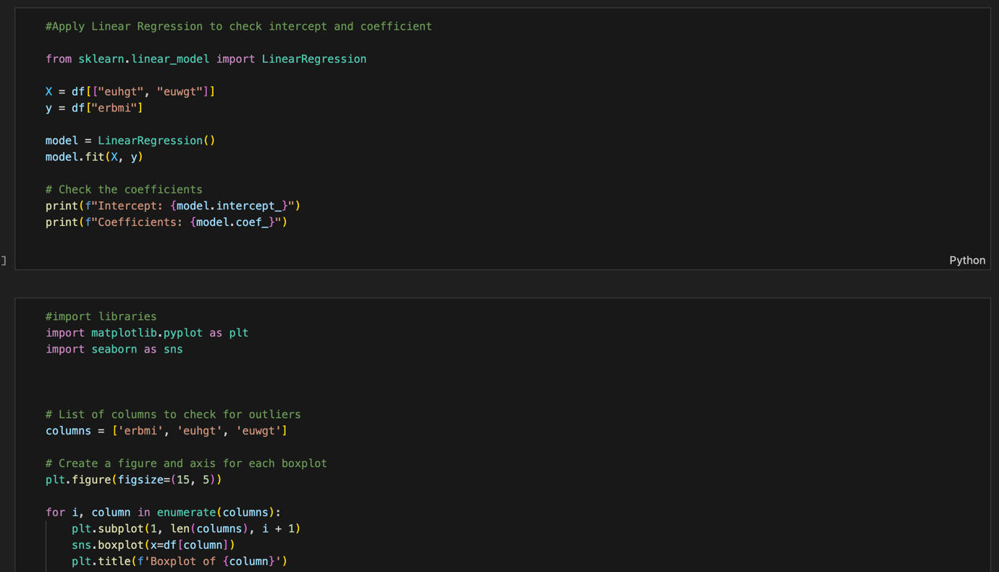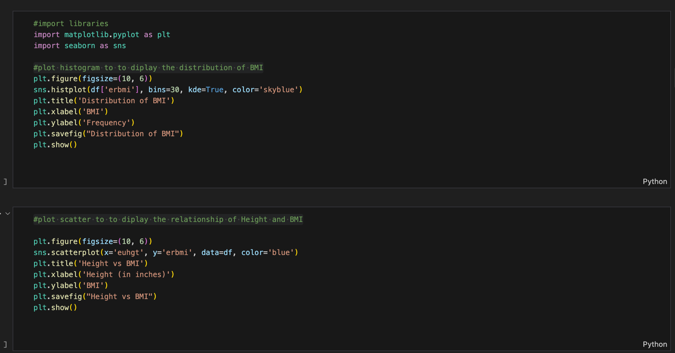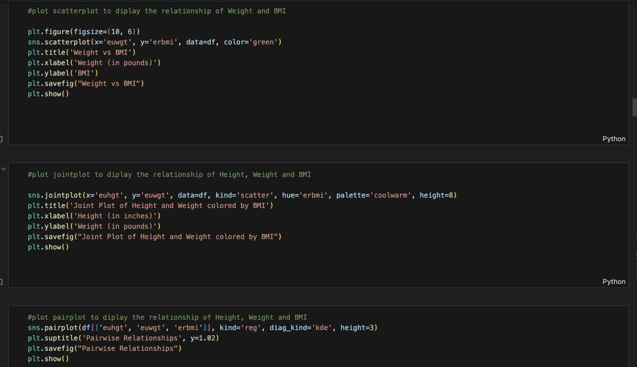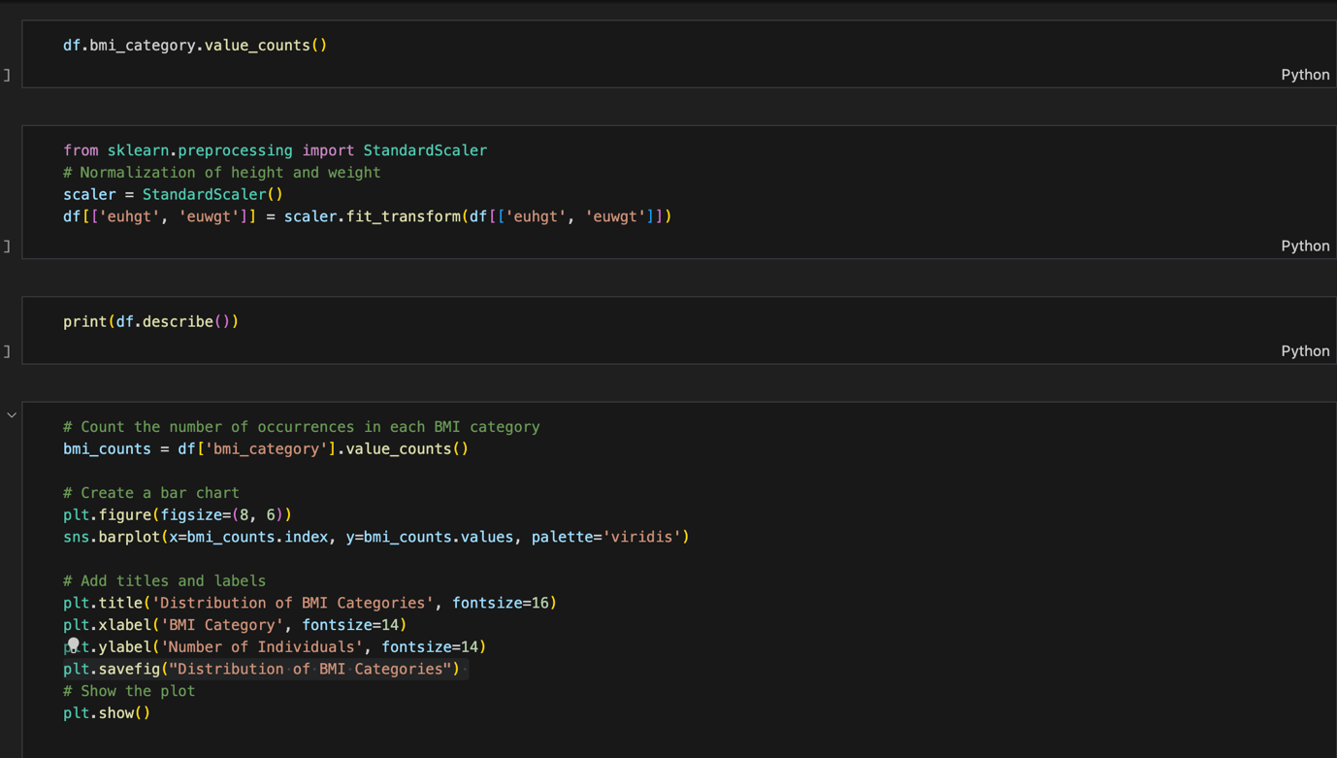

1. Machine Learning and Model Evaluation

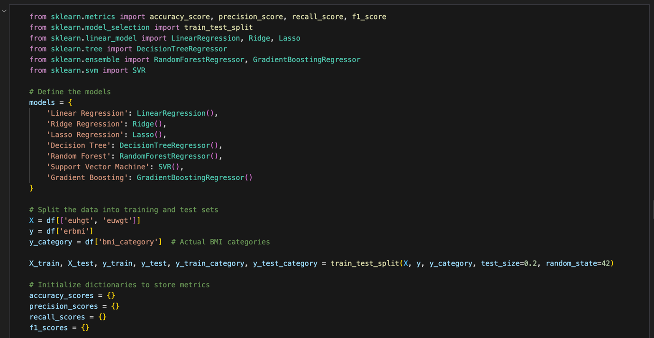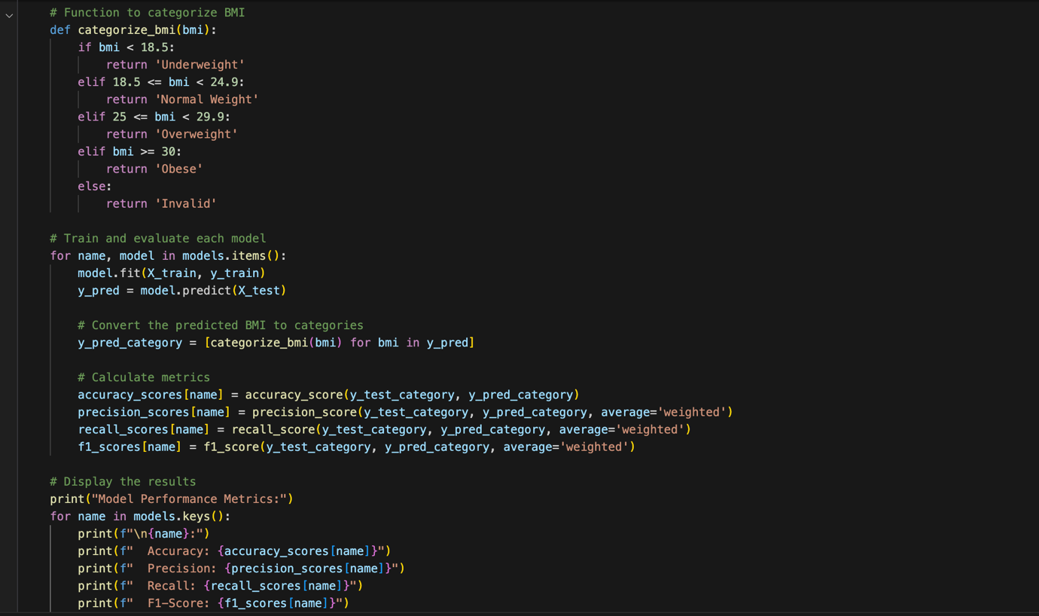

1. Statistical Analysis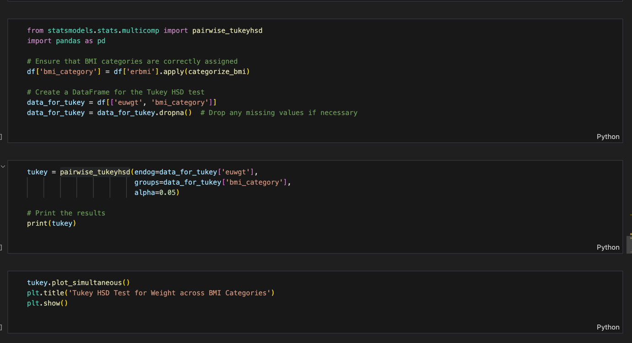

# Appendix – Web Application Code

1. App Model

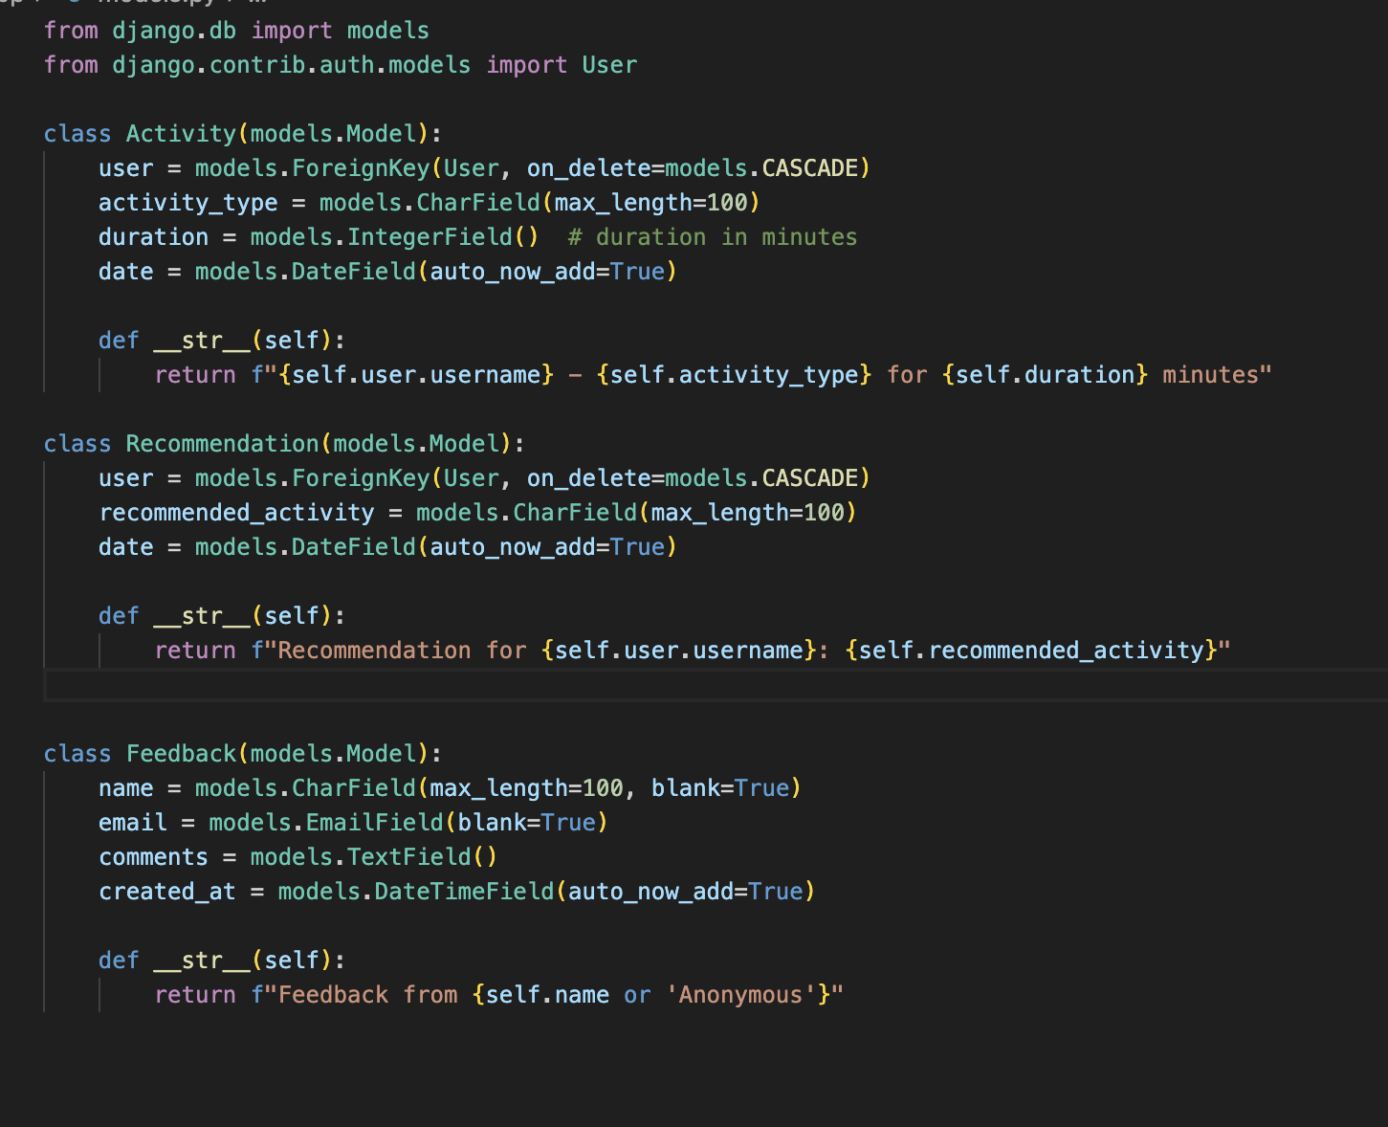

1. App Views

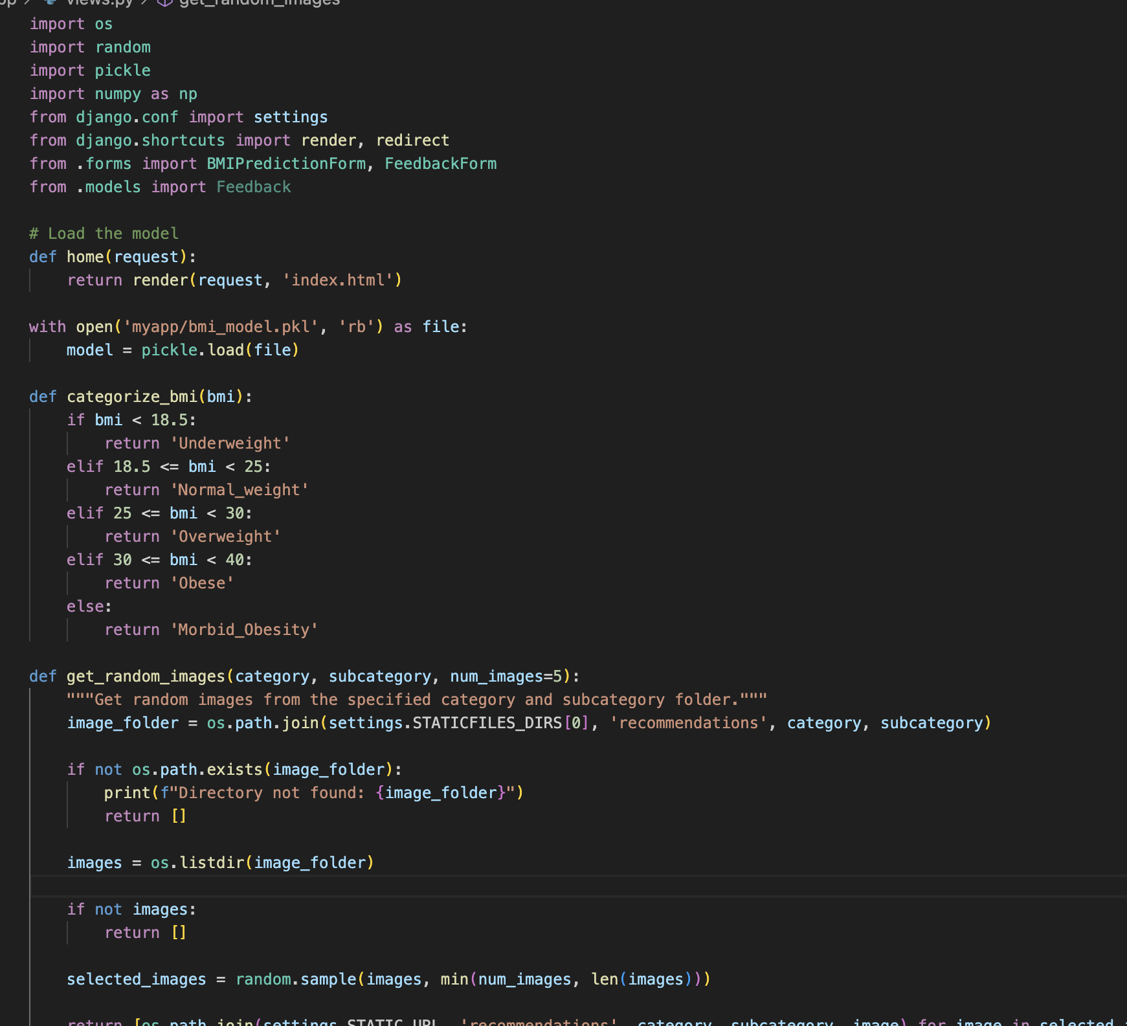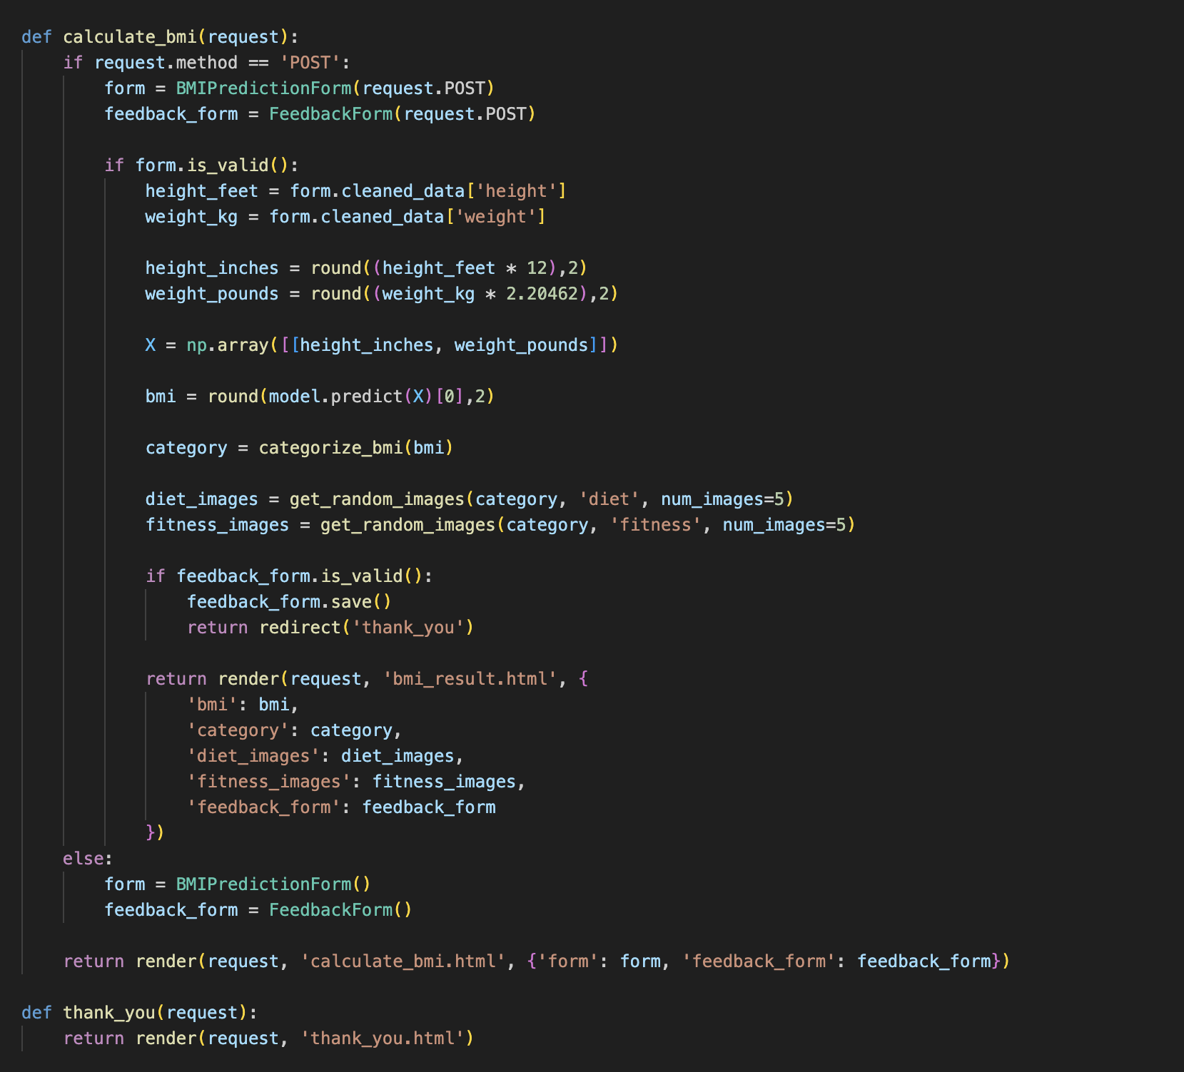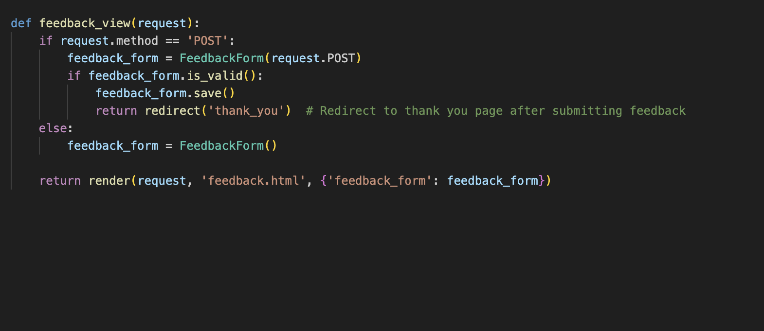

1. App Urls

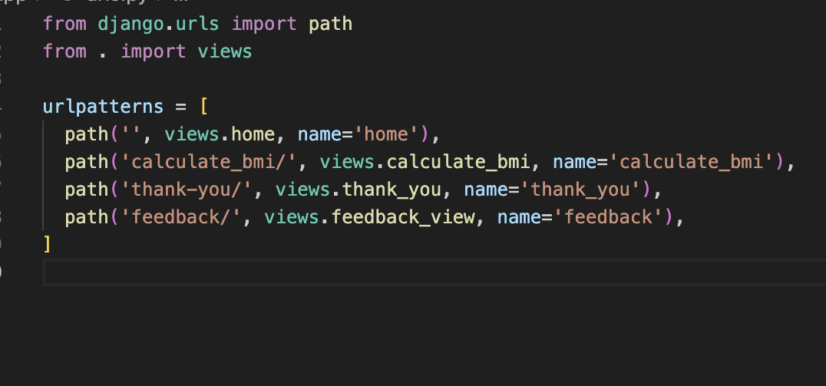

1. App Form

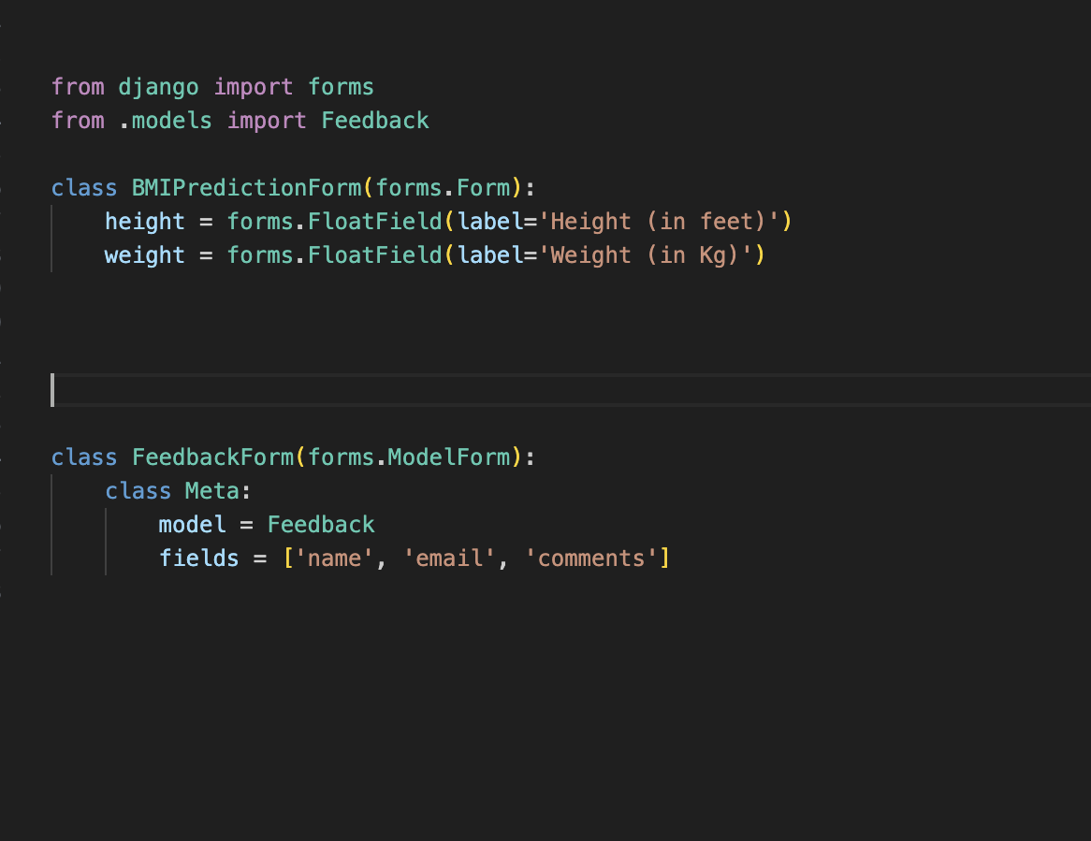

1. App Base Html File

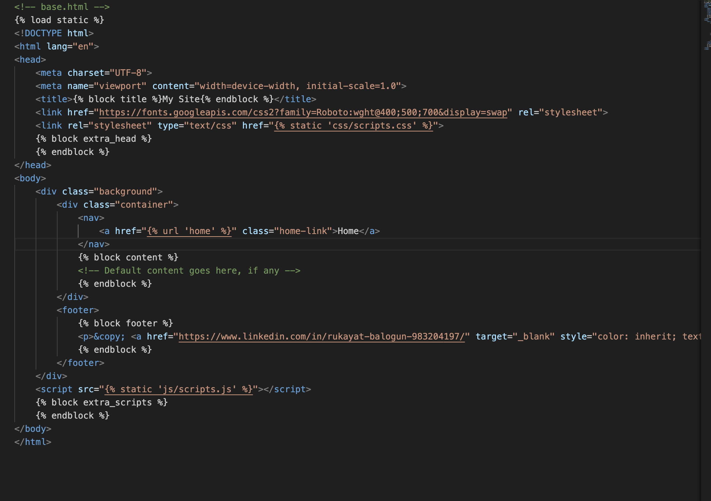

1. BMI result code

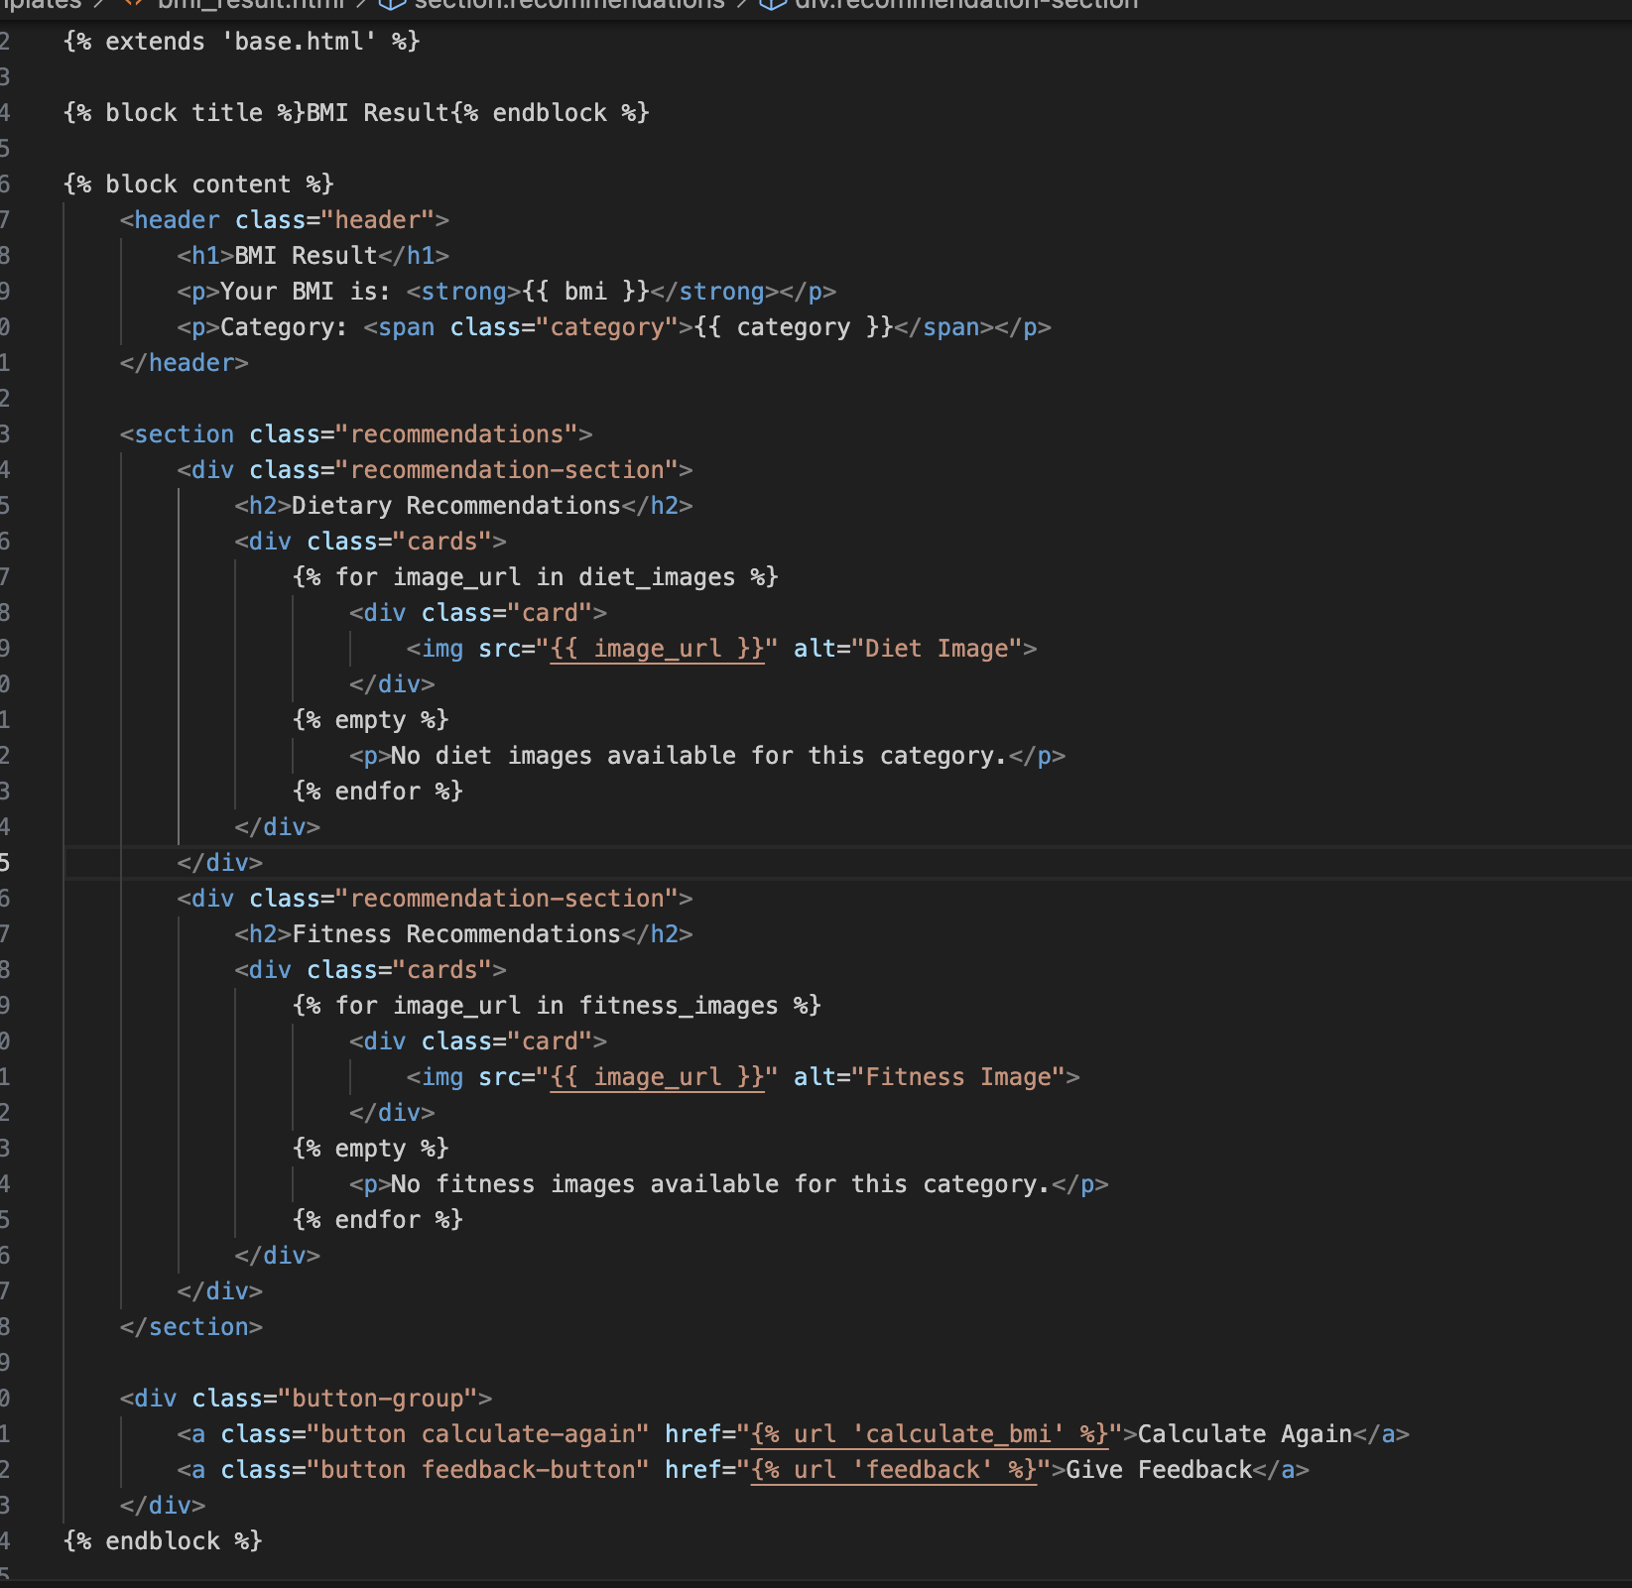

1. Calculate BMI HTML code

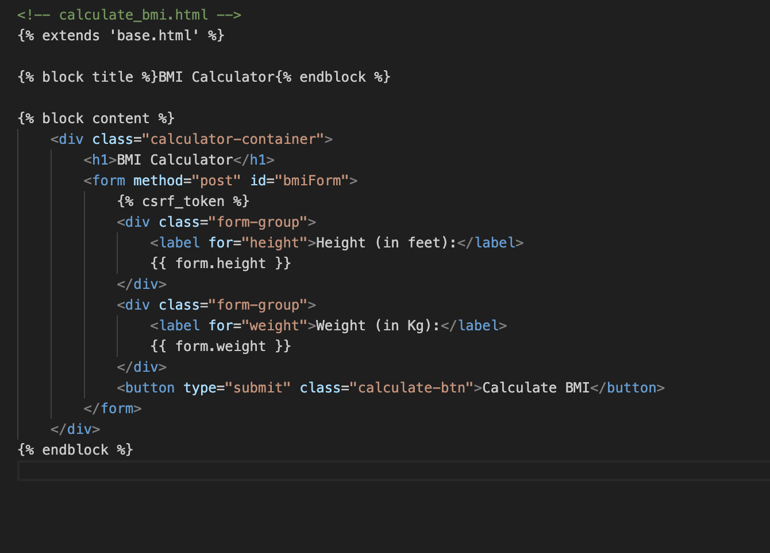

1. Index HTML code

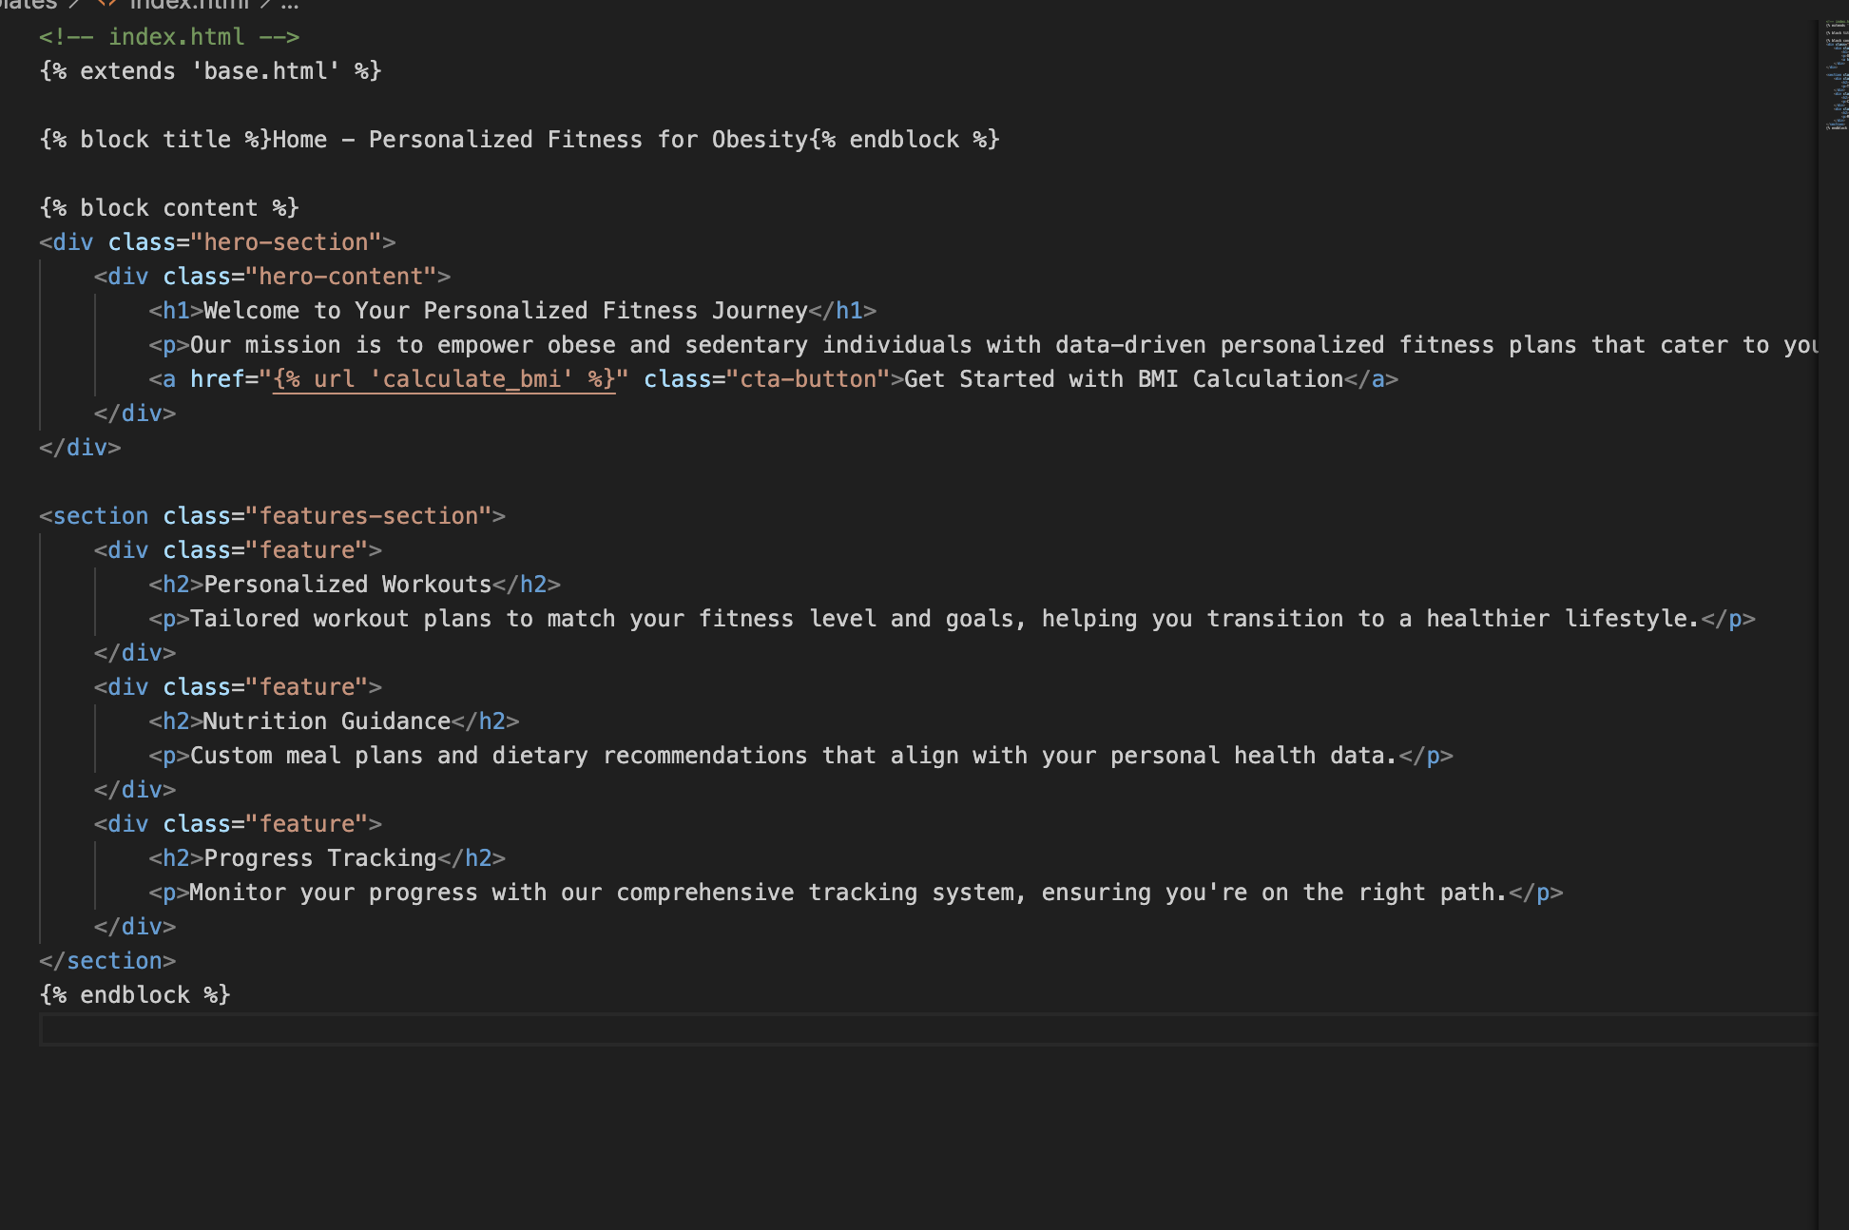

1. Thank you HTML code

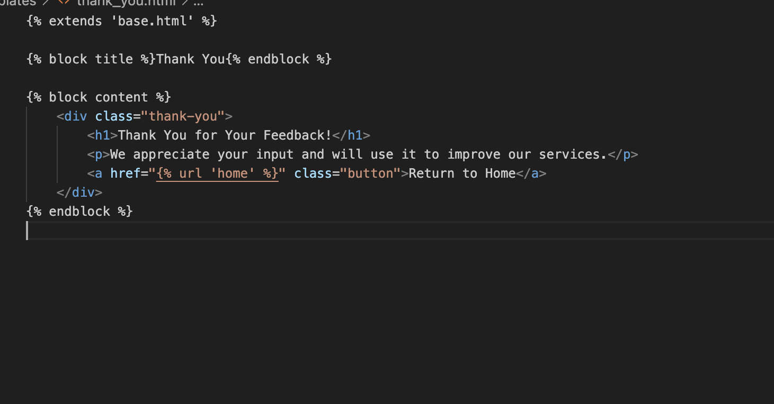

1. Feedback HTML code

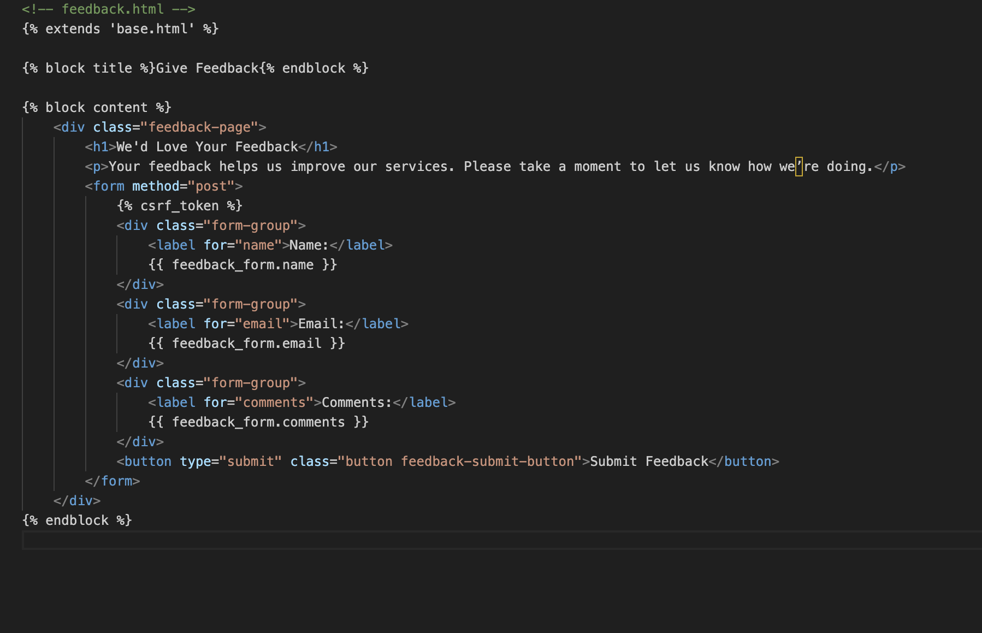

# Appendix – Web Application Frontend

